18 The senses - exercises and discussion
Exercises and discussion E3.27

1 Which of the following would best explain why a strong stimulus is felt in a particular part
of the skin but a weak stimulus is not?
(a) There are no sensory endings in that region.
(b) There are fewer sensory endings.
(c) The sensory endings in that region are not easily stimulated. (A)

2 How might (a) the number of sensory endings affected, (b) the types of sensory endings responding enable you to detect the difference between a touch and a pinch? (A)

3 (a) If the arm is flexing at the elbow, in which muscle will the stretch receptors be
stimulated?
(b) There are tension receptors and stretch receptors. Which of these would you expect to find
in a tendon? (A)

4 As you get older, your eye lens loses some of its elasticity and will not change its shape so
much when the ciliary muscle contracts. What effect do you think this has on (a) your near
vision, (b) your distant vision? (A)

5 Where is the focal point, relative to the retina,
(a) in long-sighted people (i) for near objects, (ii) for distant objects
(b) in short-sighted people (i) for near objects, (ii) for distant objects? (A)

6 How would the shape of the spectacle lenses of a person who is slightly long-sighted
differ from those of a very long-sighted person? (A)

7 The nearest distance at which you can clearly focus an object is called your 'near point'.
The figures below show how the near point changes with age.
Age/ years | 10 | 20 | 30 | 40 | 50 | 70
Near point/ cm | 9 | 10 | 12.5 | 18 | 50 | 100

(a) Plot these figures on a graph.
(b) Why does a 70-year-old person have difficulty in reading newsprint without the aid of
spectacles?
(c) At approximately what age would you expect to need reading spectacles?
(d) What kind of spectacles will be needed by (i) a 50-year-old (ii) a 70-year-old person? (I)

8 You are asked to design an experiment to see whether vitamin A improves night vision in
members of your class. You decide to give half the class extra vitamin A for 6 weeks and
then compare their night vision with that of the rest of the class.
(a) How would you select the group to be given the extra vitamin A?
(b) How would you standardise their intake of vitamins?
(c) What tests would you conduct before giving the vitamin supplement?
(d) How would you record and test the students’ night vision?
(e) How would you analyse your results? (E)

The senses - exercises and discussion (continued)
Exercises and discussion E3.28

9 The block graphs below show the frequency of nerve impulses picked up by micro-
electrodes in nerve fibres coming from single taste receptors, A, B and C, when stimulated by different substances in turn. (NOTE: Quinine tastes bitter.)
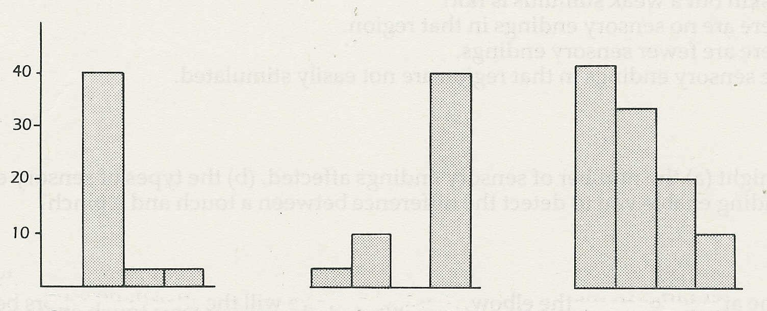

impulses per second

acid (HCl)
acid (HCl)
acid (HCl)
salt (NaCl)
salt (NaCl)
salt (NaCl)
quinine
A
B
C
quinine
quinine
sugar
sugar
sugar

© Journal of Neurophysiology

(a) What sensation would you expect to experience if pure lemon juice was placed on receptor
cell A? Explain your answer.
(b) What sensation would you expect to experience if lemonade reached (i) receptors B
and C simultaneously, (ii) receptor C only? Explain your answer.
(c) Which of these receptors is least useful in being able to distinguish one chemical from
another? Explain your answer. (I)
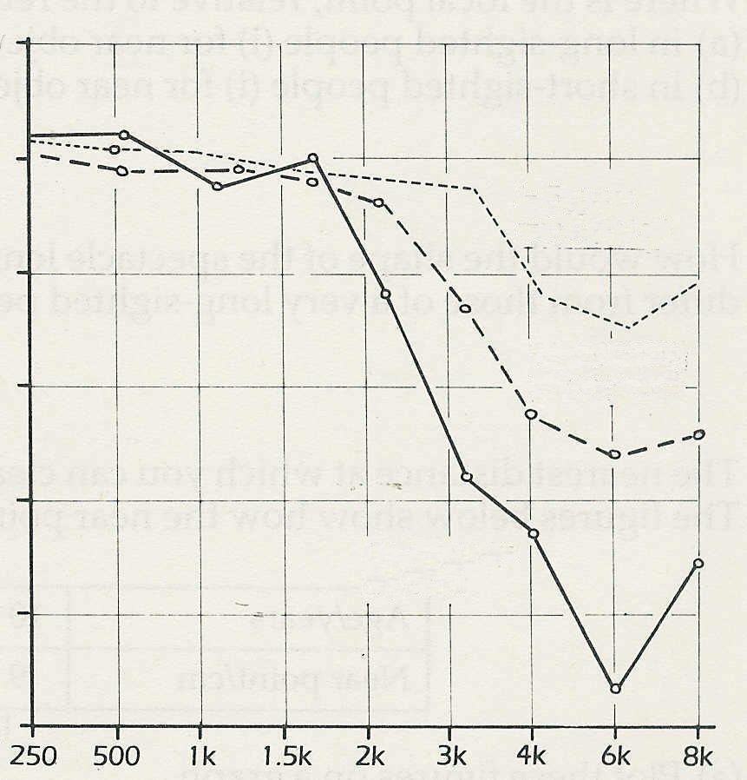
high sensitivity
low sensitivity
increasing sensitivity
1-5 years
not exposed
16-20 years
not exposed
16-20 years
exposed
frequency/ Hz
10 The graph shows how the sensitivity of
hearing varies with the frequency of
sound in three groups of airport inspectors.
The solid line represents inspectors
who had worked at the airport for 16-20
years and had been exposed to aircraft noise.
The broken line represents inspectors
who had worked for the same period but
were not exposed to aircraft noise.
The dotted line is for younger inspectors who
had worked from 1-5 years without being
exposed to aircraft noise.
© Occupational Health Review

(a) What does the graph suggest about the effect of age on the sensitivity of the human ear.
(b) What does the graph suggest about the effect of prolonged exposure to loud noise on
the sensitivity of the ear? (I)

Exercises and discussion E3.29
The senses - exercises and discussion (continued)

11 The graph below plots the approximate threshold of human hearing for a 29 year-old person. ‘Sounds’ below, the line cannot be heard by humans.
The vertical scale represents the loudness of the sound measured in decibels (dB). The
horizontal scale represents the frequency of the sound (the pitch) in hertz (Hz) (vibrations
per second). The greater the frequency the higher is the pitch of the sound.
The shaded area represents the range of loudness and frequencies normally used in conversation.
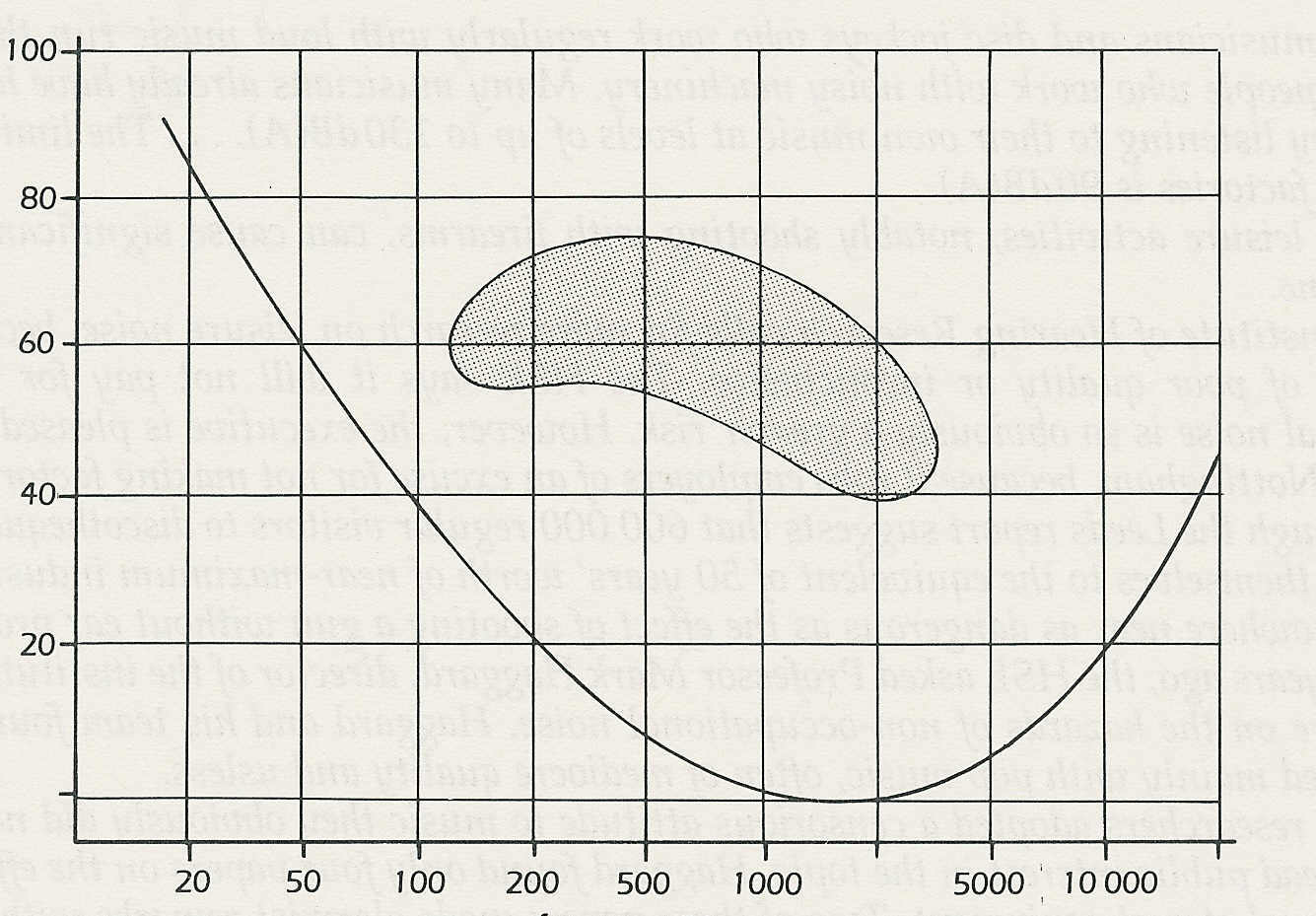

loudness/ dB

frequency/ Hz
© Hilgard, Richard C. Atkinson and Rita L. Atkinson

(a) To what range of frequencies is the human ear most sensitive?
(b) What types of sounds are most difficult to hear?
(c) Which of the following sounds could be heard by a human ear?
50Hz at 40dB 5000 Hz at 30 dB
500 Hz at 20 dB 100 Hz at 30dB.
(d) Which of the following voices fall within the range of normal human conversation?
(i) A quietly speaking person (50 dB) with a high-pitched voice (average 1000Hz)
(ii) A moderately quiet person (60 dB) with a fairly high-pitched voice (average 500Hz)
(iii) A loudly speaking person (70 dB) with a deep voice (150Hz). (I)

12 Read the following extract from 'Are we led by the nose?' ('Olfactory' is the technica1 term
relating to the sense of smell)
As we sniff, air is drawn past the turbinate bones, which reside in the nasal cavity. Attached to
a part of this bony area is the olfactory epithelium, a layer of yellow tissue, whose total area is
4-5 square centimetres, and which is covered by mucus. The equivalent area in a dog's nose
measures 18cm²; in cats the figure is 21 cm².
Smelly molecules must penetrate the mucus layer before they gain access to the sensitive cells.
These cells, of which there are estimated to be about 10 million up a human nose, are
equipped with beating 'hairs,' called cilia, whose membranes are studded with proteins. These
proteins are widely held to be the sites at which interaction occurs between odorous molecules
and the sensory cell. Current opinion has it that each sensory cell houses many different types
of proteinaceous receptors, each of which responds to many different kinds of odorous
molecules. In turn, each odorant may stimulate several sorts of protein . © NEW SCIENTIST.
(a) How many times greater is the area of a cat's olfactory epithelium than a human's? (b) Which part of a sensory cell is thought to detect smells? (c) Is it thought that a single sensory cell can detect only one or several types of smell? (C)

