Exercises and discussion E3.24
The skeleton, muscles and movement - exercises and discussion

1 Match the following structures and functions.
(a) Transmits pull of muscle to bone (i) joint
(b) Holds bones together at movable joint (ii) synovial fluid
(c) Covers bone surfaces at a movable joint (iii) tendon
(d) Helps reduce friction in movable joint (iv) ligament
(e) Contracts to produce movement (v) cartilage
(f) Region of contact between two bones (A) (vi) muscle
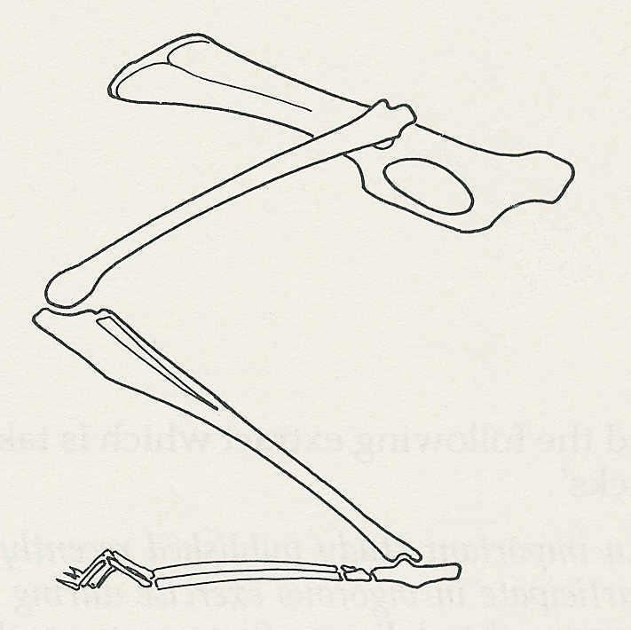
2 (a) On the diagram of a rabbit's hind leg,
draw muscles which would (i) extend
the leg at the knee, (ii) flex the foot at
the ankle, (iii) flex the leg at the knee.
Label each muscle with the appropriate
numeral (i) - (iii).
pelvic girdle
(b) Which of the three muscles is likely
to be the most powerful? Explain your
reasoning. (A)

3 The drawing shows the skeleton of the hand.
(a) Draw the outline of the fingers, palm
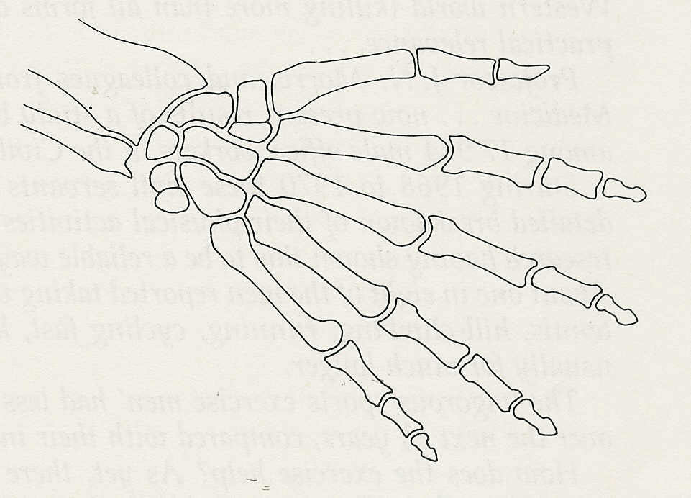
and wrist.
(b) Assume that the drawing represents
your own hand. By how much has the
drawing been reduced?
(c) Where would you expect to find the
muscles which flex the fingers? (A)

4 (a) A well known study compared the incidence of heart attacks in
London Transport bus drivers and bus conductors. The study included 31,000 men between
the ages of 35 and 64. It was found that, over a 2-year period, the conductors had 50%, fewer
heart attacks than the drivers. (NOTE. At the time of this study, London buses were double-
deckers and the conductor collected the fares).
How do these results support the hypothesis that regular exercise reduces the risk of heart
attacks?
(b) A subsequent study analysed the waist-band size of the uniform trousers issued to
drivers and conductors when they joined London Transport. It was found that, on average, the
trousers issued to drivers were at least 1 inch wider in the waist than those issued to
conductors.
How does this finding affect the hypothesis above? (I)

5 Say how you would design an experiment to compare the strength of the flexor muscles of the
arm in students from your class. How could you use your experimental design to find out whether exercise improves the strength of the relevant muscles? (E)

Exercises and discussion E3.25
The skeleton, muscles and movement - exercises and discussion (continued)

6 The graph shows the levels of lactic
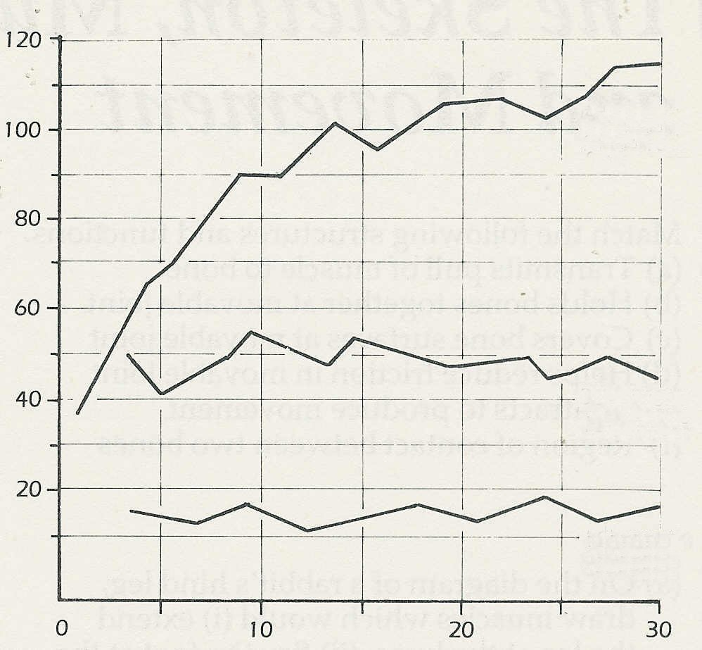
acid in the blood during a 30-minute
lactic acid/ mg per 100 cm³ blood
60/s work
240/s rest
period of work. In each case the total
amount of work done was the same but
the periods of work and rest differed.
(a) How do the three patterns of work
differ from each other?
(b) Which pattern of working
produces the lowest concentration
30/s work
120/s rest
of lactic acid?
(c) Some physiologists think that
fatigue is related to levels of lactic
10/ s work
40/ s rest
acid in the blood. If they are right,
which pattern of work is likely to
be the least tiring? (I)
time/ minutes
© Passmore and Robson

7 Read the following extract which is taken from an article called 'Exercise does reduce heart attacks'.
An important study published in The Lancet shows that men who participate in vigorous
exercise during their leisure time obtain significant protection against coronary heart disease.
Since coronary thrombosis is the commonest cause of death in men in the Western world
(killing more than all forms of cancer put together), this is a finding of great practical
relevance. . . .
Professor ]. N. Morris and colleagues from the London School of Hygiene and Tropical
Medicine. . . now present results of a study concerning coronary heart disease among 17,944
male office workers in the Civil Service.
For two years these civil servants were asked on a Monday morning to provide a detailed
breakdown of their physical activities on the preceding Friday and Saturday; previous
research having shown this to be a reliable way of assessing the men's habitual physical
activity. About one in eight of the men reported taking vigorous exercise in the form of sports
(swimming, tennis, hill-climbing, running, cycling fast, keep-fit and so on) for at least five
minutes and usually for much longer.
The ‘vigorous sports exercise men' had less than half the incidence of coronary heart disease
over the next 8 years, compared with their inactive peers. . . .
How does the exercise help? As yet, there are few direct clues as to the mechanism of the
protective effect. The current view is that peaks of high-intensity exercise may help to prevent
the build up of obstructions in the vital coronary blood vessels or to increase the release into
the blood stream of beneficial high-density lipoproteins. The important thing to bear in mind
is the simple fact that vigorous outdoor exercise is likely to be extremely good for you - as
well as enjoyable for its own sake. © NEW SCIENTIST

(a) How many men were studied in Prof. Morris's research?
(b) For how long did the subjects keep records of their leisure activities?
(c) For how long was the study continued?
(d) Why do you think Prof. Morris chose to study (i) men, (ii) office workers?
(e) What percentage of the subjects took vigorous exercise at weekends?
(f) What were the results of the study? ,
(g) In what ways might vigorous exercise help to reduce the risk of heart attack? (C)

