Exercises and discussion E3.18
The skin, and temperature control - exercises and discussion

1 Capillary blood vessels in the dermis bring food and oxygen to all the structures in the skin. What are the additional functions of the capillaries which
(a) supply the sweat glands,
(b) form capillary loops beneath the epidermis? (R)

2 The graph shows the effect on body
mouth
temperature/ ºC
temperature (as measured by a
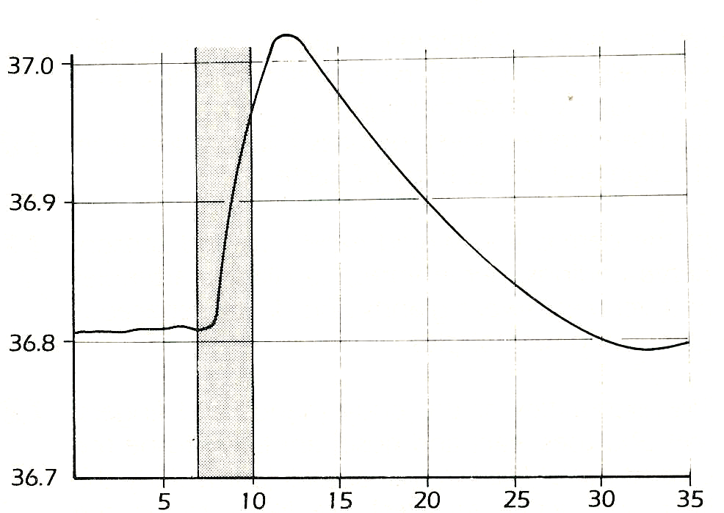
thermometer in the mouth) of a person
who has one arm immersed in warm
water (45°C). The shaded area
represents the period of immersion.
(a) Why, do you think, did the whole
body temperature rise while the
arm was immersed?
(b) What might have been the cause
of the continuing rise in body
temperature even after the arm
was removed from the warm water?
(c) Suggest a reason why the body
temperature after 35 minutes was lower
than the body temperature at first. (I)
time/ minutes

3 If the blood in a cat's carotid artery (which carries blood from the heart to the head) is
slightly warmed, the cat starts to sweat from its paws (the only part of the body with sweat
glands) even though its general body temperature has not changed.
(a) What does this suggest about
(i) the part of the cat’s body which detects a rise in blood temperature,
(ii) the method by which the sweating response is started in the sweat glands?
(b) If a person's right hand is immersed in hot water, vaso-dilation is observed in the left hand.
Suggest two possible ways in which this might be brought about.
(c) In the same experiment, if the blood flow from the right hand is restricted by applying
pressure, vaso-dilation in the left hand does not occur. How does this result affect your
explanations in (b)?
(d) If the right hand is immersed in cold water, and the blood flow restricted, the left hand
still shows vaso-constriction.
Suggest an explanation for this. (I)

4 A popular fallacy is that an alcoholic drink warms you up. In fact, alcohol causes
vaso-dilation. Suggest
(a) why alcohol may indeed make you feel warm,
(b) why, at the same time, it may be cooling you down. (A)

The skin, and temperature control - exercises and discussion (continued)
Exercises and discussion E3.19

5 (a) Even in a resting condition, there is always some evaporation of water from the skin. It has
been calculated that the average adult loses about 700 cm³ of water through the lungs and skin
in 24 hours. If the amount of energy needed to evaporate water is approximately 2.44 kJ cm⁻³,
what is the heat loss resulting from evaporation in one day?
(b) If a man without adequate waterproof clothing goes hill walking in cold weather and is soaked
in a rain storm, his clothing may absorb as much as 500 cm³ of water. The latent heat of
vaporisation of water is 2.44 kJ cm ⁻³. Explain why he is in danger of hypothermia and why a
good breakfast might reduce the risk. (A)

6 The graph below shows the readings, at one-minute intervals shown by a clinical thermometer from the time it was first placed in the mouth,
Graph A shows the readings taken in normal conditions.
Graph B shows readings taken after drinking a hot cup of tea.
Graph C shows readings after taking a cold drink.
From the results, suggest what should be done to obtain an accurate measurement of mouth temperature. (I)
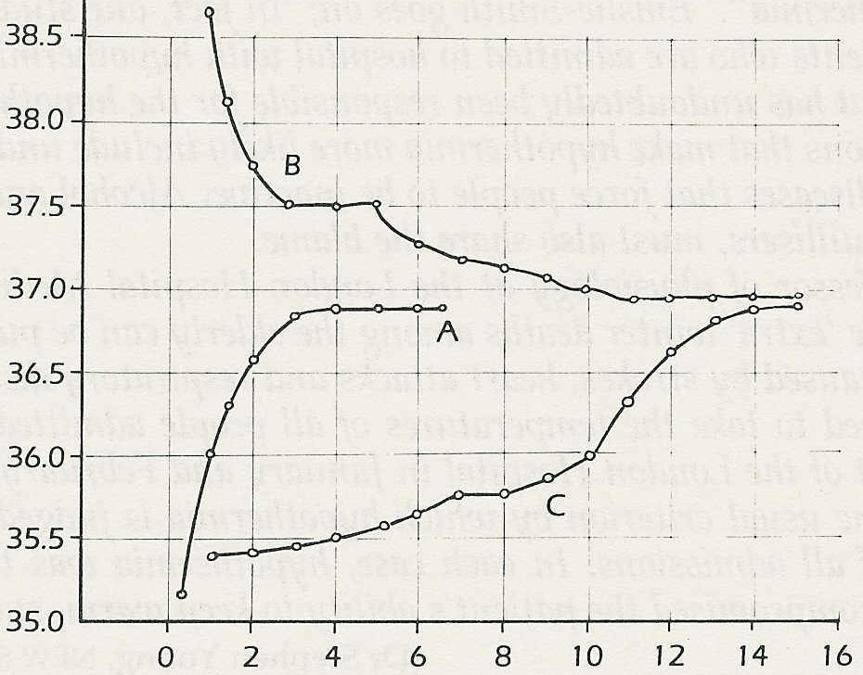

mouth temperature/ º C

© Emslie-Smith, Paterson, Scratcherd & Read

time/ minutes

7 The table gives the body temperatures,
taken at 4-hour intervals, of two men.
Time of day | Body temperature/ ºC
 | Day shift | Night shift
7.30 p.m.  11.30 p.m.  3.30 a.m.  7.30 a.m.  12.00 noon  3.30 p.m  7.30 p.m. | 37.1  36.4  35.8  36.1  36.7  36.7  37.1 | 36.9  36.65  36.2  36.3  36.15  36.3  36.9
One man works a day shift from 8 a.m. to
5 p.m. and sleeps from 11.30 p.m. to 7 a.m.
The other man works a night shift from
11 p.m. to 7.30 a.m. and sleeps from 8 a.m.
to 3.30 p.m.
Plot the two sets of figures on one graph
and discuss the relationship between body
temperature and daily activity in these two
men. (1)

8 After exercise the skin feels hot. Choose the best hypothesis to explain this observation,
from the four below..
(a) The body needs to get rid of surplus heat.
(b) There is an increased flow of blood in the skin.
(c) The temperature of the skin has risen,
(d) The blood vessels come closer to the skin surface. (H)

