Exercises and discussion E3.12

Breathing - exercises and discussion
1
Gas | Composition/ %
Gas | Inspired air | Expired air | Alveolar air
Oxygen  Carbon dioxide  Water  Nitrogen | 20.71  0.04  1.25  78.00 | 14.6  4.0  5.9  75.5 | 13.3  5.3  5.9  75.5

Use the information in the table to answer the following questions.
(a) How much oxygen is there in 100 cm³ inhaled air?
(b) How much of this oxygen is removed by breathing?
(c) If, during quiet breathing, about 500 cm³ air is exchanged per breath, and 16 breaths are
taken per minute, what volume of oxygen is used in one hour? (I)
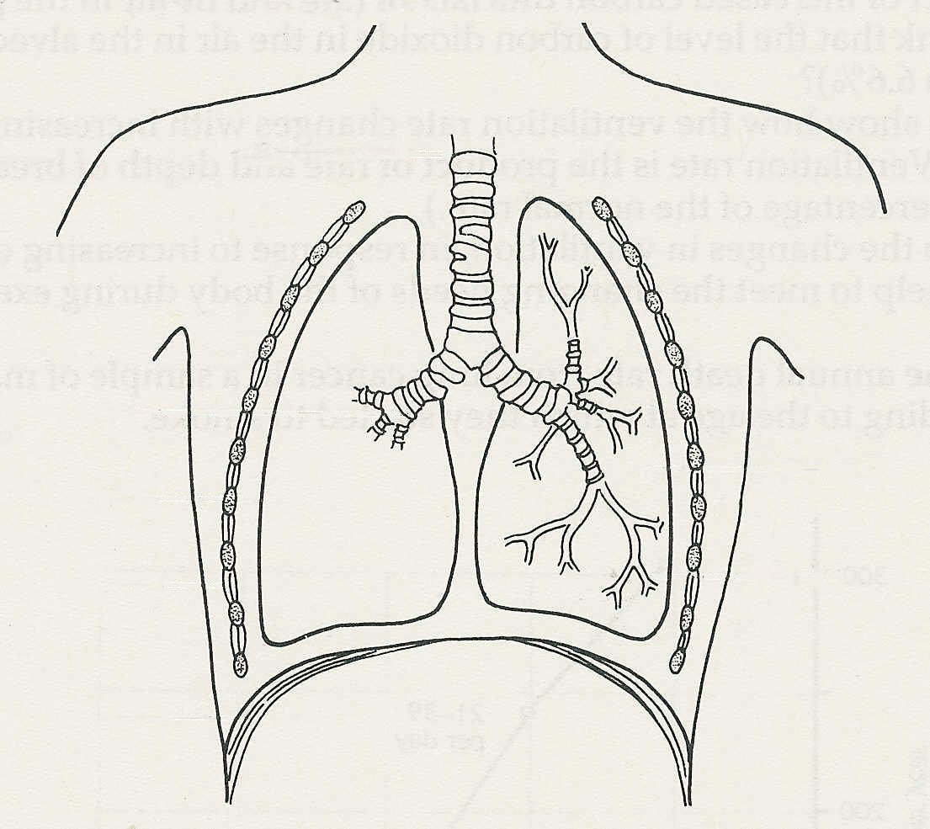
2 Name the structures A-G in
A
the diagram. (A)

B

C
F

G
D

E

3 Describe the events which take place in the thorax to cause air to be taken into the lungs. (R)

4 (a) In what two ways does your breathing change when you take exercise?
(b) In what two ways do these changes help to meet the requirements of active muscles? (R)

5 State the differences between the terms 'respiration', ‘gaseous exchange’ and ‘ventilation’. (A)

6 A student breathes in and out through the
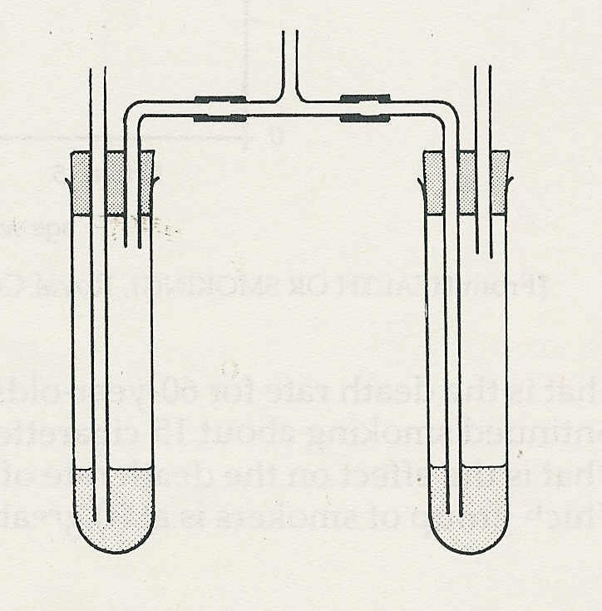
P
tube P in the apparatus illustrated.
(a) Through which test tube will inhaled air pass?
(b) Name a liquid in the tubes which would
detect a difference in composition between
inhaled and exhaled air.
(c) After a minute or two of breathing, how
would the liquids in tubes A and B differ
in appearance?
(d) What might you reasonably deduce from
A
B
this difference? (A)
Breathing -exercises and discussion (continued)
Exercises and discussion E3.13

7 The table shows the results of a famous experiment in which the subject breathed air containing different concentrations of carbon dioxide.

% CO₂ in inspired air | 0.79 | 2.02 | 3.07 | 3.73 | 5.14 | 5.58 | 6.02
% CO₂ in alveolar air (calculated) | 5.5 | 5.6 | 5.5 | 5.9 | 6.2 | 6.6 | 6.6
Average depth of breathing/ cm³ | 739 | 864 | 1216 | 1330 | 1771 | 1845 | 2104
Average frequency of breathing per minute | 14 | 15 | 15 | 14 | 19 | 16 | 27
Ventilation rate (normal = 100) | 116 | 153 | 226 | 273 | 498 | 411 | 857

© Journal of Physiology

(a) What is the effect of increased carbon dioxide on (i) the rate, (ii) the depth of breathing?
(b) Why do you think that the level of carbon dioxide in the air in the alveoli changes so
little (from 5.5 to 6.6%)?
(c) Draw a graph to show how the ventilation rate changes with increasing carbon dioxide
concentration. (Ventilation rate is the product of rate and depth of breathing and expressed
as a percentage of the normal rate.)
(d) In what ways do the changes in ventilation, in response to increasing carbon dioxide
concentration, help to meet the changing needs of the body during exercise? (I)

8 The graph shows the annual death rate from lung cancer in a sample of male smokers over
the age of 60, according to the age at which they started to smoke.
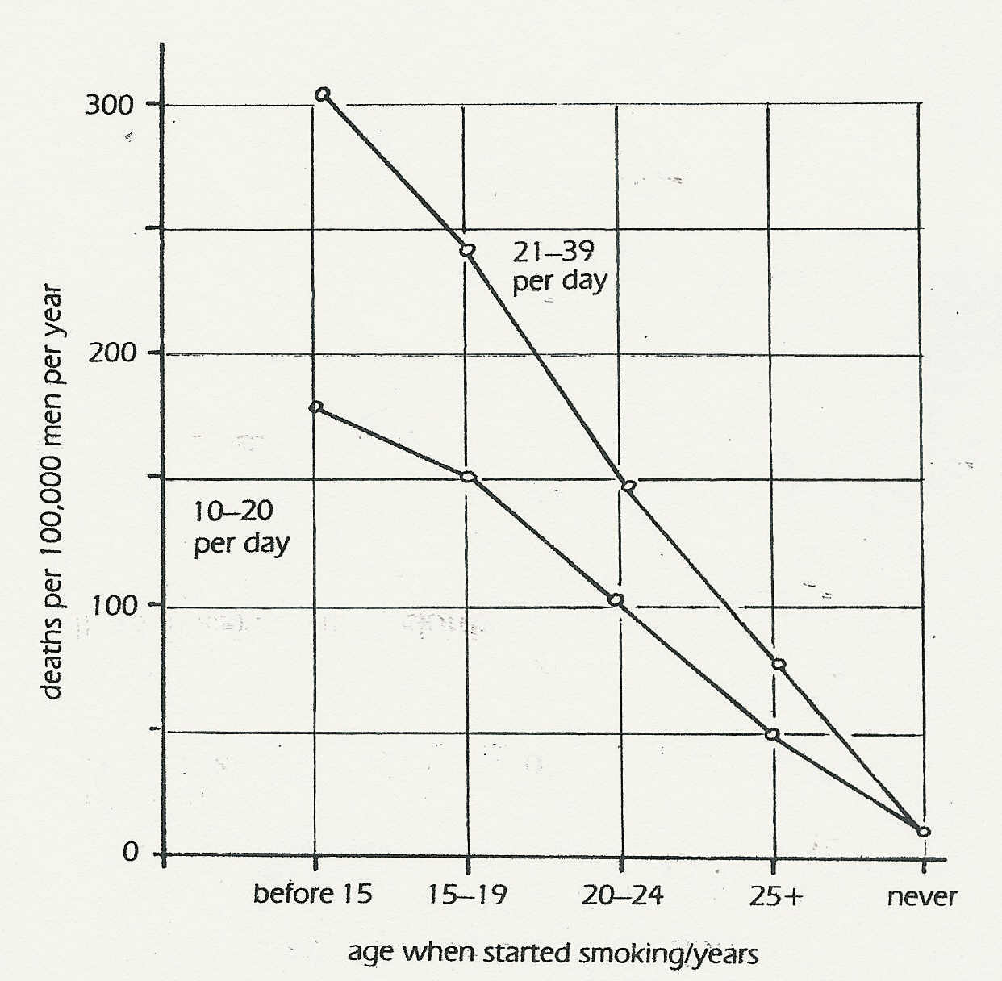

© Royal College
of Physicians

(a) What is the death rate for 60-year-olds in the sample, who started to smoke at 20 and
continued smoking about 15 cigarettes a day?
(b) What is the effect on the death rate of starting to smoke later in life?
(c) Which group of smokers is at (i) greatest risk, (ii) least risk? (I)
Exercises and discussion 3.14

Breathing- exercises and discussion (continued)

9 Drawing X represents a microscopic section through a healthy lung to show an air passage
and alveoli. Drawing Y represents a similar section taken from a person with emphysema.

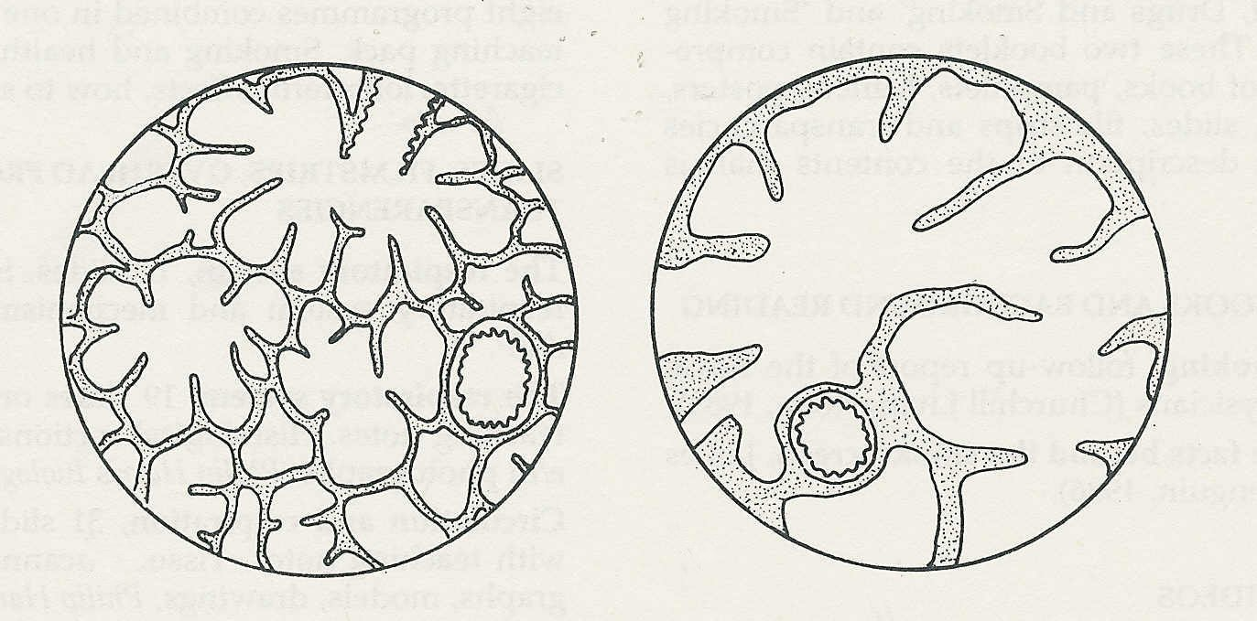

X
Y

(a) What is the principal difference between the healthy and diseased tissue?
(b) In what ways would this affect the efficient functioning of the lungs?
(c) What effects might this have on the person with emphysema? (A)

10 The following passage is reproduced from an article on 'Smoking blocks the arteries'.

A study released last week of habitual cigarette smokers indicates that smoking causes excessive interaction of platelets, components of the blood that trigger clotting in arteries. 'Our findings indicate that chronic smokers - even those who look and feel healthy - have an active disease in their blood vessels,' said John Oates from Vanderbilt University in Nashville Tennessee.
The researchers at Vanderbilt compared six apparently healthy male habitual smokers, aged 24 to 46, with six healthy non smoking volunteers. Urine samples were used to detect the chemical thromboxane A2 which is secreted during the process of forming clots. The smokers had 'significantly elevated levels’ of a metabolic product of thromboxane A2.
'The finding indicates that platelet dysfunction is present in smokers before any clinical signs of blood vessel disease are observed’, Oates said. The research is published in Circulation, a journal of the American Heart Association.
© NEW SCIENTIST
(a) What do you think excessive interaction of platelets' means?
(b) What events are, presumably, taking place in the blood when thromboxane A2 is being
released?
(c) What is meant by 'a metabolic product of thromboxane A2' and how would it get into
the urine? (C)

