The blood circulatory system - exercises and discussion
Exercises and discussion E3.09

1 Some students carried out an experiment to compare the effect of exercise on the heart rate of girls and boys. They sent the class out for a run and measured their pulse rates when they came back.
This was a poorly designed experiment. Which of the following design features is least
likely to have affected the results?
(a) The students did not do the same amount of exercise.
(b) Their resting heart rate was not measured.
(c) Their breathing rates were not compared.
(d) No account was taken of body weight. (E)

2 A drop of blood from a blood donor is mixed with serum from a group A person and serum from a group B person. The donor's red cells clumped in the A serum but not in the B serum. What is the donor's blood group? (I)

3 There is a vaccine and an anti-serum against diphtheria. In what circumstances would you expect each of them to be used? (A)

4 Draw up a table to show the change in composition of the blood as it passes through
(a) the lungs, (b) the intestine, (c) the kidneys, (d) an active muscle. (A)

5 Oxyhaemoglobin is an unstable substance and breaks down easily to oxygen and haemoglobin. Because of its instability oxyhaemoglobin
(a) can carry extra oxygen
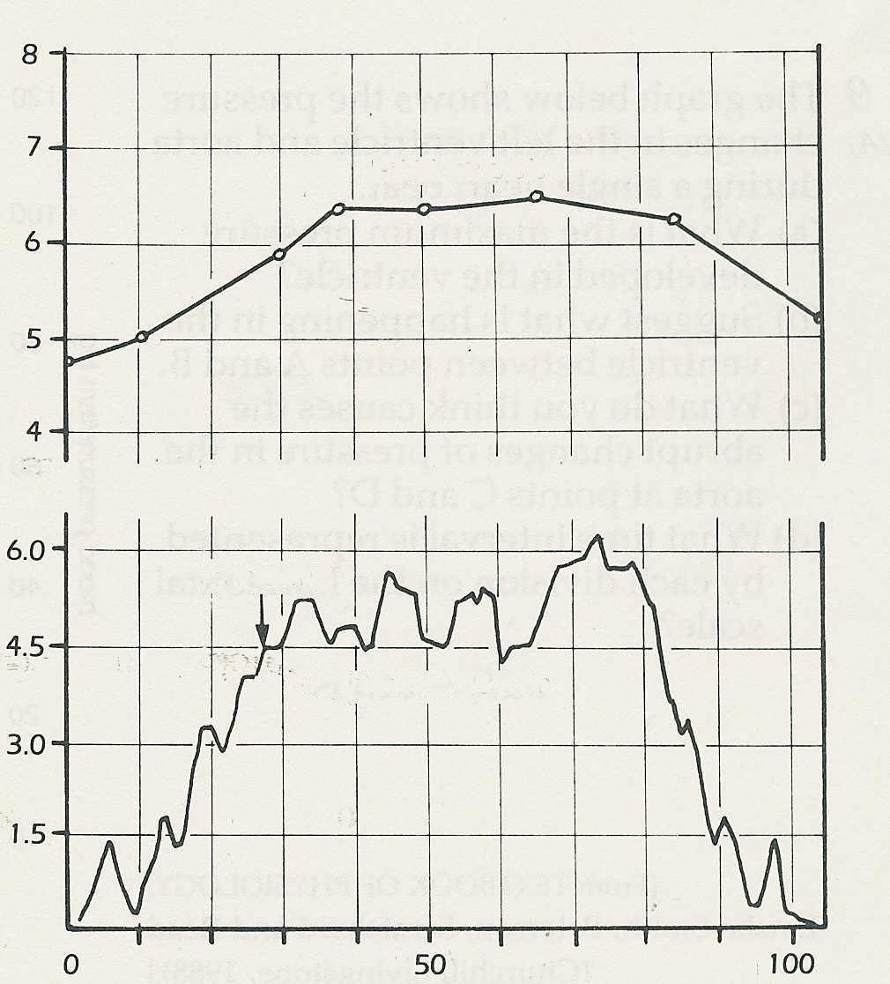
(b) readily picks up oxygen from the1ungs
million red cells per cm³
(c) readily gives up oxygen to body cells
(d) is quickly broken down in the liver. (A)
red blood cells

6 The graph on the right shows the average
red blood cell count in ten members
of a climbing expedition.
(a) In what way is the red cell count
related to altitude?
(b) What is the likely advantage of this
change in red-cell numbers?
(c) How long did it take for the red-cell
base camp
count to reach its maximum (i) from
altitude/km
the start of the expedition, (ii) from
night camp altitude
reaching base camp? (I)

days
© Bell, Davidson & Emslie-Smith

The blood circulatory system - exercises and discussion (continued)
Exercises and discussion E3.10

7 The following table shows how the heart responds to exercise.

Work/ kgm  per min | Oxygen uptake/  cm³ per min | Pulse rate/ per min | Heart output/ litres per min | Stroke volume/  cm³ | A-V oxygen difference/ cm³  per 100 cm³
rest  288  540  900  1260 | 267  910  1430  2143  3007 | 64  104  122  161  173 | 6.4  13.1  15.2  17.8  20.9 | 100  126  125  110  120 | 4.3  7.0  9.4  12.3  14.5

© Samson Wright’s Applied Physiology, by permission of Oxford University Press.

Note: Stroke volume: is the volume of blood expelled by the heart each time it contracts.
A-V oxygen difference is the difference in the concentration of oxygen in the arteries and
veins.
(a) Which seems more important in raising the heart's output: the rise in stroke volume
or the increase in pulse rate?
(b) Why, do you think, does the stroke volume not increase beyond 126 cm³?
(c) By how many times does the oxygen uptake increase from rest to maximum work?
(d) By how many times does the heart's output of blood increase from rest to maximum
work?
(e) As the increase in the heart's output is less than the increase in oxygen uptake, how
else do you think the extra oxygen demand is met?

8 The following table shows the combined
Smoking category | Relative risk of coronary heart disease
Non-smoker  Ex-smoker  Pipe/cigars only  Cigarettes  10 per day  20 per day  20+ per day | 1.0  1.2  1.3  1.9  2.2  3.4
results of eight American studies involving
nearly 7000 men aged 40-59.
Plot these results on two bar charts or
histograms. The charts will be the same but,
in the first case, assume you are a tobacco
manufacturer and choose a scale that might
seem to minimise the risks of smoking. In
the second case, assume you are an anti-
smoking campaigner and wish to
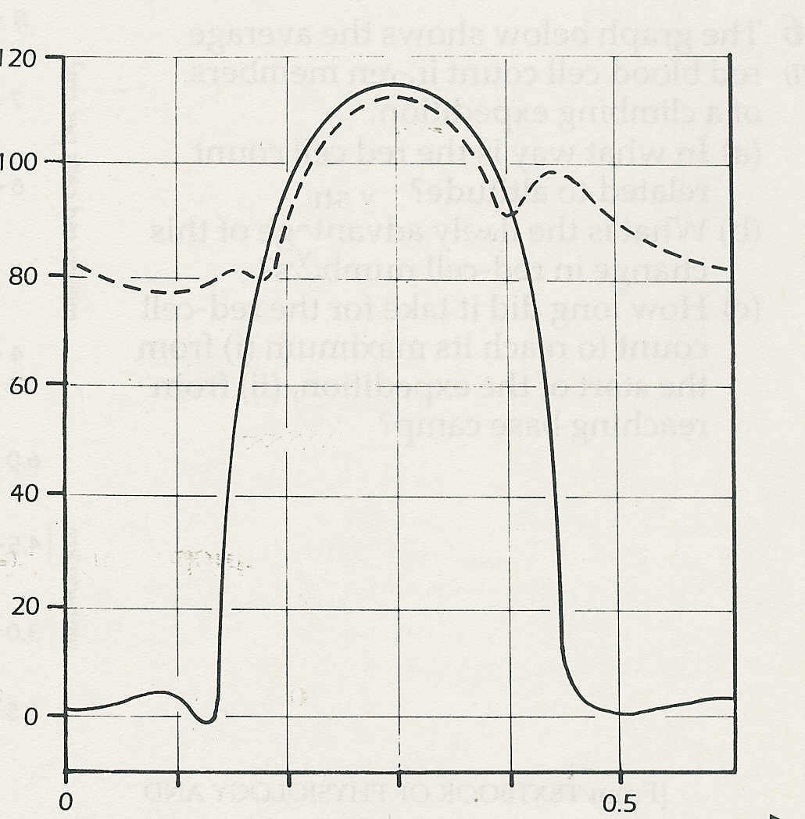
emphasise the risks of smoking. (I)
blood pressure/ mm Hg
aorta
ventricle
B
C
D

9 The graph shows the pressure
changes in the left ventricle and aorta
during a single heart beat.
(a) What is the maximum pressure
developed in the ventricle?
(b) Suggest what is happening in the
ventricle between points A and B.
(c) What do you think causes the
abrupt changes of pressure in the
aorta at points C and D?
(d) What time interval is represented
by each division on the horizontal scale? (A)
time/ seconds
A
The blood circulatory system - exercises and discussion (continued)
Exercises and discussion E3.11

10 Read the following extracts taken from an article on 'Cholesterol test for heart
disease "does not work"'.
A study of middle-aged men in Britain has cast doubt on a widely-held opinion of heart specialists throughout the world. The study shows that the presence of a certain type of cholesterol in the blood is no indication of whether or not a person will develop heart disease. Previously, heart specialists, especially in the US, have thought that low levels of the cholesterol
are dangerous, and that high levels actually protect a person from developing heart disease.
Cholesterol can be split into two major types: high-density lipoprotein (HDL) cholesterol and
low-density lipoprotein (LDL) cholesterol. Doctors do not dispute that cholesterol as such can
lead to heart disease, but, up to now, they have thought that it is the LDL type that is dangerous. Studies in the US, Scandinavia and Israel have indicated that HDL cholesterol could be good
for you. People with low levels of HDL cholesterol in the blood seemed to be at greater risk of developing heart disease than those with high levels. In fact, some heart specialists have even suggested that high levels of HDL cholesterol in the blood may actually protect against heart disease. As a result, some doctors, especially in the US, believe that measuring levels of HDL
cholesterol in the blood can be used to predict whether a person is likely to develop heart disease. Researchers from the Royal Free Hospital Medical School in London have shattered this belief.
The results of the first study in Britain on levels of HDL cholesterol in men at risk of developing
heart disease show that it is not a major factor affecting the development of heart disease.
Shaper emphasises that the results do not indicate that cholesterol is cleared of blame for
helping to cause heart disease: 'We are saying "Look at the total cholesterol", without taking
into account levels of HDL.'
However, other researchers in Britain are taking a cautious approach to the new results. An editorial published in The Lancet says that it 'may be premature to conclude that HDL is not a significant risk factor in British men'.
The editorial says that the British Regional Heart Study differs from other studies in the way it takes samples of HDL cholesterol from the blood. This, it says, may have affected the results.
The Lancet also points to the fact that samples of blood in the study have to travel considerable distances before an analysis is made. This, it says, must have delayed the preparation of some of the blood samples, which may have also affected the results.
© NEW SCIENTIST

Note: Lipoproteins are a combination of lipids and proteins. Much of the lipid in the blood
is in the form of lipoprotein. Cholesterol is a lipid.
(a) What are the two forms of cholesterol in the blood?
(b) Which of these two forms is considered, by some doctors, to be associated with an
increased risk of heart disease?
(c) What are the views of the research team at the Royal Free Hospital Medical School?
(d) What reasons are suggested for the difference between their views and those of other
researchers? (C)

11 Blood pressure in the veins is lower than that in the arteries. The best hypothesis to
explain this is that -
(a) the capillaries offer resistance to the blood flow
(b) veins are further from the heart
(c) most veins carry blood up-hill
(d) veins have thinner walls than arteries. (R/H)

