Exercises and discussion E3.06
Digestion - exercises and discussion

1 Which of the following explanations is least likely?
There is little digestion of starch in the stomach because:
(a) the stomach contains hydrochloric acid
(b) peristalsis is taking place .
(c) the stomach does not secrete a starch-digesting enzyme
(d) salivary amylase does not. work in acid conditions. (A)

2 In an experiment to investigate the influence of temperature on the rate of reaction of
amylase on a starch solution, the following results were obtained:

Temperature °C | Reaction time before iodine  gave negative results/min
20  25  28  31  33  37  44  47  50  55 | 25  17  11  7  4.5  4  3  6.5  12.5  no change even  after 30 min

Plot these results on a graph, with temperature on the horizontal axis.
(a) Between 20º C and 35º C, what is the effect of temperature on the rate of reaction?
(b) What appears to be the optimum temperature for the reaction between salivary amylase and
starch?
(c) Why do you think the reaction starts to slow down above 44º C?
(d) Why do you think the reaction stops completely above 50° C? (A/I)

3 The graph shows the concentration of
blood glucose/mg per 100cm³
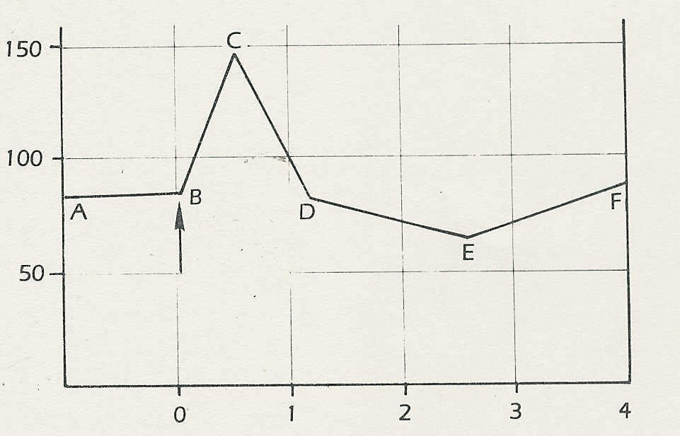
glucose in a person's blood 1 hour before
and 4 hours after eating 50 g glucose.
The liver regulates the concentration of
glucose in the blood.
(a) From the graph, approximately what is
the normal concentration of glucose in the
blood?
glucose
ingested
(b) Why do you think the level rose at point B?
(c) What do you think was happening between
points C and D?
(d) What do you think was happening between
time/hours
points E and F? (A/I)

Exercises and discussion E3.07
Digestion - exercises and discussion (continued)

4 Organs such as the ileum and lungs which absorb substances are often modified in ways
which increase the rate of absorption. Which of the following would you not expect to increase the rate of absorption?
(a) A thin epithelial lining.
(b) A slow blood flow.
(c) A large surface area.
(d) Many blood capillaries. (R/A)

5 A liquid extracted from the stomach was mixed with some finely ground meat and kept at
body temperature. After 2 hours, the meat had disappeared. Before concluding that the gastric liquid contained an enzyme, which of the following controls would you carry out?
(a) Try the experiment at a different temperature.
(b) Check the pH of the liquid from the stomach.
(c) Repeat the experiment using starch instead of meat.
(d) Repeat the experiment after boiling the liquid from the stomach. (E/A)

6 When saliva is added to starch solution, the starch disappears and sugar appears. Which
of the following experiments would be most valuable in establishing that the sugar has
come from the starch rather than from the saliva?
(a) Showing that carbon atoms in the starch subsequently were present in the sugar.
(b) Finding out the chemical composition of starch, sugar and saliva.
(c) Investigating the changes in saliva when it is boiled. ,
(d) Adding other substances to starch to see if the sugar was produced. (E)

7 Would you expect vitamins to be digested before they are absorbed? Give reasons for your
answer. (A)

8 The following extract is taken from ‘A pineapple a day'.
Judy Mazel's book 'The Beverly Hills Diet’ suggests we get fat not because we eat too many calories, but because we do not digest our food properly and anything not digested is turned into fat. (This includes the few specks of saccharine which we all think helps us to slim.)
Anyone with a knowledge of science up to GCSE standard will regard all this as a leg-pull.
But it is all down there in print and seemed to be fooling thousands even when the author writes that carbohydrate rots and festers in the stomach; that melba toast turns into alcohol in
the stomach, and that potatoes turn into vodka. In the same way as in eastern mysticism, a
pseudo-title is required. In Beverly-Hillbilly language it is called 'Conscious Combining'.
This means that you must NOT combine fats, carbohydrates and: proteins in one meal because, we are told, they cannot be digested, and what is not digested turns into fat.
© Prof. Arnold Bender

(a) Why is it very unlikely that, '.. . . carbohydrate rots and festers in the stomach', that
'melba toast turns to alcohol' or that 'potatoes turn into vodka'?
(b) Comment on the recommendation in 'The Beverly Hills Diet' that we should not
combine fats, carbohydrates and proteins in one meal because they cannot be
digested. (A)

Digestion - exercises and discussion (continued)
Exercises and discussion E3.08

9 Rabbits do not eat meat. Which of the following is the best hypothesis to explain this
observation?
(a) They do not like meat.
(b) They cannot digest meat.
(c) They have no protein-digesting enzymes. (H)

10 It is assumed that alcohol is absorbed in the stomach.. Which of the following pieces of evidence would best support this assumption?
(a) No enzymes for digesting alcohol are found in the ileum.
(b) Chemists can show that the alcohol molecule is small.
(c) Alcohol can be shown to appear in the blood circulation soon after it is drunk.
(d) Some people feel intoxicated very soon after drinking alcohol. (I)

