Food and diet - exercises and discussion
Exercises and discussion E3.01

1
Food 10g | Energy/kJ | Protein/g | Vitamin A/µg | Vitamin C/µg | Vitamin D/µg
Egg  Cooking oil  Bread  Butter  Milk  Sugar  Cod  Mackerel | 66  377  101  312  27  165  29  80 | 1.2  0  0.96  0.05  0.3  0  1.6  1.6 | 30.0  0  0  100  4.4  0  0  4.5 | 0  0  0  0  100  0  0  0 | 0.15  0  0  0.12  0.005  0  0  2.3

The table above gives some food values for 10 g portions of eight foods.
(a) Use these figures to complete the table below for a breakfast. (Coffee has no food
value.)

Menu | Mass/g | Energy/kJ | Protein/g | Vitamins  A, C or D
1 fried egg | 65
+ cooking oil | 6
1 slice bread | 35
+ butter | 5
1 cup coffee
+ milk | 60
+ sugar | 7
Totals

(b) Assuming that you need 12000kJ per day, what proportion of your energy needs is
provided by this breakfast?
(c) We need about 0.6g protein per day for every kilogram of body mass. What proportion
of your daily protein needs is provided by this breakfast? (If you do not know your body
mass, assume it is 50kg.)
(d) How could you increase your intake of vitamin C at this meal without raising its
energy content? (A)

2 Cod and other white fish contain about 0.05g fat per 10 g portion. Oily fish, such as
herring, pilchards, sardine and mackerel contain about l.4g fat (unsaturated) per 10g
portion. Use this information plus that in the table above to compare the nutritional value
of the two types of fish. (A)

3 Boiled potato provides 33kJ energy per 10g portion. 10g chips provides 105kJ. 10g potato
crisps provides 220kJ. Why do you think there is such a difference in energy content? (A)

Food and diet - exercises (continued)
Exercises and discussion E3.02

4
Food 100g | Protein/g | Vitamin C  /µg | Vitamin A  /µg | Fibre/g | Iron/mg | Calcium/mg
Liver  Cornflakes  Milk  Potatoes | 27  7.5  3.3  1.4 | 10  0  1  10 | 1700  0  50  0 | 0  11  0  2 | 7.5  1.1  0  0.3 | 0  5  120  0

Which of these foods would you include in a diet in order to try and
(a) prevent anaemia (c) prevent constipation
(b) promote growth (d) increase resistance to disease. (I)

5 1g body fat is equivalent to about 32kJ energy. An hour’s walking uses about 1250kJ energy.
An overweight man decides to walk to work each day (15 min each way) and to reduce his daily food intake by an amount equivalent to 1000kJ. How much weight might he lose each week. (Assume he goes to work 5 days each week). (I)

6 Read the following passage which is taken from an article, 'The well-nourished
vegetarian'. (An 'omnivorous' diet is one which includes meat as well as plant products.) (C)

The third likely point of difference 'between vegetarian and omnivorous, diets is in the amount
and type of fat in each. There are two main categories of fat in the diet: the triglycerides (most.
fats are in this category) and cholesterol. Both these classes of fat are also found in the
blood. High levels of cholesterol in the blood are clearly related to a high incidence
of coronary heart disease (which is the biggest single cause of death among Western men) and
the bulk of evidence suggests that the link is causative. A high intake of triglycerides can raise
blood cholesterol levels. But triglycerides are of two kinds, saturated and unsaturated; and it
seems that whereas the saturated fats do indeed raise blood cholesterol levels, unsaturated fats
(or, more specifically, the polyunsaturates, which are very unsaturated) reduce blood
cholesterol levels. In general, the fats of animals (hard fats) are highly, saturated, while the
oils of plants tend to be unsaturated.
There are notable exceptions: coconut oil, for instance, is highly saturated; and so too are
some of the cheap refined oils sold for cooking. But corn, soya, sunflower or safflower oils in
particular are highly unsaturated. So in general a vegetarian ought to eat less fat than an
omnivore; ought to eat a higher proportion of polyunsaturates; and ought therefore to have
lower blood cholesterol and suffer fewer of the diseases associated with high blood
cholesterol.
©NEW SCIENTIST
According to the article:
(a) What are the two main categories of dietary fat?
(b) What does '. . . the bulk of evidence suggests that the link is causative.' mean?
(c) What are the two types of triglyceride?
(d) Which of these is associated with high blood cholesterol? .
(e) Name a saturated fat (i) from an animal source, (ii) from a plant source.

Food and diet - exercises (continued)
Exercises and discussion E3.03

7 The following figures give the fat content of 85g portions of food: mince (stewed) 14g, pork chop (grilled) 20g, chicken (roast) 12g, sausage (grilled) 21g, cod (fried in batter) 9g, hamburger (fried) 15g. Put these in the order to which they contribute to a healthy diet, starting with the most healthy. (A)

8 A sample of food was ground up with a little water, and separate samples of the resulting
pulp were tested with Benedict's solution, iodine and DCPIP. In each case, the resulting , mixture was blue. ,
What information does this give you about the food sample? (A)

9 A zoologist is trying find out whether rabbits need vitamin C in their diet. Assuming
that a sufficiently large number of rabbits is used and adequate controls are applied, the best design of experiment would be to give the rabbits:
(a) an artificial diet of pure protein, carbohydrate, fats, minerals and vitamins but lacking
vitamin C
(b) an artificial diet as above but with extra vitamin C
(c) a natural diet of grass, carrots etc. but with added vitamin C .
(d) natural food but of one kind only, e.g. exclusively grass or exclusively carrots (E)

10 Six drops of lemon juice decolourised 1 cm³ DCPIP solution.
Nine drops of grapefruit juice decolourised 1 cm³ DCPIP solution.
Which juice contains more vitamin C? (1)
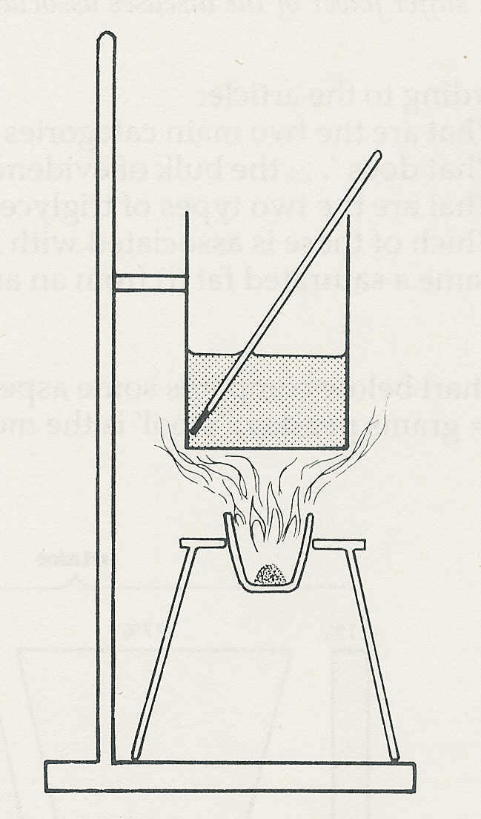
11 To find the energy value of sugar 1g of
sugar is burned in a crucible, the flame
produced is used to heat 100 g water in a
metal can and the rise in temperature of the
water measured.
The most likely source of error is
(a) inaccurate weighing of sugar
(b) incomplete combustion of the sugar
(c) inability to measure the temperature
difference accurately enough
(d) heat from the burning sugar escaping
without heating the water. (E)

12 A piece of apple is crushed with water, boiled, cooled and tested with iodine solution. No blue colour appears.
The best interpretation of these results is
(a) apples do not contain starch
(b) this piece of apple contains no starch
(c) the apple does contain starch but not enough to affect the iodine
(d) the apple contains little or no starch. (I)

Food and diet - exercises (continued)
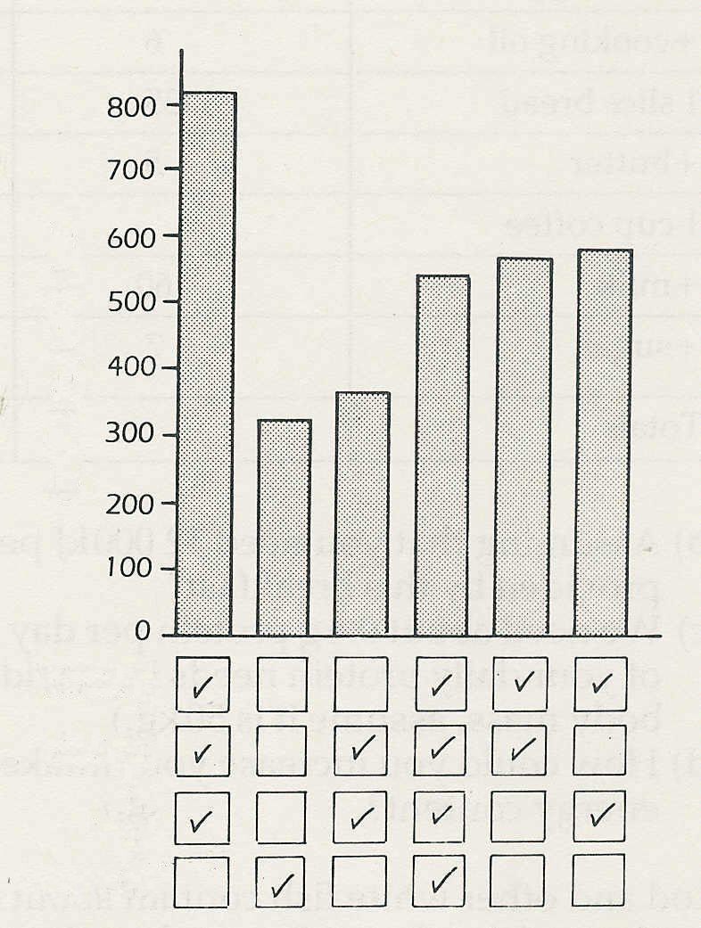
Exercises and discussion E3.04

13 A project in Japan, between 1965 and 1981,
studied the diets and life-styles of 100,000 people,
dividing them into categories according to their
death rate per 10,000
smoking and drinking habits, whether they ate meat
and had a daily intake of vegetables.
By 1981, 30,000 of the sample had died
and the mortality rates for six of the groups are
shown in the chart.
Comment on the results with regard to
(a) smoking, (b) drinking, (c) eating meat
(d) eating vegetables each day.
smoking
drinking
meat
vegetables
What other information about the trial would
you need before you could confidently interpret
the results? (1)

© NEW SCIENTIST

