Section 2 Plant structure and function - exercises and discussion
Exercises and discussion E2.01

1 The graph shows the amount of phosphate

nitrogen
air
absorption of phosphate/ arbitrary units
absorbed by roots of a beech tree, (i) when
the roots are supplied with air, (ii) when the
roots are in an atmosphere of nitrogen.
Suggest an explanation for the different
rate of uptake of phosphate in these two
conditions. (A)

© J. K. Brierley
hours
2 A student set up a potometer and used it to compare the rate of

water uptake in a cut shoot. The first set of readings was taken
on the shady side of the laboratory. The second set of readings
Uptake of water/mm
was taken by the window in bright sunlight, but still in the laboratory.
The readings shown in the table were taken at 30 second intervals
in shade
in sunlight
and represent the distance, in millimetres, travelled by the water
15
15
14
13
12
12
13
12

12
15
19
24
25
26
25
26
column in 1 minute.
(a) Plot a graph to display these results, with time along the
horizontal axis. Show the two sets of results separately on
the same graph starting from time zero in each case.
(b) If the student wanted to compare the average rate of
uptake in each situation, which readings should be used?
(c) Explain your reasoning.
(d) Calculate the two appropriate averages (means) and suggest
why exposure to sunlight seems to affect the rate of uptake. (E)

3 The graph shows the absorption and
water uptake or loss/gm
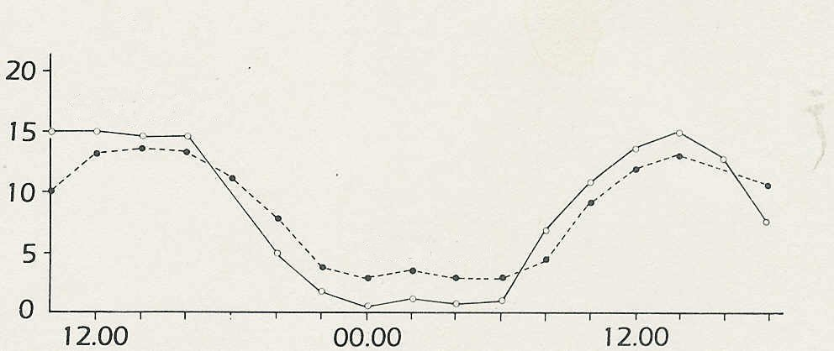
transpiration of water by a poplar tree.
transpiration
(a) During which period or periods is
transpiration more rapid than
absorption?
(b) What would be the effect if this
absorption
imbalance were to continue?
(c) During which period or periods is
absorption faster than transpiration?
(d) In these periods, what processes might
midday
midday
midnight
be causing the continued uptake water? (I/A)
absorption and transpiration by a poplar tree

© James Sutcliffe,

Plant structure and function (continued)
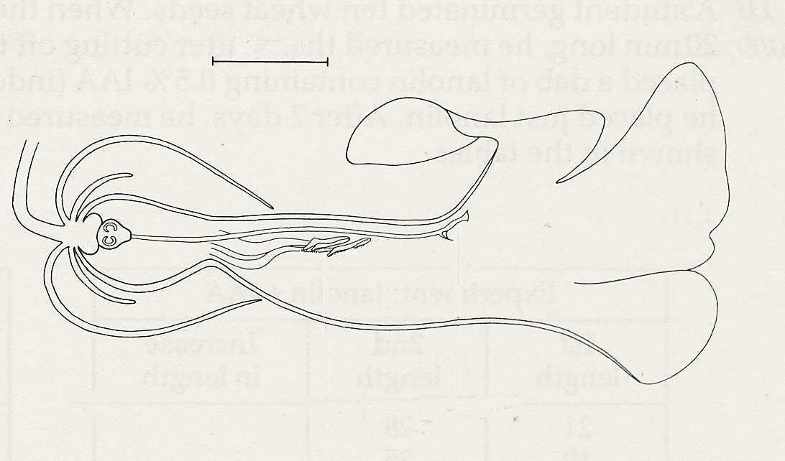
10mm
Exercises and discussion E2.02

4 The drawing shows a longitudinal section
through a flower. From the drawing, say
whether you think the flower might be
pollinated by (a) the wind, (b) ants,
(c) butterflies, (d) bumblebees. Explain the
reasons for your decision and also give
your reasons for rejecting the other
nectary
anther
stigma
possibilities. (A)
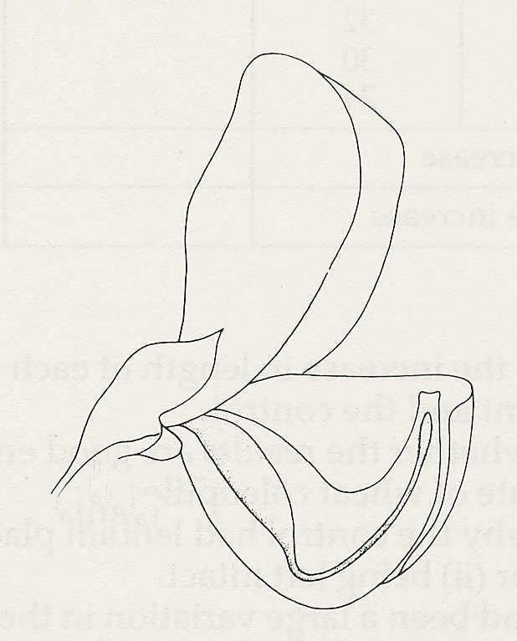

5 The drawing shows the structure of a
flower from which two petals and all the
stamens have been removed. Make a
drawing to show how the flower might
appear two weeks after pollination and
fertilisation. (A)

ovary

6 Mrs Smith planted a row of runner beans in her garden in April. Mr Jones, her neighbour, planted his runner beans at the same time. Ninety five percent of Mrs Smith's beans germinated successfully but only sixty percent of Mr Jones's came up. Put forward three possible reasons for this difference and suggest experiments to test whether your reasons are valid. (H)

7 A student decided to test the hypothesis that air is necessary for seeds to germinate. She placed 20 soaked pea seeds on moist cotton wool in a thick-walled conical flask and pumped out the air with a vacuum pump. After 10 days, none of the seeds had germinated and the student concluded that her hypothesis was acceptable.
Criticise the design of the experiment and the student's interpretation of the results. (E)

8 In the first few days when a seed germinates (i) its bulk increases (ii) its mass (weight) increases, but (iii) its dry mass (weight) decreases. Suggest an explanation for these (A)
changes.
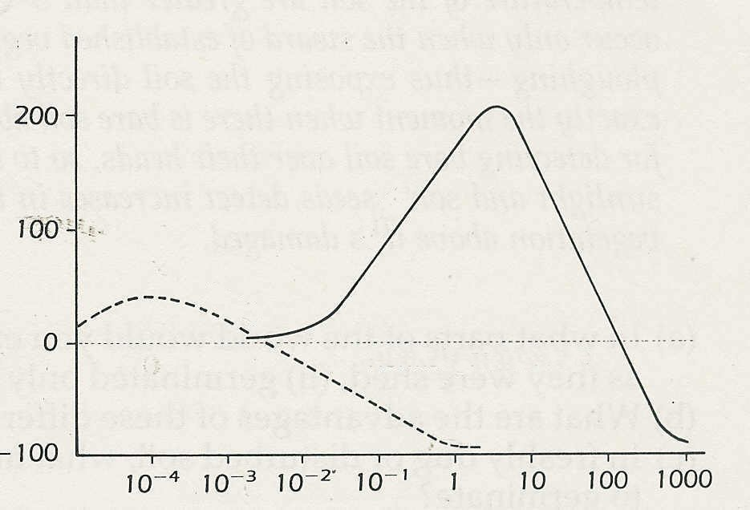
stems
% change in growth rate
9 The graph shows the extra growth in
normal growth
rate

length, in general, of roots and stems
roots
in response to increasing concentrations
of IAA (indole acetic acid).
(a) What is the optimum concentration of
IAA for (i) root growth, (ii) stem growth?
(b) What effect does a dose of 1 ppm IAA
have on (i) root growth, (ii) stem growth? (I)
IAA concentration/parts per million
© W.M. Baron
Plant structure and function (continued)
Exercises and discussion E2.03

10 A student germinated ten wheat seeds. When the coleoptiles (early shoots) were about 20 mm long, he measured them, after cutting off their tips. On five of the cut surfaces he placed a dab of lanolin containing 0.5% IAA (indole acetic acid) and on the remaining five he placed just
lanolin. After 2 days, he measured the coleoptiles again. The results are shown in the tables.

Experiment: lanolin + IAA
1st length | 2nd length | Increase in length
21  19  25  24  20 | 28  25  32  30  24
Total increase
Average increase

Control: lanolin only
1st length | 2nd length | Increase in length
22  23  18  25  21 | 26  27  25  29  26
Total increase
Average increase

(a) Calculate the increase in length of each coleoptile and the average increase for the
experiment and the control.
(b) Discuss whether the results are good enough to say confidently that IAA increases the
growth rate of wheat coleoptiles.
(c) Explain why the control had lanolin placed on the cut coleoptiles rather than (i) nothing or
(ii) being left intact.
(d) If there had been a large variation in the first lengths of the coleoptiles, what would
have been the best way of expressing the increase in length?
Note: IAA is a plant growth substance. Lanolin is a sticky grease with a consistency of soft margarine. (l/E)

11 Read the passage below, which is taken from 'Plants plan seed cycles'.
What, Grime asked, can be behind this diversity of germination strategies? Well, in southern
Europe, most damage to existing plants occurs in the summer as a result of drought. So plants whose natural habitats are in hot parts of the world shed seeds that germinate almost immediately to take advantage of reduced competition from existing vegetation weakened by drought.
Plants familiar in more northerly climes, however, adopt a different strategy. In these areas, established plants suffer most damage as a result of cold winters. So plants here tend to release seeds that can survive through the winter and take advantage of bare patches of soil where
mature plants have died.
Other plants are even more subtle. Their seeds germinate when fluctuations in the temperature of the soil are greater than 5ºC. Now temperature fluctuations as large as these occur only when the sward of established vegetation above the seed is damaged - for example, by ploughing
- thus exposing the soil directly to sunlight. So the seed contrives to germinate at exactly the moment when there is bare soil above it. Some seeds have an even subtler mechanism for detecting bare soil over their heads, so to speak. Vegetation filters the red wavelengths out of sunlight and some seeds detect increases in the amount of light in these wavelengths when the vegetation above it is damaged. © NEW SCIENTIST

(a) In what parts of the world would you expect to find seeds which (i) germinated as soon
as they were shed, (ii) germinated only after exposure to low temperatures.
(b) What are the advantages of these differences to the plants concerned?
(c) In freshly dug or disturbed soil, what might be the stimulus that promotes some seeds to
germinate? (C)
Plant structure and function (continued)
Exercises and discussion E2.04

12 Figures 1 and 2 summarise a series experiments with oat coleoptiles.
(a) Offer an explanation of the results in each case.
(b) These experiments have been criticised because they were not carried out in sterile
conditions. What difference could this make to the interpretation of the results? (E/l)
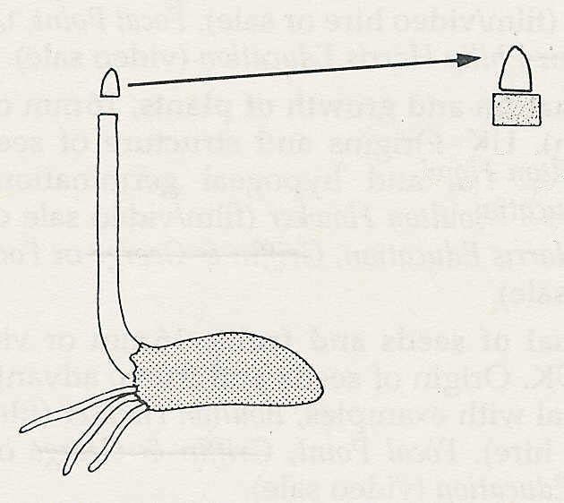
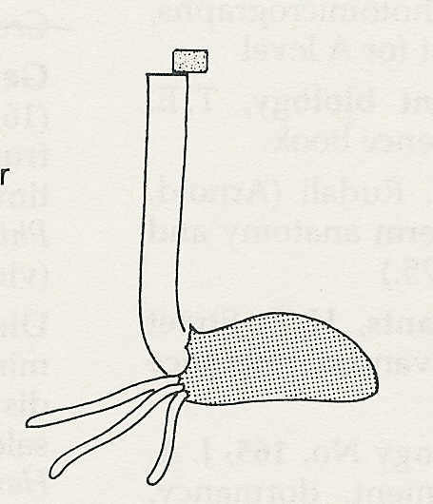
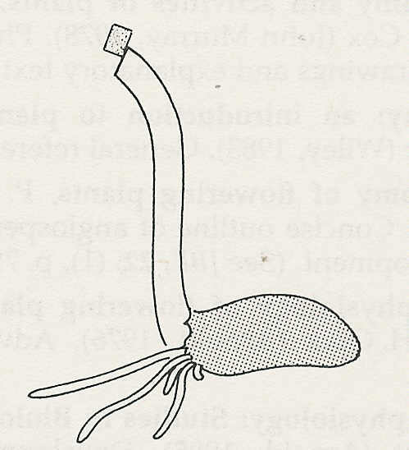

(b) Excised tip left on agar block

(c) Agar block placed to one side of decapitated coleoptile
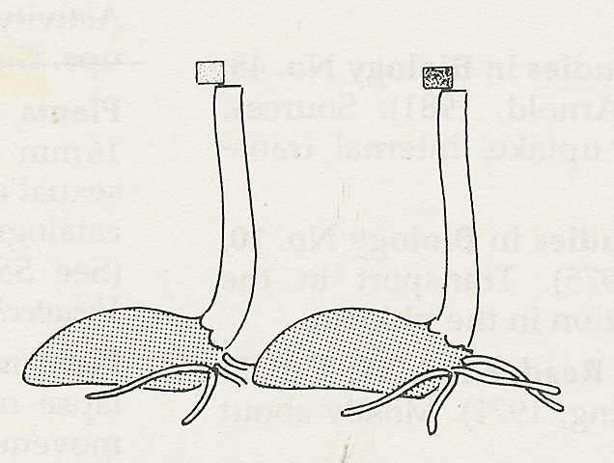
(a) Coleoptile tip cut off
(d) Result: coleoptile grows and bends as shown
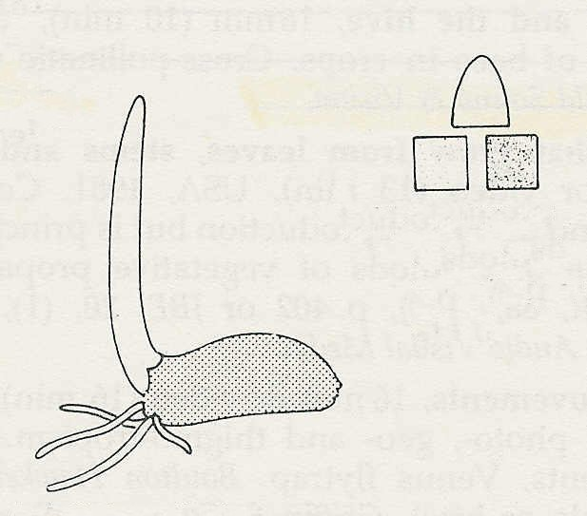
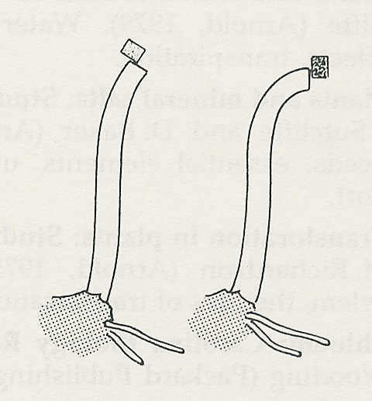
(b) Tip cut off and placed on split agar block
Figure 1

(c) Agar blocks placed on decapitated coleoptiles which are grown in darkness
(d) Result: block from beneath illuminated side produces less curvature than from the dark side
(a) Coleoptile tip illuminated as shown

Figure 2

13 Read the following passage which is taken from 'Do plants really have hormones?
Plant hormones are also important to plant breeders because the compounds can produce male-sterile flowers. Such sterility makes self-pollination impossible and so greatly simplifies
hybridisation. The enhanced yields from F₁ seeds (first generation hybrids) produced by such
methods have already been seen in horticultural produce such as tomatoes.
Both auxins and gibberellins can be used to influence the setting-and size of fruit. The same
compounds will also allow seedless fruit to develop normally. Such 'parthenocarpic' fruits, bananas, satsumas, seedless grapes, have arisen in the past through spontaneous mutations and are generally preferred by the consumer. The possibility now exists of producing them in
ordinary varieties by carefully timed spraying of phytohormones. Ripening of bananas is
controlled commercially by adjusting the level of ethene, and the range of crops known to be amenable to this type of treatment is steadily increasing: tomatoes, peppers, apples and coffee are under research.
But there are technological problems associated with the application of precise amounts of highly active chemicals to plants. The penetration of the active substance to its site of action can be unpredictable, and the susceptibility of plants to treatment may depend on their precise stage
of development. Hence, the success of chemical manipulation of crop yield depends ultimately upon the skill and knowledge of the farmer. © NEW SCIENTIST

(a) Why should production of 'male-sterile' flowers make hybridisation easier?
(b) Name two plant 'hormones’ which can be used to control the size of fruit.
(c) Which plant 'hormone' is used to control the ripening of bananas?
(d) What are the difficulties in using plant 'hormones' to control growth and
development? (A/C)

