SECTION 1 Principles of Biology - Exercises and discussion
Exercises and discussion E1.01

1 Cells and Tissues
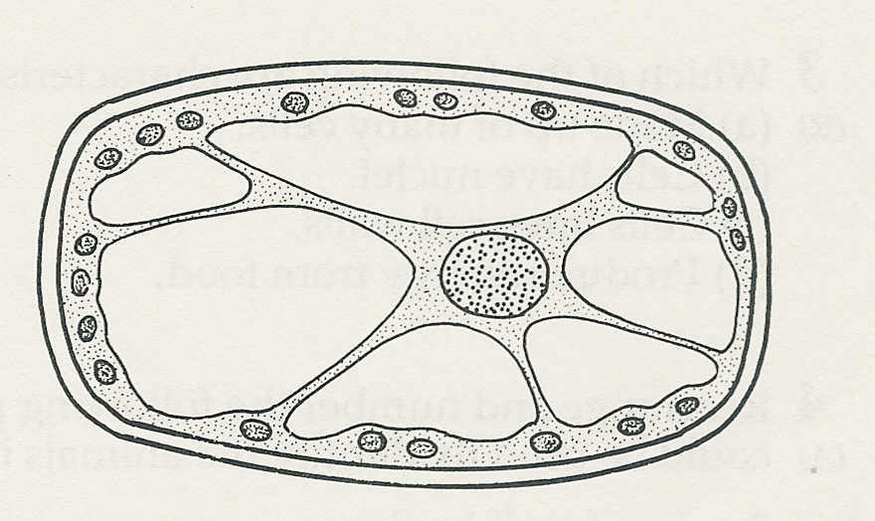
1 The drawing represents a plant cell as it
appears under the microscope. Write a
10µm
short description of the cell, making
informed guesses about the structures
shown. What is the magnification? (R/A)
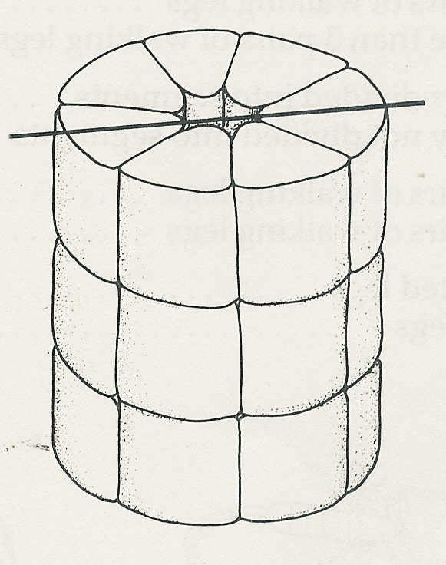
2 The drawing represents a group of cells
A
forming a kidney tubule. Make an outline
A
drawing to show what these cells would
look like in a longitudinal section made
through A-A. (A)

3 Which of the following statements are true?
All cells
(a) are specialised (d) contain chloroplasts
(b) have a cell wall (e) have a cell membrane.
(c) have cytoplasm (R)

4 Match the following functions to the cell structures listed below:
(a) controls cell division (c) controls entry of substances into a cell
(b) produces energy, (d) encloses a plant cell. (R)

mitochondrion, cell membrane, nucleus, cell wall

2 The Chemicals of Living Cells

5 From the list below select the elements and compounds which you would expect to find in
each of (a) proteins, (b) starch, (c) lipids. .
nitrogen, glucose, carbon, amino acids, fatty acid, sulphur, oxygen, glycerol, hydrogen (A/R)

6 AB represents a chemical compound and the equation below shows a chemical reaction involving AB. If the reaction is controlled by an enzyme, state what the enzyme does. (A)
AB A + B

7 A suspension of yeast is dropped into some hydrogen peroxide in a test-tube. The hydrogen peroxide fizzes vigorously and gives off oxygen.
(a) What further experiment should be carried out to test the hypothesis that an enzyme in
the yeast catalyses the breakdown of hydrogen peroxide?
(b) What result would (i) support the hypothesis, (ii) destroy the hypothesis?
(c) Explain your answers to (b). (H/E)

2 The chemicals of living cells (continued)
Exercises and discussion E1.02

8 An experiment is conducted to find the effect of temperature on an enzyme-
controlled reaction. Which of the following graphs is most likely to illustrate the results
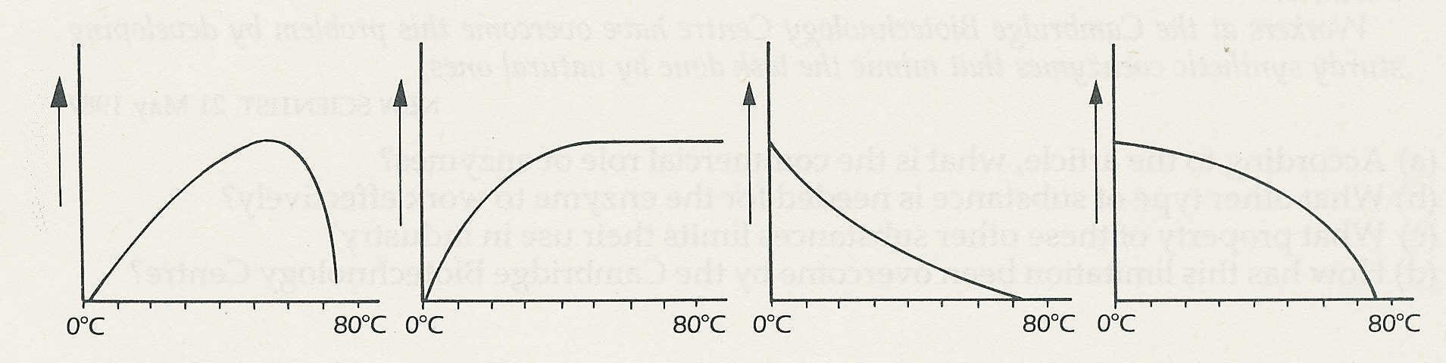
rate of reaction

9 A student's account of an experiment reads as follows:

I placed some diastase powder (a starch-digesting enzyme) in some starch solution in a test-
tube. By taking samples from the tube and testing them with iodine, I found that the starch
gradually disappeared.
I repeated the experiment but added a few cubic centimetres of dilute sodium carbonate (an
alkali) to the starch solution before adding the diastase. The starch took longer to disappear.
I concluded that diastase had an optimum pH of 7 (neutral).

Criticise (a) the student's experimental design (as judged by the report), (b) the student' s
interpretation of the results. (E)

10 Read the following extract which is taken from 'Can clean clothes damage your health ?’

Among the products of biotechnology is the 'biological' washing powder. Enzymes made by
bacteria grown in massive fermenters can digest away stubborn stains on clothing, even in
tepid water, and thus lower the cost of cleanliness. Enzymes in washing powders have a long
history, but they were not introduced into Britain until the mid-1960s. Enzymes are biological
molecules -proteins - that can alter the rate of particular chemical reactions but remain
unchanged once the reactions are over. Some 2000 enzymes have been classified, and 150
have found commercial uses. Each kind of enzyme speeds up, or catalyses a particular
reaction. Thus a small amount of enzyme can bring about a large and precisely controlled
change in the appropriate starting materials. © NEW SCIENTIST

(a) Where did the enzymes in washing powders come from?
(b) How do the enzymes help reduce the costs of washing?
(c) According to the article, what do enzymes do?
(d) For how many years have enzymes been used in washing powders in Britain? (C)

Exercises and discussion E1.03
2 The chemicals of living cells (continued)

11 Read the following extract which comes from an article called 'Enzymes become tough enough for industry':

The chemicals and pharmaceuticals industries now have a cheap precision tool at hand with
which to craft valuable chemicals and drugs. The tool is a catalyst adapted from nature, and
comprises two parts that interlink. One will not work without the other.
The part that converts chemicals into ones that are more valuable is a natural enzyme. The
other component is called a coenzyme. Without it the enzyme will not do its job. Enzymes have
enormous potential for catalysing reactions that lead to commercially important products, but
their use in industry is limited for the reason that the coenzymes on which they depend are so
unstable.
Workers at the Cambridge Biotechnology Centre have overcome this problem by developing
sturdy synthetic coenzymes that mimic the task done by natural ones. © NEW SCIENTIST

(a) According to the article, what is the commercial role of enzymes?
(b) What other type of substance is needed for the enzyme to work effectively?
(c) What property of these other substances limits their use in industry?
(d) How has this limitation been overcome by the Cambridge Biotechnology Centre? (C)

3 Energy from Respiration

12 Which of the following statements best describes the process of respiration?
Respiration in living organisms is:
(a) the intake of oxygen and output of carbon dioxide
(b) the intake of food and the output of energy
(c) the intake of food and the release of carbon dioxide
(d) the breakdown of food to release energy
(e) the oxidation of food to carbon dioxide. (R)

13 Explain what an oxygen debt is and how it is caused. (R)

14 When carbohydrate is oxidised to carbon dioxide and water in the body, 21 kJ energy is produced for every litre of oxygen used. In an experiment, a girl absorbed 2 litres of oxygen in
10 minutes. What is her energy production in kilojoules per hour? (I)

15 The process of respiration is often summarised by the equation
C₆H₁₂O₆ + 6O₂ 6CO₂ + 6H₂O + 2830kJ
On the basis of this equation, what would you regard as acceptable evidence that respiration was taking place in a sample of living tissue? (E)
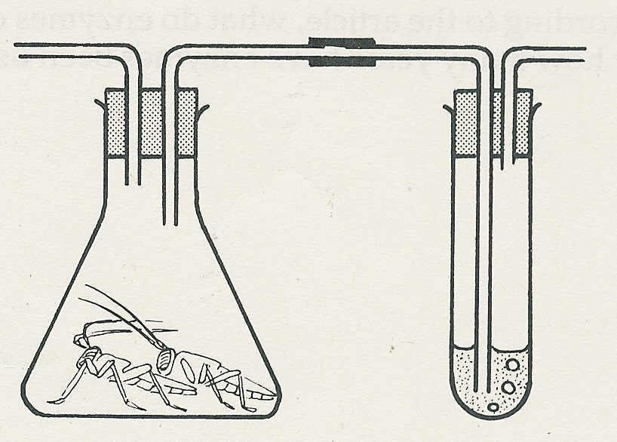

16 A student sets up an experiment to
air
try and demonstrate that locusts are
respiring. The diagram shows the
locusts
apparatus used.
After 15 minutes, the lime water has gone milky
and the student claims that this proves that the
locusts are respiring. Criticise the design of the
lime
water
experiment and show how you would improve it. (E) (E)

Exercises and discussion E1.04

3 Energy from respiration (continued)

17 The table below shows the energy used up each day either as kilojoules per kilogram of body mass or as kilojoules per square metre of body surface

 |  | kJ per day
 | mass/kg | per kg body mass | per m² body surface
Pig  © Emslie-Smith, Paterson, Scratcherd & Read  Human  Dog  Mouse | 128.0  64.3  15.2  0.018 | 80  134  216  2736 | 4510  4360  4347  4971

(a) According to the table, what is the total amount of energy used each day by (i) a human,
(ii) a mouse?
(b) Which of these two shows a greater rate of respiration in its body cells?
(c) Why, do you think, is there so little difference in the energy expenditure per square metre
of body surface? (I)

4 How substances get in and out of cells

18 Which of the following processes are best described by the terms ‘omosis', or 'diffusion' or ‘active transport' ?
(a) A dissolved substance passes from a region of high concentration inside a cell to a region
of low concentration outside the cell.
(b) A substance enters a cell until its concentration is much higher than that outside the cell.
(c) Water passes from a dilute solution to a concentrated solution across the cell membrane.
(d) A dissolved substance passes out of a cell until its concentration inside the cell is much
lower than outside.
(e) A dissolved substance passes across a cell membrane until its concentration inside and
outside the cell is the same. (A)

19 The graphs (a) to (d) represent the concentration of certain substances as measured inside
and outside a cell. Match the following descriptions to the most appropriate graph.
(i) A substance which the cell is producing and is expelled by active transport.
(ii) A substance which the cell is using and is taken up by active transport.
(iii) A substance which the cell is using and can diffuse freely through the cell membrane.
(iv) A substance which the cell is producing and is free to diffuse across the cell membrane. (I)
concentration
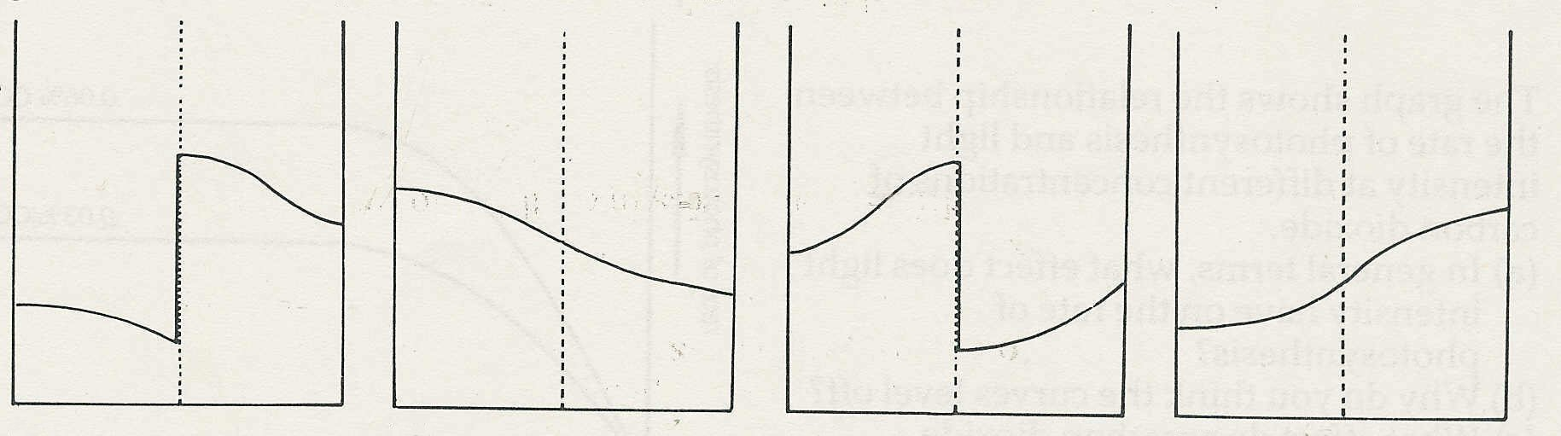
Key O = outside the cell M = cell membrane I = inside the cell
O
O
O
O
M
M
M
M
I
I
I
I
(a)
(b)
(c)
(d)
time

4 How substances get in and out of cells (continued)
Exercises and discussion E1.05

20 A piece of dialysis (‘Visking’) tubing is knotted at one end
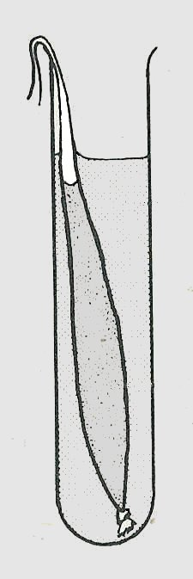
and filled with a 2 % starch solution mixed with a 10% glucose
water and iodine
solution. The tube is immersed in.a test-tube of water to
which iodine has been added.
(a) Predict what you will see after 30 minutes (i) in the
dialysis tube, (ii) in the test-tube, (iii) when you boil the
starch and glucose solutions
liquid from the test-tube with Benedict's solution.

(b) Give an explanation of these results. (E/A)

5 Photosynthesis and plant nutrition

21 Which of the following are not needed for photosynthesis
(a) sunlight (e) mineral salts
(b) oxygen (f) chlorophyll
(c) water (g) enzymes
(d) carbon dioxide (R)

22 In testing to see whether oxygen is produce4 in photosynthesis, shoots of submerged
pond plants are often used.
(a) Why do you think this type of plant is chosen?
(b) What might be the disadvantage of using such a plant? (E)

23 The chlorophyll is removed from a leaf by
boiling it in alcohol. The leaf is softened in
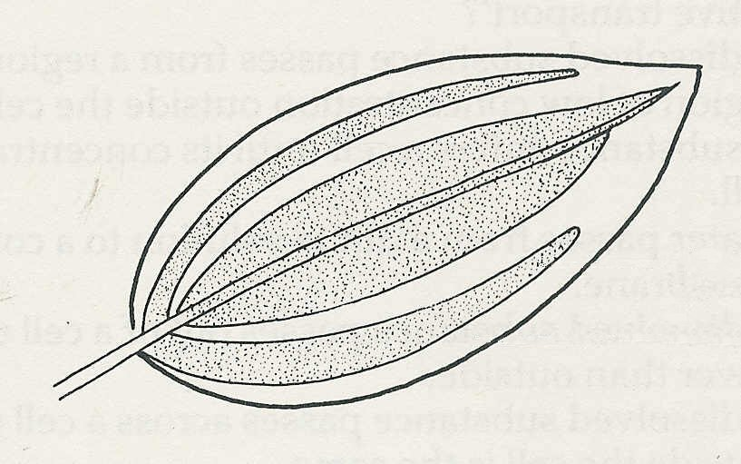
blue
hot water, and iodine solution is added.
The result is shown in the diagram.
(a) What are you entitled to deduce from
the result?
brown
(b) What might explain the distribution of
the blue colour? (E/I)

24 A student set up an experiment in which a destarched potted plant is enclosed in a black
plastic bag containing soda-lime (which absorbs carbon dioxide). 24 hours later, when a
leaf is tested with iodine no blue colour appears. The student concludes that light and carbon dioxide are both necessary for photosynthesis~
Criticise the experimental design and say, in outline only, how you would try to test
whether light and carbon dioxide were necessary for photosynthesis. (E)
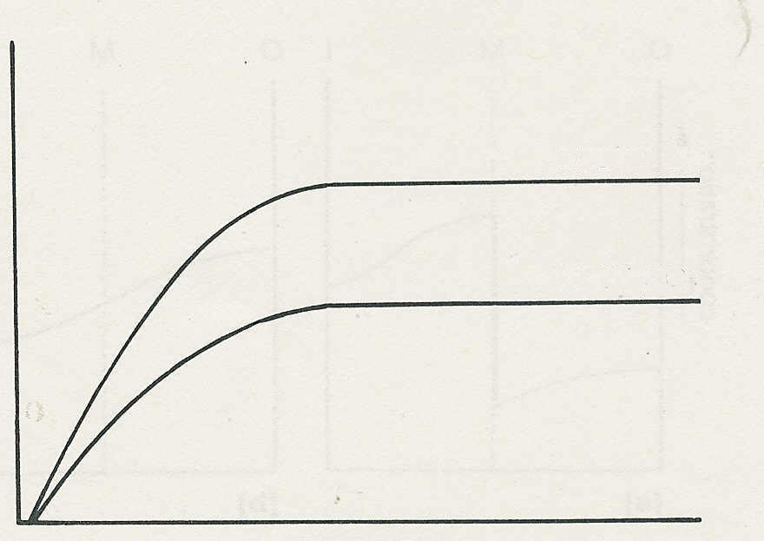

25 The graph shows the relationship between
rate of photosynthesis
the rate of photosynthesis and light
intensity at different concentrations of
0.03 % CO₂
carbon dioxide.
(a) In general terms, what effect does light
intensity have on the rate of photosynthesis?
(b) Why do you think the curves level off?
(c) What effect does carbon dioxide
concentration appear to have on the rate of
photosynthesis? (I)
light intensity

Exercises and discussion E1.06
5 Photosynthesis and plant nutrition (continued)

26 The graph shows the increased yield of
winter wheat in response to adding more
yield/ tonnes per hectare
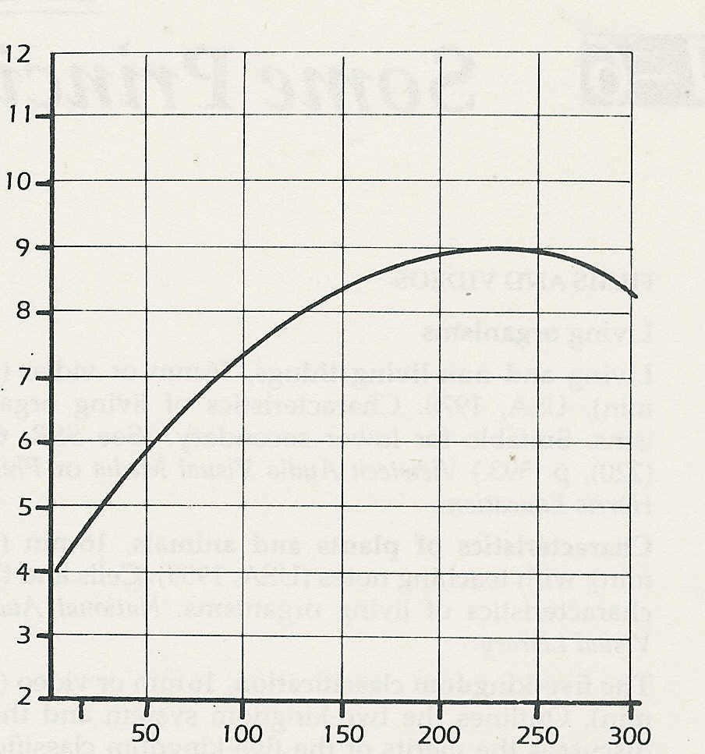
nitrogenous fertiliser.
(a) If the applied nitrogen is doubled from
50 to 100 kg per hectare, how much extra
wheat does the farmer get?
(b) If the applied nitrogen is doubled from
100 to 200 kg per hectare, how much
extra wheat is obtained?
(c) What sort of calculations will a farmer
need to make before deciding to increase
the applied nitrogen from 150 to 200 kg per
hectare? (I)
applied nitrogen (top dressing)/ kg per hectare
E1.7

