4 How substances get in and out of cells
Self-assessment questions 4.01

1 Containers X and Y each hold one litre of air. X also contains 0.4g of a gas and Y contains
0.6 g of the same gas. The two containers are connected together as shown in the diagram.
(a) Which way will the gas diffuse?
(b) After a long period of time, what will be the concentration of the gas (in grams per litre)
in each container?
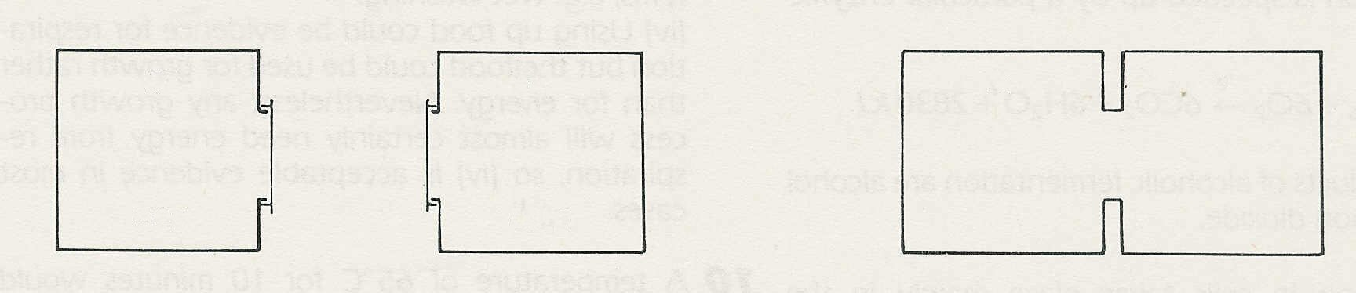

X

Y
X
Y

0.4g
0.6g

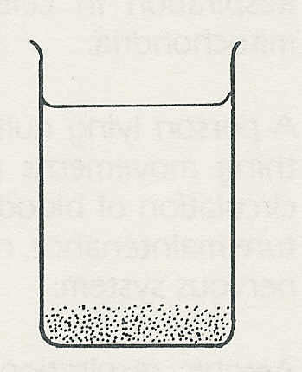
2 The diagram represents (not to scale) molecules of a salt dissolved in the
bottom layer of water in a beaker. Make two similar diagrams to show the
distribution of salt molecules (a) after a few minutes, (b) after several hours.

3 When a cell is respiring aerobically, which two gases are likely to be
diffusing in and out of the cell, and in which direction will they be diffusing?
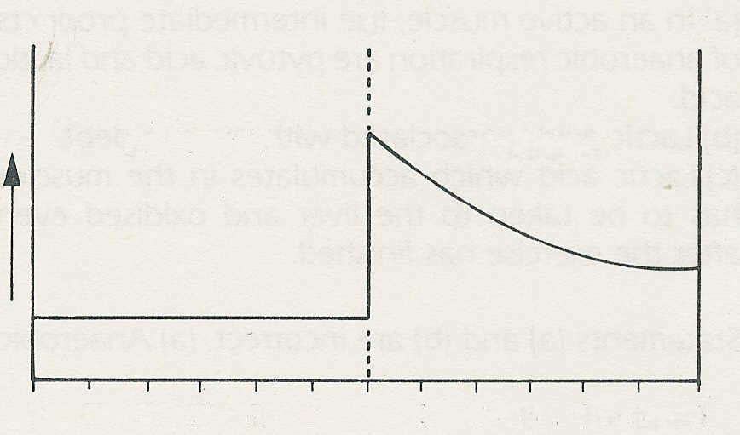
cell membrane
outside cell
cytoplasm
A
B
C
6 5 4 3 2 1 1 2 3 4 5 6
4 The graph shows the concentration of a
substance inside and outside a cell.
concentration
(a) If the substance is free to move by
diffusion, which way will it move
(i) inside the cell
(ii) between the cell and the medium
outside the cell?
(b) If, after some hours, the concentration
has not changed, what assumption
would you make about the movement
of the substance across the cell membrane?

5 (a) Which one of the following is the best definition of osmosis?
(i) The movement of water from a concentrated solution to a dilute solution across a
partially permeable membrane. .
(ii) The movement of a dissolved substance from a concentrated solution to a dilute
solution across a partially permeable membrane.
(iii) The movement of water from a dilute solution to a concentrated solution across a partially
permeable membrane.
(iv) The uptake of water by a living cell.
(b) Which of the statements is an acceptable description of diffusion?

How substances get in and out of cells (continued)
Self-assessment questions 4.02
membrane
6 The diagram shows a vessel which contains
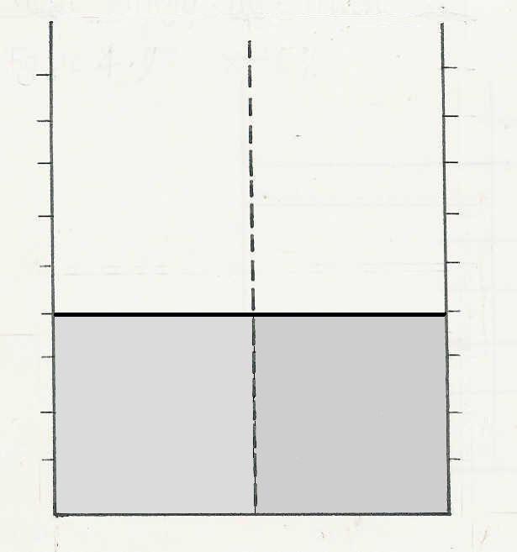
a concentrated and a dilute solution separated
8

6

4

2
by a partially permeable membrane. Draw a
similar diagram to show the liquid levels after
an hour or two.

7 Which statement is correct?
(a) A concentrated solution has a high
osmotic potential (water potential).
(b) A concentrated solution has a low
osmotic potential (water potential).
dilute solution
concentrated solution

8 The drawing shows the outline of a human cell.
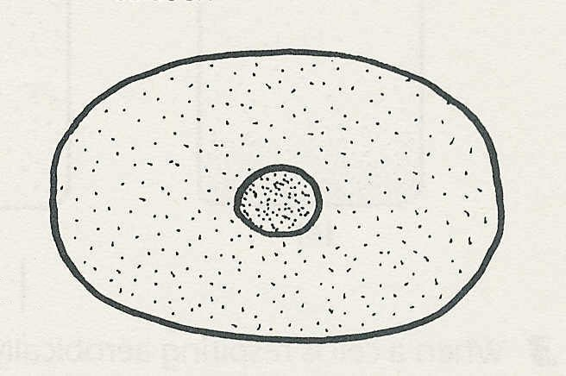
Copy the drawing and make two further drawings to show
how the cell would appear if it were to be immersed for a
few minutes in a solution with
(a) a lower osmotic potential (water potential) than its
own cytoplasm
(b) a higher osmotic potential (water potential) than its
own cytoplasm.

9 Why is it important that a cell membrane does not allow all dissolved substances to diffuse freely through it?

10 The concentration of the tissue fluid, which bathes all cells in the body, is kept more or less
constant. Why is this important?

11 When meat is salted, bacteria cannot grow on it. Suggest a reason for this.

