2 The chemicals of living cells
Self-assessment questions 2.01

1 Apart from food, what other substances do cells need to take in?

2 Water has a high capacity for heat (thermal capacity). This is an advantage in living cells because …. (Select one of the following statements)
(a) any rise in temperature is small in comparison with the amount of heat absorbed by a cell
(b) any rise in temperature is large in comparison with the amount of heat absorbed by a cell
(c) the 75% water in a cell does not retain a lot of heat
(d) any change in temperature will cause a cell to heat up or cool down quickly.

3 (a) Give three examples of cell structures which contain structural proteins.
(b) What is the other type of protein in a cell?

4 Name the chemical elements present in a protein.

5 What name is given to the sub-units which make up all proteins?

6 A protein molecule which is denatured, has
(a) split into smaller molecules
(b) changed its shape
(c) combined with another molecule
(d) been diluted..

7 What kind of substance is a lipid?

8 In a cell, where are lipids found?

9 (a) What are the two types of chemical compound which combine to form a lipid?
(b) What elements are present in a lipid?

10 (a) Name four examples of compounds which are classed as carbohydrate.
(b) What elements are present in carbohydrates?

11 Write the formula for glucose.
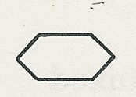
12 If represents a glucose molecule draw (a) a maltose molecule, (b) part of a starch molecule.

13 Select the most appropriate words from the list below to complete the following paragraph All cells contain ……. which are ……. and act as …..…. which ….…. chemical
reactions. The reactions do not ….….the ….…. which can take part in further reactions.

substances, proteins, enzymes, catalysts, speed up, use up, slow down

14 Enzymes will usually react with only one substance. This can be explained by the 'lock
and key' theory. If this theory is correct, which of the following substances, represented
by P, Q, R and S would be acted on by enzyme A?

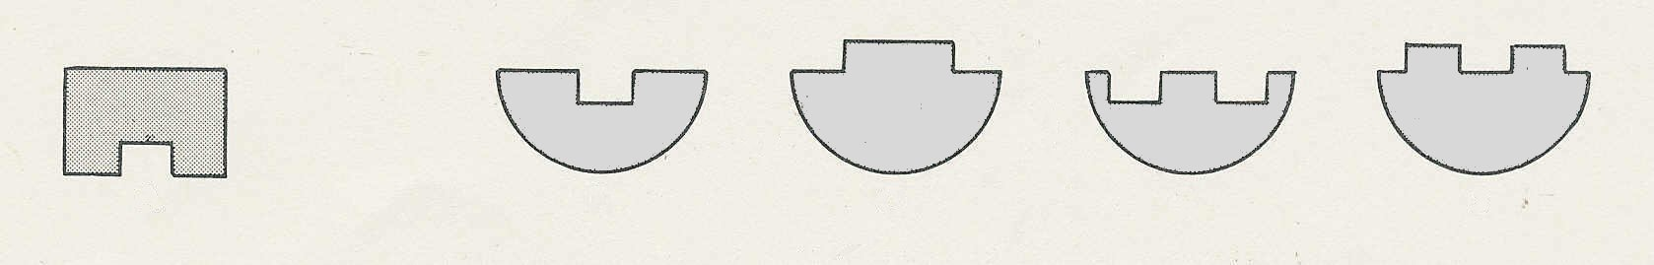

A
P
Q
R
S
The chemicals of living cells (continued)
Self-assessment questions 2.02

15 If an enzyme-controlled reaction normally takes place at 10ºC, in general terms how will
the reaction be affected by (a) a fall in temperature to 2°C , (b) a rise in temperature to 20°C.
(c) a rise in temperature to 65°C?

16 If an enzyme is denatured, why does it no longer work?
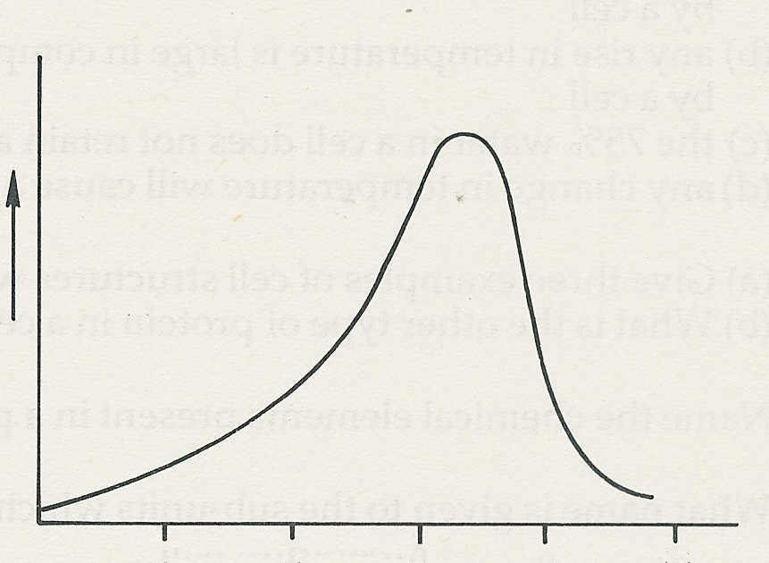
pH
2
4
6
8
10
rate of reaction
17 The graph shows the rate of an enzyme
reaction at different levels of acidity or
alkalinity (pH). From the graph, what is the
optimum pH for this enzyme?
(a) pH 2 (c) pH 10
(b) pH 7 (d) none of these.

18 A protein-digesting enzyme when mixed with starch solution would
(a) have no action (c) produce glucose
(b) produce amino acids (d) digest the starch?

19 Select the most appropriate words from the list below to complete the following
paragraph.
All enzymes are produced inside ……. Enzymes which do their work outside cells are
called ……. Enzymes which do their work inside cells are called …….. Most of our digestive enzymes are examples of ……. enzymes.

animals, extra-cellular, intra-cellular, cells, digestive, nuclei, catalysts.

20 Give two examples of chemical reactions which are catalysed by enzymes in the course of
brewing.

21 What does the enzyme catalase do?

22 Substance A is being investigated to see if it is an enzyme. When substance A is mixed with substance B a reaction takes place. A control experiment is conducted using a sample of A which has been boiled.
(a) Why is boiling used as a control?
(b) If the reaction still worked after A had been boiled, what might be your interpretation?

23 In an investigation to compare the rates at which starch is being broken down by an
enzyme
(a) what test is used
(b) how do you know when the reaction is completed?

6

