9 Asexual reproduction and cloning in plants
Self-assessment questions 9.01

1 In natural vegetative propagation, which of the following structures are most likely to give
rise to new individuals: (a) stems, (b) roots, (c) buds, (d) leaves, (e) flowers?

2 The drawing shows a plant which reproduces vegetatively.
(a) What will need to happen before shoots A - C become independent plants?
(b) How might a gardener assist this process?
(c) What name is given to the horizontal stem in this kind of propagation?
(d) Name a commercially grown fruit whose plants are propagated in this way
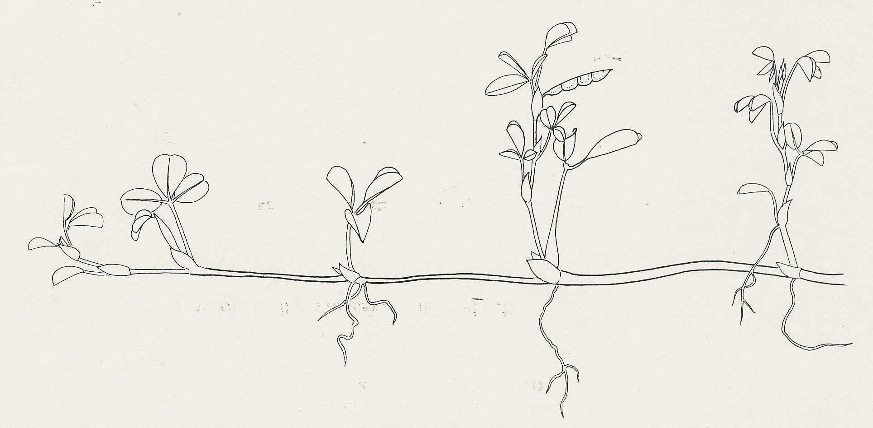

A
B
C

3 Before stem cuttings are planted, the cut end of the stem is often dipped in a hormone
powder. What is the point of this?

4 The following are thought to be some of the advantages of either vegetative reproduction or sexual reproduction:
produces greater variety in the offspring, good at colonising new areas, reduces competition
from other species, maintains desirable qualities in the offspring, good at colonising favourable
areas
Make a table with these qualities under the headings of 'Sexual reproduction' and 'Vegetative reproduction'.

5 If a gardener wanted to propagate a useful variety of apple tree in a way which maintained all its desirable qualities, which of the following techniques would be used:
(a) planting stem cuttings in potting compost
(b) grafting stem cuttings onto a rootstock
(c) grafting buds on to a root stock
(d) growing the seeds produced from the useful variety
(e) cross-pollinating the variety with another good variety and growing the seeds
resulting from the cross?

6 What name is given to the population of genetically identical offspring which result from a
process of asexual (vegetative) reproduction?

7 Which structures of a flowering plant give rise to (a) potatoes, (b) the fleshy scales of an onion?

8 In the process of tissue culture in plants, what is needed to induce the formation of a complete plant, in addition to a growth medium with nutrients?

