24 Applied genetics
Self-assessment questions 24.01

1 A strain of barley (A) has a high yield of seeds but a long stem which is subject to ‘lodging’
(a flattening of areas of the crop). Another strain (B) has a short, sturdy stem but a lower yield.
The genotype of variety A is HHss (high yield, long stem) and the genotype of B is hhSS (low yield, short stem)
(a) Show how a plant breeder would cross these varieties to produce a high yielding, short
stemmed variety.
(b) Explain why this variety would not breed true.

2 Choose from the list of words below, to complete the following sentence.
In genetic engineering, a …..A …..from one organism is introduced into the ….. B …..
of an unrelated organism.
chromosome, nucleus, gene, protein, genome

3 What name is given to an enzyme which is used to cut a DNA molecule at specific sites?

4 What bacterial cell structures are used to carry the genes intended for genetic engineering?

5 Name three useful products that can be obtained by genetic engineering.

6 Outline the steps involved in using bacteria to produce human insulin.

7 Give three examples of genetic engineering that are intended to improve crop plants.

8 DNA can be split into fragments using restriction enzymes.
(a) Outline the technique used to separate these fragments.
(b) What property of the DNA fragments allows this separation?

9 The illustration shows the separation of DNA
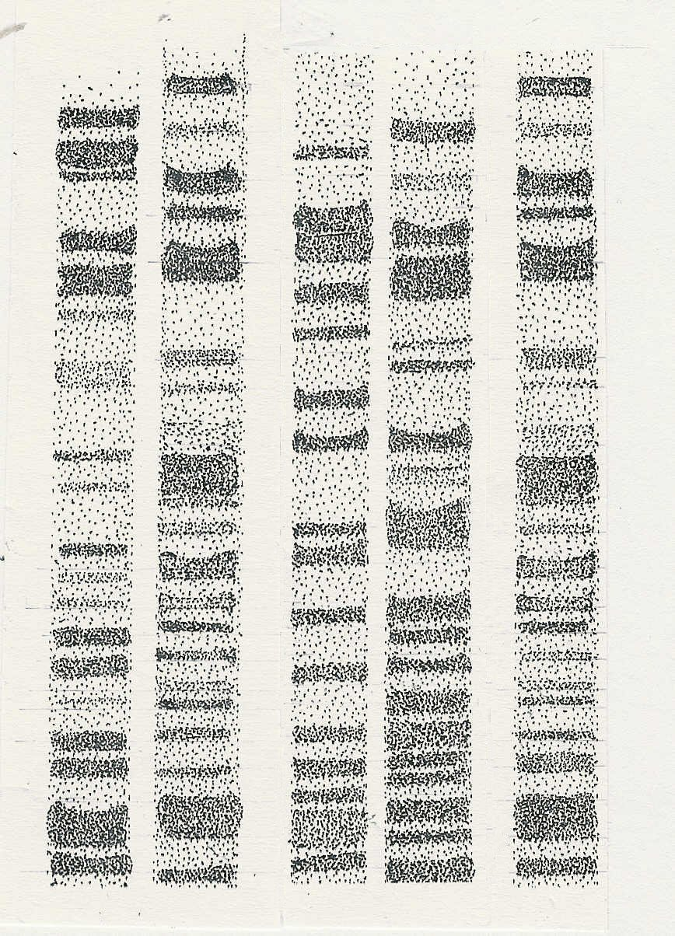
V
CS
S1
S2
S3
fragments produced from blood samples taken at
the scene of a crime, plus those of three suspects.

Rule horizontal lines through the DNA bands from the
crime scene, to cross the three suspects profiles.
(a)Which suspect is most likely to be guilty?
(b) Explain why you think so.

V Victim
CS Sample taken from crime scene
S1 Suspect 1
S2 Suspect 2
S3 Suspect 3

Applied genetics (continued)
Self-assessment questions 24.02

10 What is the special characteristic of (a) stem cells, (b) embryonic stem cells?

11 What are the possible sources of human embryonic stem cells?

12 What would be the advantage of using a patient’s own stem cells e.g. blood stem cells, to treat his or her illness?

