Experiment 9. Discussion

1 (a) Why was soda lime included?
(b) What might have happened if soda lime had been omitted?

2 What was the point of keeping the tube immersed in water?

3 On what grounds can one assume that it is oxygen rather than any other atmospheric gas which
is taken up?

4 Why should the results be expressed as 'per gram' of living material?

5 If you used the apparatus to compare the rates of respiration in two or more samples of living
organisms, suggest reasons for any observed differences.

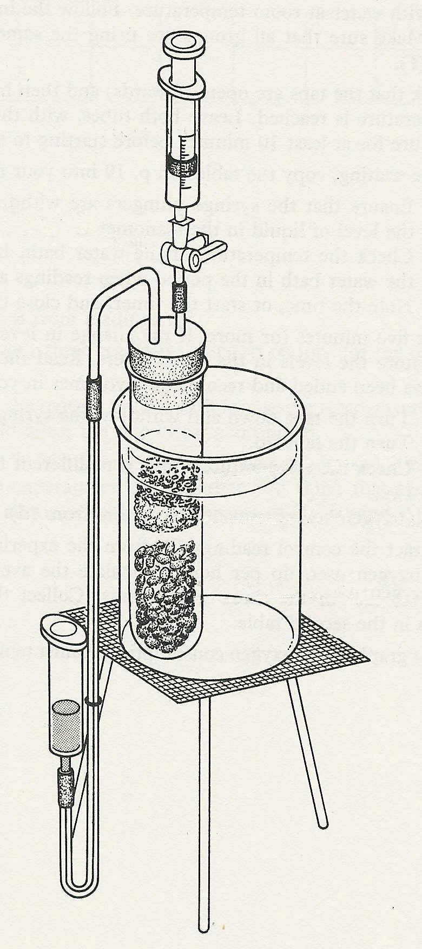
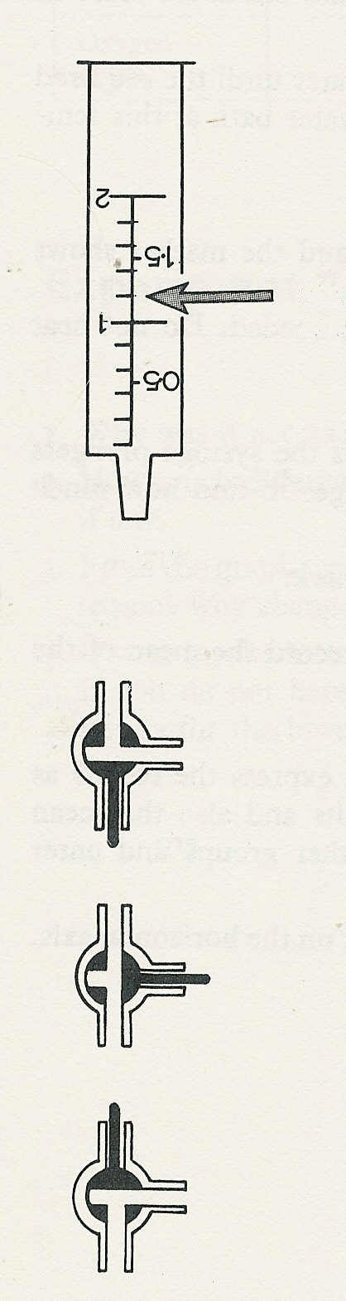

the reading is 0.8 cm³
Fig. 1
(a)
(b)
(c)
3-way tap
soda lime
cotton wool
living material
manometer reservoir
Function of the 3-way tap
Fig. 2

