Experiment 9 Perception

The exercises in this book have been mainly concerned with the functions and limitations of the
senses of touch, taste and sight. There is, however, a vast difference between the information sent to the brain by the sense organs and the interpretation made by the brain. This interpretation is called perception and depends, to a great extent, on learning and past experience.
For example, Fig. 1 is a two-dimensional pattern of straight lines and its image on the retina is the same, but it is perceived by most people as a cube. Moreover, it can be
seen as a cube with the shaded area either as its face or the inside of the back wall. The image on the retina does not change but the perception does. The brain does not settle for one or other view because both are equally acceptable (probable).

In Fig. 2 the brain is prepared to 'see' an object which is not there, namely a solid letter 'E'. Although the latter is not drawn, the brain 'sees' it as the most probable explanation of the three, otherwise meaningless, angular black areas.
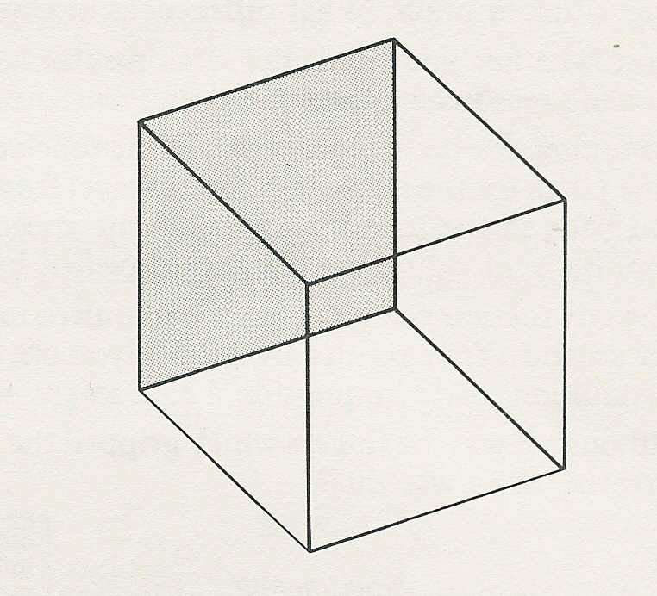
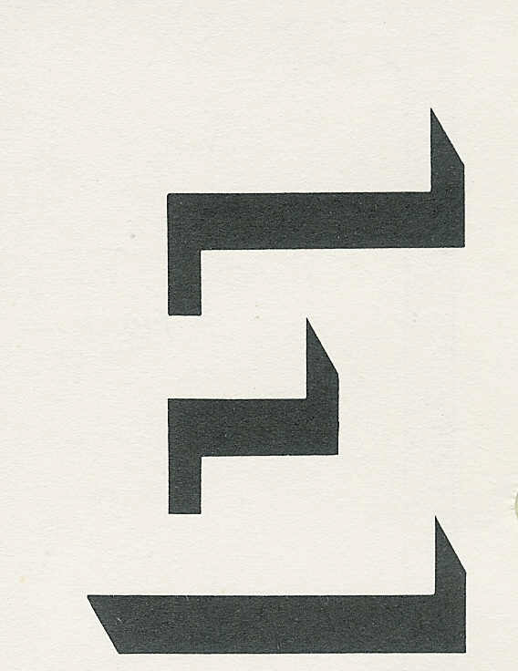
Fig. 1
Fig. 2

