Experiment 8 Discussion

Read the introductory paragraphs to the experiment once again.

1 Although the hydrogencarbonate indicator solution is a pH indicator, i.e. its colour depends on its acidity, this experiment assumes that its changes of colour depend entirely on changes in the carbon dioxide content of the air or water. Explain why this is a reasonable assumption.

2 (a) What change in pH is suggested by the indicator becoming more yellow?
(b) What change in the composition of the water in the test-tube is most likely to cause such a
change of pH?

3 (a) What change in pH is suggested by the indicator becoming more red or purple?
(b) What change in the composition of the water in the test-tube is most likely to cause such a
change in pH?

4 What was the purpose of setting up tube 3?

5 What effect did the presence or absence of light have on the concentration of carbon dioxide in tubes 1 and 2?

6 If you know something about the processes in pond-weed which lead to gaseous exchange,
explain the difference in results in test-tubes 1 and 2.

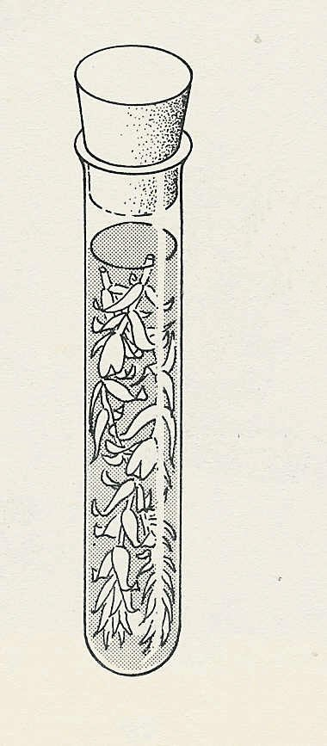

pond-weed in hydrogencarbonate indicator
Fig. 1

