Experiment 8. Pathways for gases in a leaf

(a) If you have not already tried Experiment 9, or do not plan to do it, paint an area about 10 cm square on both the upper and lower surface of a leaf with a thin layer of clear nail varnish and leave the varnish to dry for 10 minutes. Meanwhile, continue with instruction (b).

(b) Fill a beaker two thirds full with water (hot water if available) and heat it on a tripod and gauze over a Bunsen burner until it reaches about 70 °C.

(c) Extinguish the burner when the water is hot enough.

(d) Hold a leaf (not the one with the nail varnish) in forceps and plunge it into the hot water
(Fig. 1), whilst observing the lower surface of the leaf.

(e) Repeat the experiment with a fresh leaf but this time watch the upper surface.

(f) If you followed instruction (a), use fine forceps to peel the dried varnish from the lower surface, place it on a slide and examine it under the microscope. Only a small piece of peel is needed.

(g) Count the number of stomata visible in the field of the microscope and record the results in your notebook. If the stomata are too numerous to count over the whole field of vision, count only those in, say, a quarter of the field or between marks on the slide. Alternatively, use a higher magnification if available. (See Fig. 2 on p. 9.02)

(h) Repeat the operation with the nail varnish from the upper surface.

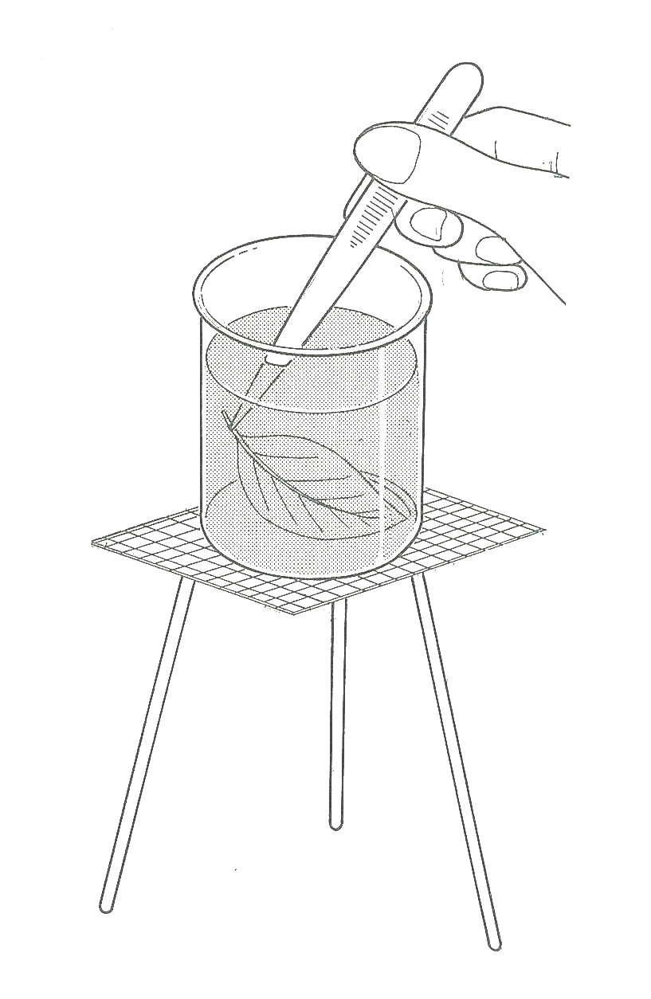

Experiment 8. Discussion

1 What did you observe when the leaf was placed in
hot water while watching
(a) the lower surface,
(b) the upper surface?

2 What was the function of the hot water in this
experiment?

3 Judging from your varnish peels, which surface
of the leaf had the greater number of stomata?

4 Use your results and your knowledge of leaf anatomy to explain your observations in this experiment.

Fig. 1

