Experiment 8 Eye and hand co-ordination

It is best to work in pairs; a subject to conduct the trials and an observer to time them. It is possible, however, to do the experiment on your own.

(a) Copy the table given below into your notebook.

(b) Use adhesive tape to stick the sheet with the 'star' outline to the bench, with the MIRROR line away from you and not less than about 30 cm from the front edge of the bench.

(c) Place the mirror vertically on the line and support it, if necessary, with a clamp or book placed behind it.

(d) Clamp a piece of card in a clamp stand and arrange it between yourself and the mirror
(see Fig. 1) so that when you put a pencil on the 'start here' circle (looking in the mirror), you can see the star and your hand in the mirror, but not by direct vision.

(e) Use the right hand if right-handed, or left hand if left-handed, and place the pencil point on the 'start here' circle.

(f) The observer notes the time or starts the stop-clock and the subject, moving in the direction
indicated by the arrow, traces round the outline of the star, looking only at the mirror image and making the line, however erratic, pass through every circle. When the outline is completed, the
observer notes the time taken and enters it in the table.

(g) The pencil line is rubbed out, or the sheet replaced, and the same subject repeats the trial but
with the opposite hand, and the observer notes and records the time as before.

(h) The trials are repeated at least twice more for each hand, running the trials consecutively,
i.e. 2 trials with the right, followed by 2 trials with the left, and the times noted and recorded.
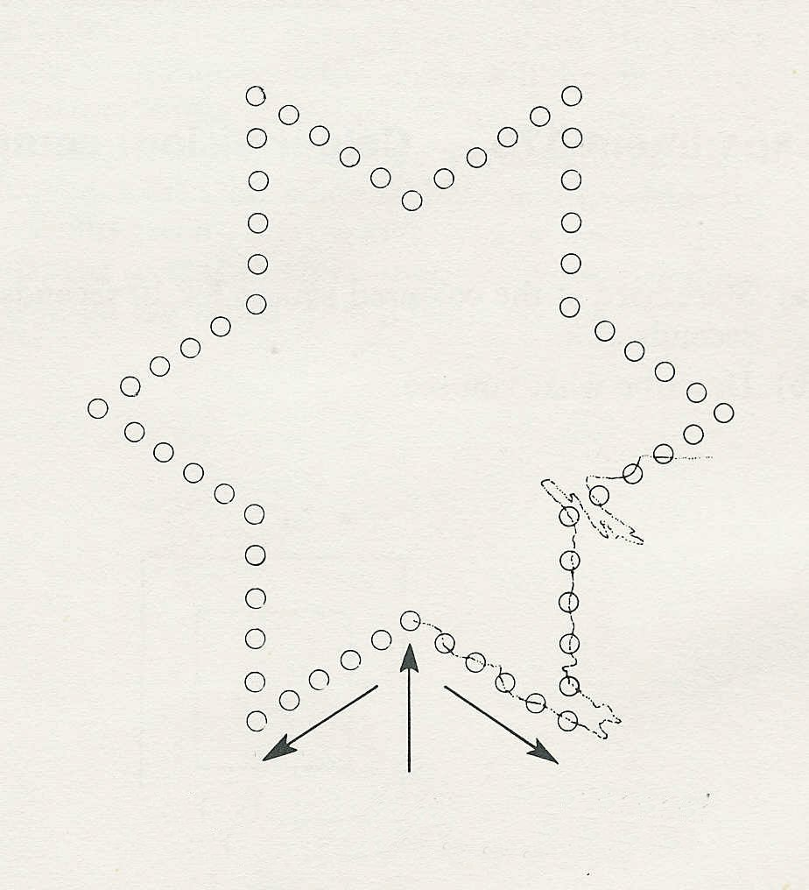
Time to complete the drawing
Right | Left
The line must pass through each circle, no matter how erratic it is
left hand this way
right hand this way
start here

