Experiment 7 Judgement of distance - preparation

Outline Pins with coloured heads are stuck into a polystyrene block and their comparative distances judged using one or both eyes.

Advance preparation and materials

Polystyrene blocks. If possible, use a 'compact' form of expanded polystyrene 1-2 cm thick, but ceiling tiles will do, though they may not last so long. Use a fine felt-tip pen to mark out grids on the polystyrene as shown in Fig. 1, and then cut out the blocks using a hot wire or small soldering iron and steel ruler, leaving a margin of 5 mm or more. Mark the FRONT of
the block as shown.

Coloured pins. Glass- headed pins with heads of about 3 mm diameter are used. These may be obtained from haberdashers. Plastic-headed pins may be adequate substitutes.
Each group needs one polystyrene block and 6 pins of different colours.

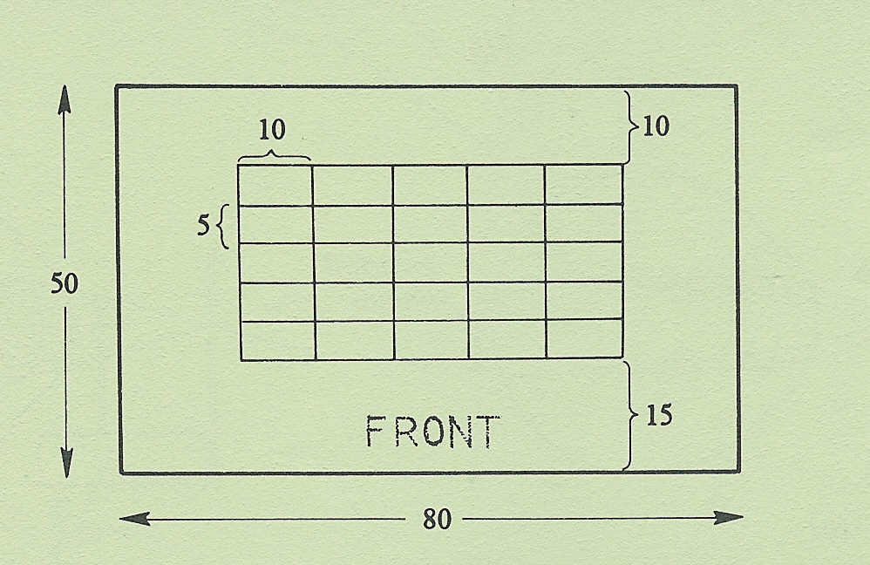

Fig 1

measurements are in mm

Experiment 7 Discussion - answers

Students will probably find it quite difficult to decide the order when using only one eye but should have little difficulty when using both eyes. This should be reflected in the scores. Using one eye, the only clue to distance (in the absence of parallax) will be the relative size of the pins. Since the diameter of the heads varies slightly, this will be unreliable. The design of the apparatus prevents overlap of objects, which would normally be an important clue. Using both eyes, the degree of convergence of the eyes when concentrating on each pin will be a source of sensory information. This information must come from stretch receptors in the external eye muscles.

