Experiment 7. Discussion

I If the volume of fruit juice needed to decolourize DCPIP is greater than the volume of 0.1 % ascorbic acid, does this mean that the juice contains more or less vitamin C than
ascorbic acid solution?

2 On this basis, which of your samples contained the most vitamin C?

3 Did the canned fruit. juice differ greatly from the fresh juice?

4 Suppose that 0.8 cm³ orange juice decolourized 1 cm³ DCPIP but it took 1.6 cm³grapefruit
juice to decolourize the same volume of DCPIP; does this mean that oranges contain more vitamin C than grapefruit?

5 What might take place at a canning factory which could (a) reduce, (b) increase the
vitamin C content of fruit juice?

6 Did the fruit juice which had been exposed to air for several days have significantly less
vitamin C than the fresh juice?

7 Sodium sulphite is not vitamin C and yet it decolourized DCPIP - Why did it do this?
(See introductory notes on p. 7.01 and instruction (i).)

8 Since chemicals other than vitamin C will decolourize DCPIP, does this mean that using the dye as a test for vitamin C is unsatisfactory?

9 If canned or bottled juice has sulphur dioxide or sodium sulphite added as a preservative,
will this affect the reliability of your results with DCPIP?

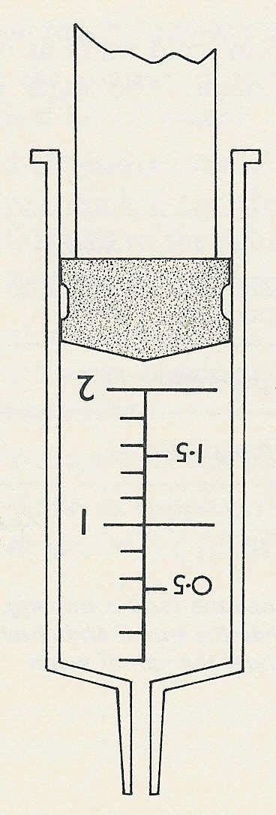
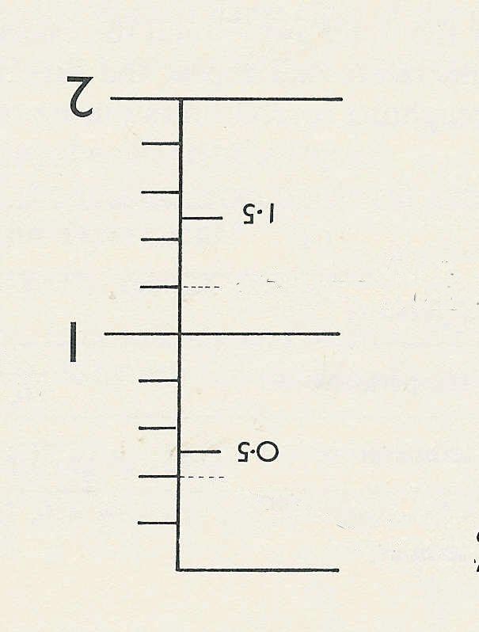

Fill to here with
DCPIP
Fill to here with ascorbic acid or fruit juice
This reading is 1.6 cm³
This reading is 0.8 cm³
Using the 2cm³ syringe

