Experiment 6. Discussion

I What happened to the glowing splint when it was placed in the test-tube?

2 What gas usually causes this reaction ?

3 The test does not prove that only this gas is present in the test-tube. What other gases might be present?

4 What evidence do you have which suggests that the production of this gas depends on light reaching the plant ?

5 What evidence is there to suggest that the gas in the test-tube came from the pond-weed and not directly from the water in the jar ?

6 How could you eliminate this last possibility ?

Push the pond-weed stems into the hole in the cork  lid  elastic band  Figure 1 | Figure 3 333  Turn the test-tube upside down and fit the lid on the jar
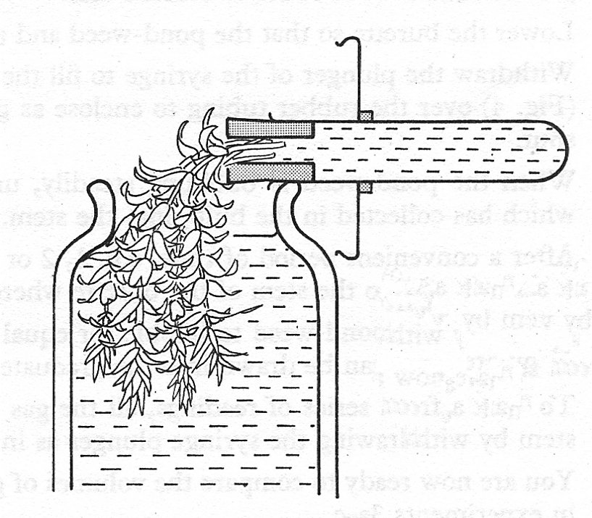  Hold the test-tube  horizontally with the cork over the edge of the jar  Figure 2 | Figure 4  close the mouth of the tube with your thumb

