Experiment 6. Two-way diffusion in a liquid

(a) Melt the gelatine in the boiling tube by immersing it almost up to the rim in a beaker or jar of hot water. While waiting for the gelatine to melt, continue with (b).

(b) Use a spirit marker to label two test-tubes A and B and draw lines round them at 8, 12 and
13.5 cm from the bottom of the tube (see Fig. I).

(c) Pour liquid gelatine into both tubes up to the first mark and use a dropping pipette or syringe to add 10 drops of 1% cresol red (a pH indicator) to each. Close each tube in turn with your thumb or a rubber bung and invert it several times to mix the indicator with the gelatine.

(d) Allow the coloured gelatine to set firm. This can be hastened by dipping the tubes in cold water. Meanwhile, make three copies of Fig. 1 in your notebook, labelling only the first one.

(e) When the yellow gelatine has set, re-melt the gelatine in the boiling tube if necessary and pour a further layer of cool but liquid gelatine into both tubes up to the second mark and cool quickly.
The next operation uses ammonia solution, which gives off a pungent gas. It is harmless enough
provided you do not sniff it at close range.

(f) When the clear gelatine has set in tube A, add 1 % ammonia solution up to the third mark and insert the bung (Fig. 2). Do the same for tube B but use 10% ammonia solution.

(g) Put your initials on the tubes and leave them on their sides for 3-7 days.

(h) After 3-7 days, examine the tubes and use crayons or shading to indicate the distribution and
colour of the indicator on your two remaining drawings.

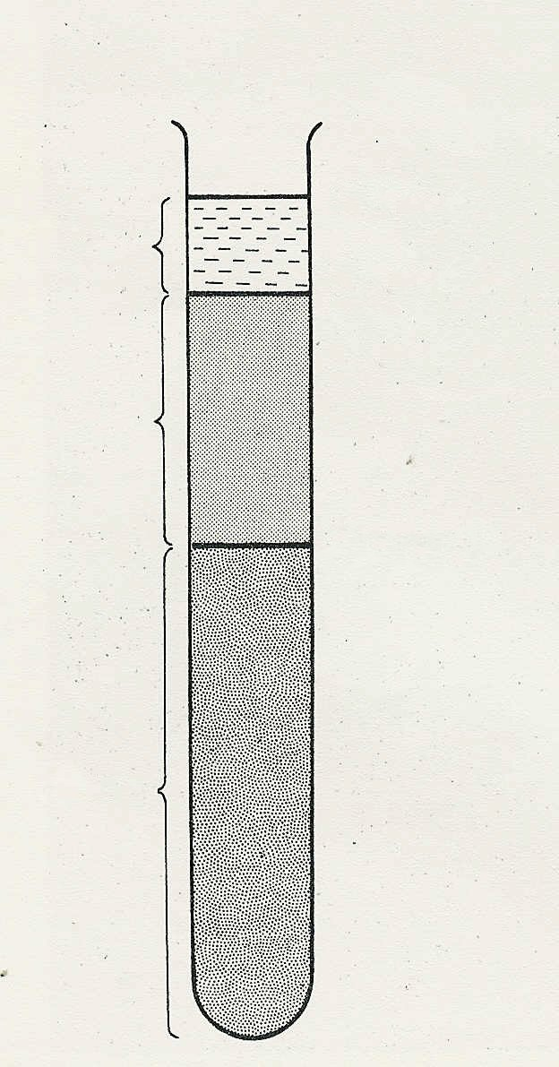
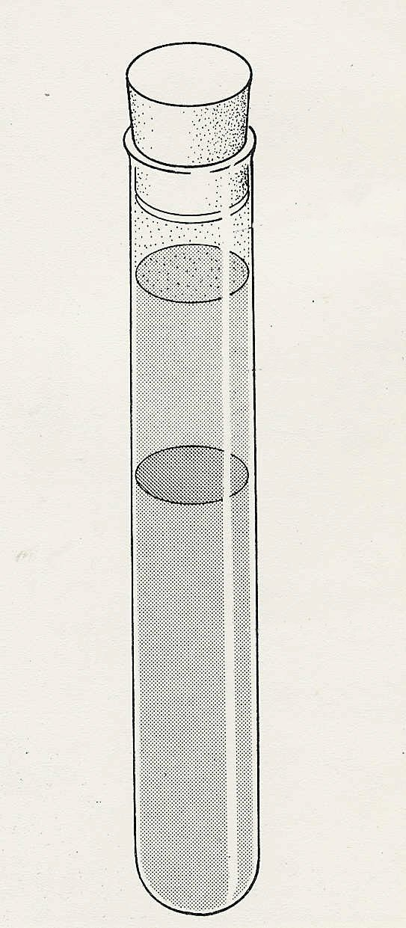
1.5 cm
4 cm
8 cm
third mark
second mark
first mark
ammonia solution
clear gelatine
yellow gelatine
Fig.1
Fig. 2

