Experiment 6 Testing food for the presence of starch

PRECAUTION. Experiment 3 showed that the starch test is a sensitive one, so if you use a
test-tube for more than one experiment, make sure it is thoroughly cleaned out each time or
else traces of starch from one food sample may remain on the sides and give a positive
result for a sample which, in fact, contains no starch. For the same reason, the mortar and pestle must be washed between each test.

(a) Label six test-tubes 1~6.
Copy the table given below into your notebook.

(b) Crush a 1 cm cube, or equivalent quantity, of the first food sample in a mortar with
about 10 cm³ water (50mm in a test-tube).

(c) Pour the mixture into a clean test-tube and, using a test-tube holder, heat the mixture
in a small flame of a Bunsen burner till it boils for a few seconds, shaking the tube
gently all the time.

(d) Cool the tube under a running tap.

(e) Add five drops of iodine solution.

(f) Record your results in the table in your notebook and repeat the experiment with the next food sample.

Food sample | Colour change with iodine | Interpretation of result
1 Potato
2 Onion
3 Bread
4 Banana
5 Apple
6 Dried milk
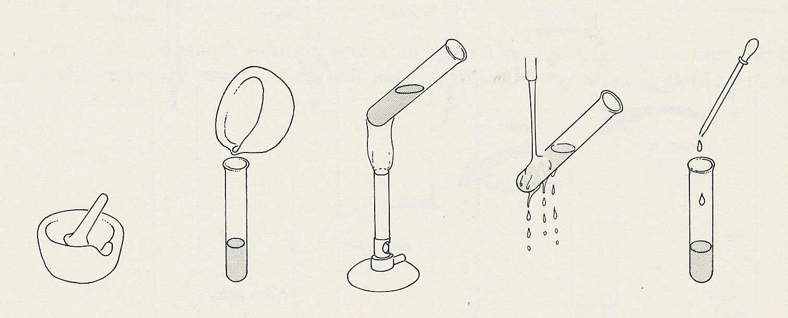
crush with water
pour into test-tube
boil
cool under tap
add iodine

