Experiment 6. The response of radicles to unilateral gravity

You are provided with two pea seedlings with fairly straight radicles.

(a) Make an accurate drawing of each seedling similar to Fig. 1, in your notebook, showing any
kinks or bends in the radicle. Leave space for two more drawings.

(b) Measure each radicle in millimetres and write the length over the appropriate drawing.

(c) By pushing a pin through the cotyledons fix seedling B to one of the numbers marked on the pin board or cork inside box B, so that the radicle is horizontal.

(d) Pin seedling A to the same number on the turntable of the clinostat. Make a note of your
number.

(e) Both sets of seedlings will be kept at a high level of humidity by putting wet blotting paper round the inside walls of the containers. Box B will remain stationary while the turntable A will be rotated slowly in a horizontal position (Fig. 2).

(f) After a period of from 1 to 6 days remove the lids and BEFORE unpinning your seedlings note any change in the direction in which the radicles are pointing.

(g) Make an accurate drawing of each seedling in your notebook, alongside or below your previous drawings. Measure the radicle lengths again and write them over the appropriate drawing.

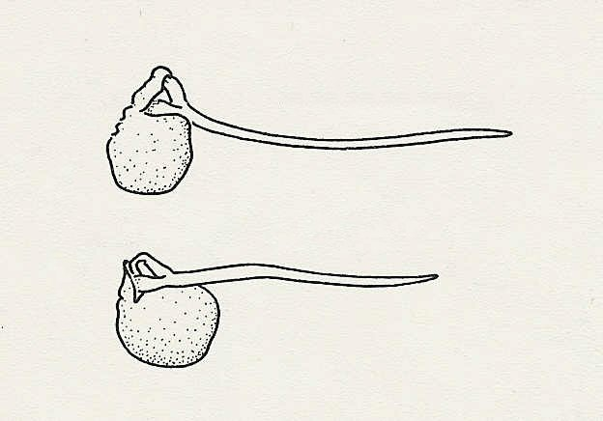
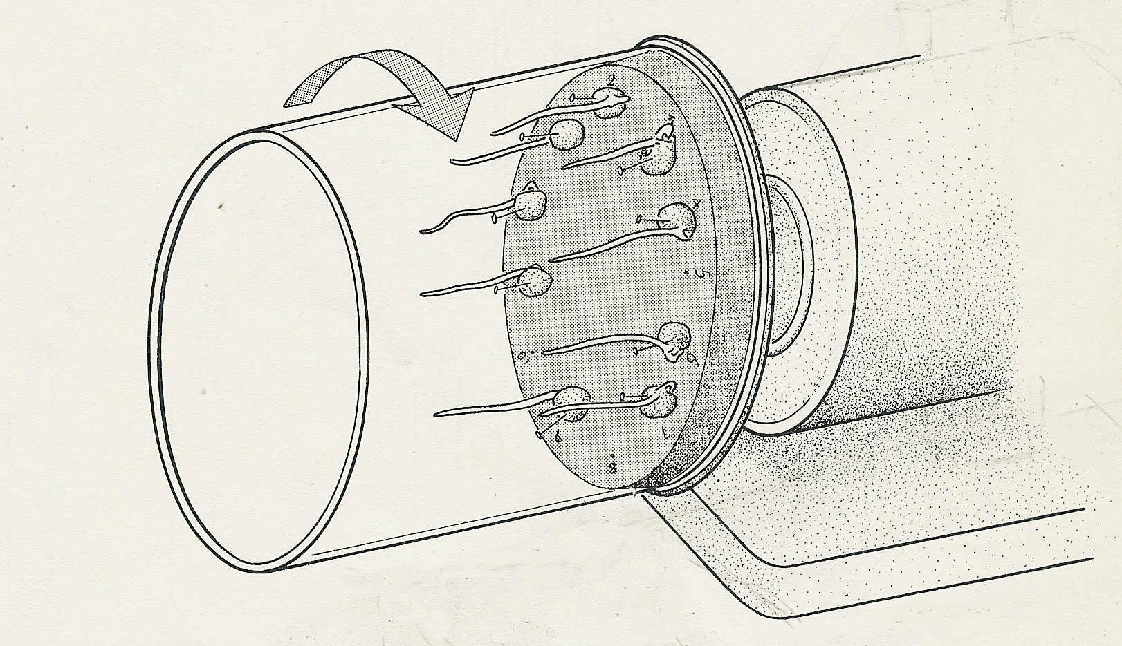
Fig. 1
35 mm
33 mm
Leave space here for drawing results
plastic cover lined with moist blotting paper
cork turntable
CLINOSTAT

