Experiment 5. Discussion

I What change in the liquid level did you observe in the two tubes ?

2 What does this change tell you about the volume of air in each boiling tube ?

3 What are the principal gases in the atmosphere and what is the percentage volume of each ?

4 What is the function of the soda-lime in this experiment? What might happen if it were not included?

5 Which atmospheric gases could be responsible for the change in the volume of air in the boiling tube?

6 Say why you regard your results as reasonable evidence that respiration is taking place in the organisms under investigation.

7 Why were the two tubes placed in a water bath?

8 Tube B is a 'control' to the experiment. What is its purpose?

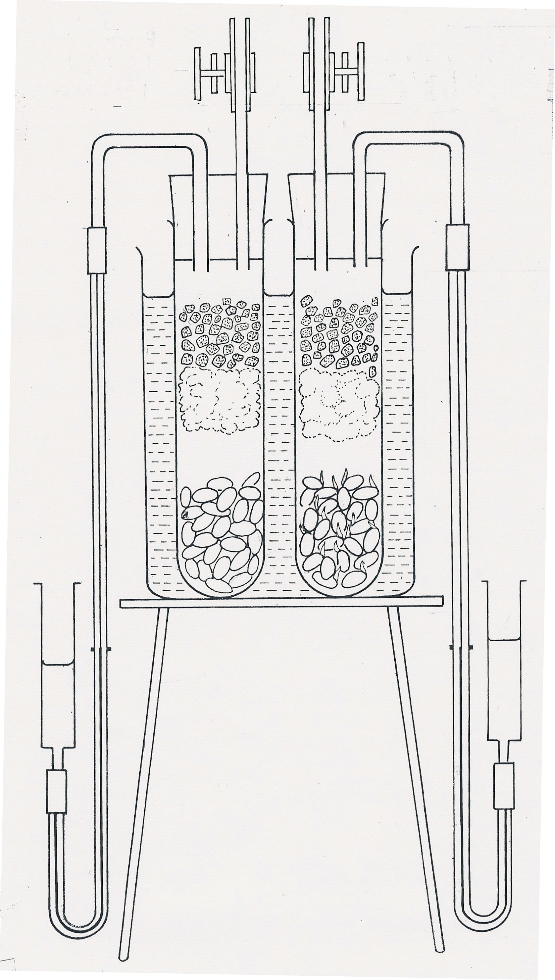
germinating
seeds
dead seeds
soda-lime
cotton wool
screw clip
manometer
starting level of
liquid in manometer
manometer
reservoir
water bath

