Experiment 5. Discussion

I What is the least concentration of starch that iodine solution will detect?

2. If your answer to question 1 is a single percentage, it will need a qualifying statement.

3 Do you think a .0001 % solution contains any starch at all?

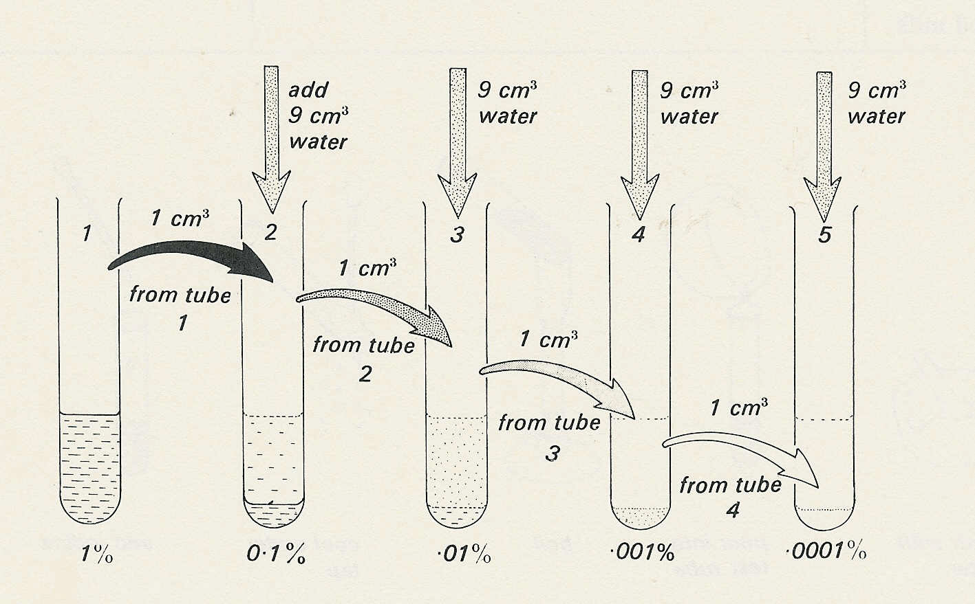
Making a serial dilution

