Experiment 5. The effect of the concentration of enzyme on the rate of reaction

(a) Copy the table given below into your notebook.

(b) Label four test-tubes 1-4.

(c) Using a graduated pipette or syringe, add 5 cm³1% urea solution to each tube.

(d) Rinse the pipette or syringe and use it to add 2 cm³ dilute ethanoic acid to each tube.

(e) Add ten drops of BDH universal indicator to each tube, using the dropper incorporated
in the bottle itself or a dropping pipette.

(f) Rinse the graduated pipette and use it to put 3 cm³ boiled urease solution into tube 4.

(g) Now place the following volumes of urease (unboiled) in tubes 1-3:
(1) 2 cm³, (2) 3 cm³, (3) 5 cm³.

(h) At intervals of 30 seconds shake the tubes, observe the colour of the indicator in each
tube and record the corresponding pH in your table (see the key below).

BDH Universal Indicator pH

PINK 4 (acid)
ORANGE 5
YELLOW 6
GREEN 7
BLUE-GREEN 8 (alkaline)

Time intervals (30 seconds)
Tube | 5 cm³ urea solution 2cm³ ethanoic acid, plus: | 1 | 2 | 3 | 4 | 5 | 6 | 7 | 8 | 9 | 10 | 11 | 12 | 13 | 14 | 15 | 16
1 | 2 cm³ urease
2 | 3 cm³ urease
3 | 4 cm³ urease
4 | 3 cm³ boiled urease

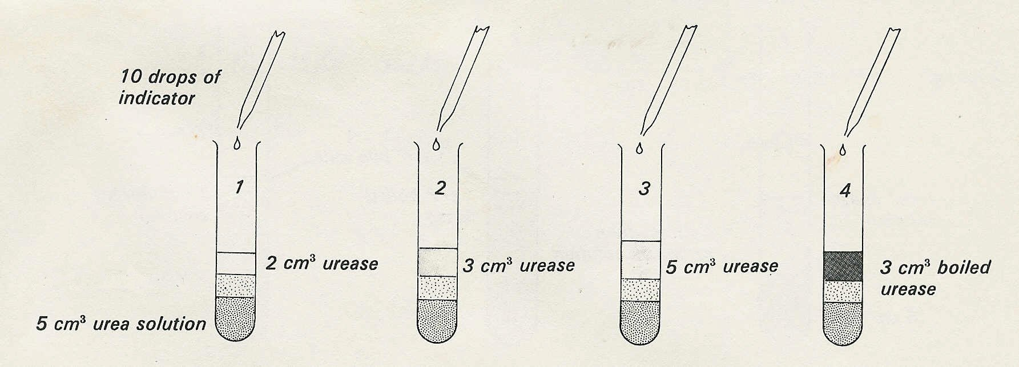
2cm³ ethanoic
acid

