.

Experiment 5. Uptake of water by an uprooted plant

(a) Select an uprooted plant and carefully dry the lower part of the stem. Mould a ball of 'Blu-tack', or 'Plasticine' closely round this part of the stem to make an air-tight seal. Lower the root system carefully into the barrel of a 5 or 10 cm³ syringe and press the plastic material firmly into the mouth of the syringe barrel to seal the plant in (Fig. 1).

(b) Hold the plant upside down and completely fill the syringe
barrel with water, using another syringe with a needle fitted
(Fig.2). The presence of a few air bubbles does not matter.

(c) Fit the syringe barrel into the vertical arm of a potometer.

(d) Clamp the potometer upright in a retort stand. Fill a small syringe with water and fit it to the side-arm of the 3-way tap.

(e) Turn the tap upwards and depress the syringe on the
side arm to expel all air bubbles from the capillary and
then adjust the water column to just below the zero on
the capillary scale.

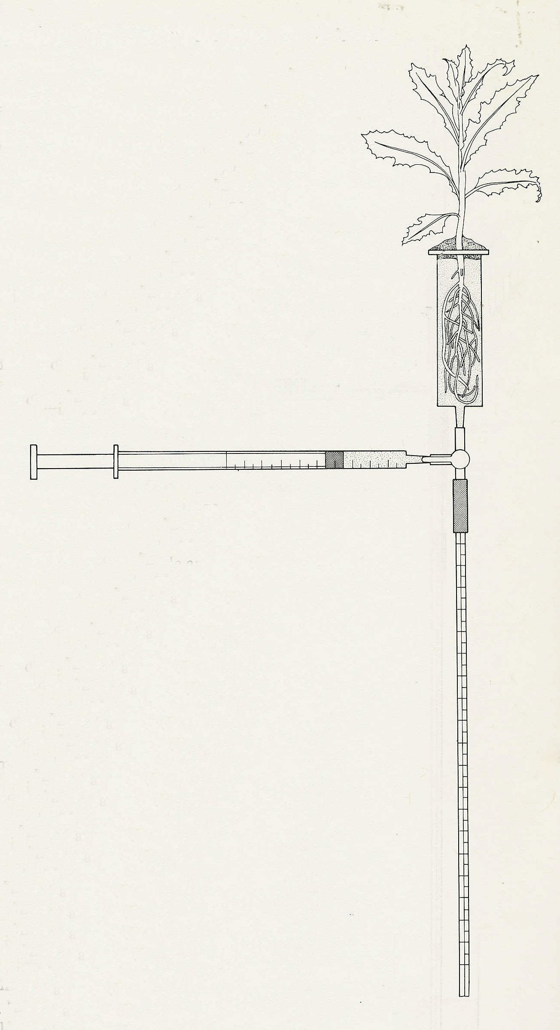

(f) Turn the tap horizontally and watch the meniscus (air/water boundary). If it falls, the plant is not adequately sealed into the syringe barrel. If it rises, observe when it reaches the zero on the scale and start- the stop-clock (or note the time).After one minute, note how far the meniscus has travelled up the capillary and record this distance, in mm, in your notebook. If the movement is very slow, it may be necessary to extend the observation to 2 or 3 minutes but still express the result as mm travelled in one minute.

(g) Turn the tap upwards and depress the syringe plunger sufficiently to return the meniscus to just below the zero on the scale. Turn the tap horizontally and again measure the distance the meniscus moves in one minute. Repeat this procedure to obtain 3 readings and work out the average distance travelled per minute.

(h) The volume of water absorbed per minute by the plant is calculated by the difference between the syringe readings at the beginning and end of the experiment divided by the time.

(i) Varying conditions. The plant can be subjected to the same conditions as described in Experiment 3 (p. 3.01) to see what effect these conditions have on the rate of water uptake.

‘blu-tack’ or plasticine
Fig. 1

