Experiment 5 Control of diffusion

(a) Use a cork borer to cut cylinders of tissue from a beetroot. (DO NOT cut on to the bench but use a plastic Petri dish lid or similar). Push the cores of tissue out of the borer with the flat end of a pencil
(Fig. 1 p. 5.02). Place these cylinders of beetroot on a tile or Petri dish lid and use a scalpel or razor blade to cut them into discs about 3 mm thick (Fig 2). You will need 12 discs.

(b) Place the discs in a beaker or jar and wash them in cold water for at least 5 minutes. Either leave them under a running tap or fill and empty the container about five times during the washing process, but in either case continue with (c) and (d).

(c) Label two test-tubes with the figures 30, and 70, and use a syringe or graduated pipette to put 6 cm³ of cold tap-water in each.

(d) Prepare a water bath by half filling a beaker or can with cold water, place it on a tripod and gauze and put a thermometer in the water but DO NOT start heating it yet.

(e) When the beetroot discs have been washed, impale 6 of them on a mounted needle with a space between each one (Fig. 3).

(f) Heat the water bath with a small Bunsen flame till the water reaches 25 ºC, remove the burner and allow the temperature to rise to 30°, heating again briefly if necessary.

(g) Note the time and place the mounted needle with the discs in the water bath for exactly 1 minute. At the end of this time, take the discs off the needle and drop them into the tube labelled 30.

(h) Heat the water bath again till the thermometer reads about 67°, remove the flame and allow the temperature to rise to 70°. Impale 6 more discs, immerse them in the water bath for 1 minute and then transfer them to the tube labelled 70. Leave the discs in the test-tubes for 20 minutes or more.

(i) After 20 minutes or more, shake the tubes, hold them up to the light and compare the colours of the liquids in each.

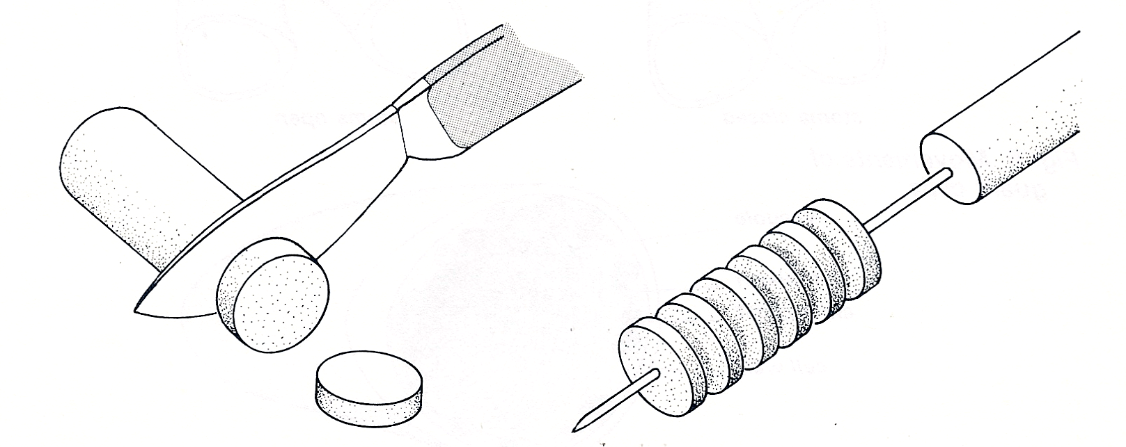

Fig. 2 Cut 12 discs of beetroot
Fig. 3 Impale 6 discs on the mounted needle

