Experiment 4. The role of the cotyledons in germination - preparation

Outline Soaked bean seeds are dissected to obtain embryos with varying quantities of cotyledon attached. These are allowed to germinate for a week and the amount of growth compared.

Prior knowledge The terms hilum, testa, cotyledons, embryo, plumule, radicle, hypocotyl or
epicotyl, lateral roots are used. Some of these are explained in the diagrams.

Advance preparation and materials
Seeds. Soak runner beans for 2 days. Allow 6 or more per group. (50 runner beans weigh
about 55 g.)
Jars. Collect tall, parallel-sided, clear glass, wide-mouthed jars with screw caps (e.g. 200g coffee jar
Expanded polystyrene blocks. Cut up a ceiling tile with scissors, hot wire or soldering iron. Rectangles 130 x 45 mm will fit into 200 g instant coffee jars. One tile will provide 12 such blocks. Allow 1 per group.
Blotting paper or paper towels . Cut strips 45 x 290 mm and pin these round the polystyrene blocks. Allow 1 per group.
Pins. Entomological pins or other fine, rustless pins are essential.

Apparatus-per group
1 screw top jar 1 polystyrene block with blotting paper
1 scalpel or razor blade 1 Petri dish lid or tile for cutting on
4 entomological pins

NOTE. In some cases, the embryo attached to the ¼ -cotyledon will show more extensive growth than that attached to the whole cotyledon. Similarly the fragment may show more growth than the ¼. It is best to assess the class results as a whole before attempting the questions.

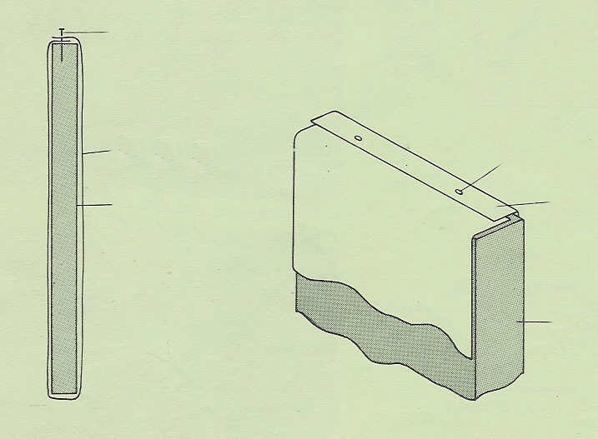

pin
blotting paper
strip of expanded polystyrene
pin
blotting paper
polystyrene

