Experiment 4. Rate of transpiration and water uptake - preparation

Outline The potometer is used as described in Experiment 2 (p. 2.02) but is weighed at the
beginning and end of the experiment to determine the mass of water evaporated.

Prior knowledge It is best if the students have tried Experiment 2 but full details for setting up and using the potometer are given in the instructions for this experiment.
To answer the questions, students will need to know about the processes of photosynthesis,
respiration and evaporation.

Advance preparation and materials

Potometer. As for Experiment 2 but fitted with a 1 cm³ syringe.
Shoots. As for Experiment 2.
Balance With a top-pan balance, the shoot and potometer can be placed horizontally across the scale pan, provided that no part of the shoot touches the surrounds. Alternatively, cut three notches in a light cardboard box to act as a holder (Fig. 1). Tape the box to the scale pan. Its mass can be ignored since it is only differences in weights which are needed.

Apparatus - per group

As for Experiment 2 but one or more balances should be provided to weigh up to 100 g with, at
least, 0.01 g intervals.
A hand lens is helpful in reading the volume on the syringe scale.

NOTES. Although not specified in the instructions, the students could be advised to make regular measurements of the rate of uptake (see Experiment 2, p. 2.01) while waiting for the
10-20 minutes to elapse. In this way they will be able to check that the rate of uptake is not impaired. If the rate stops or slows down abruptly it is usually due to air entering the upper part of the apparatus and interrupting the flow of water. In this case, it is necessary to remove the shoot and start again.

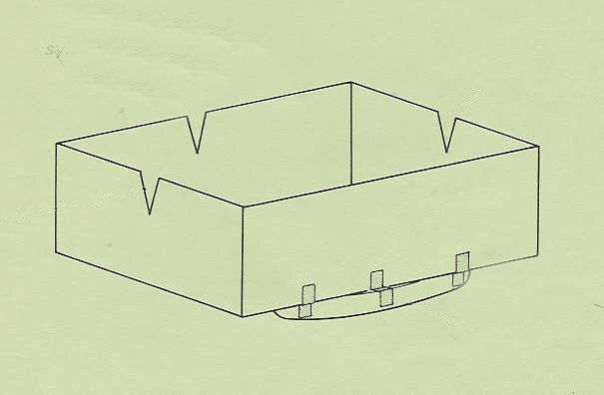
notch for syringe
notch for shoot
notch for capillary
tape box to scale pan

