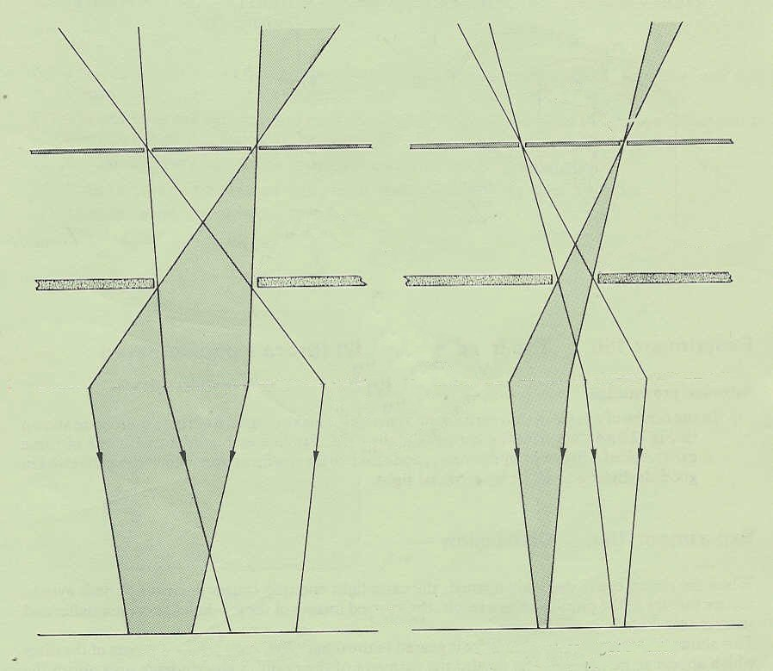
refraction at lens (corneal refraction ignored)
card
iris
pin-hole
pupil narrow
pupil wide
retina
blurred discs of light
discs appear to get smaller and move apart
Fig. 3 (relates to Experiment 4b, p.4.02)

