Experiment 4a. The iris diaphragm (1)

If bench lamps are available, provide one per pair of students. Alternatively torches may be used or simply a torch bulb and battery (see Fig. 1).
Students working on their own will need a small plane mirror. If the room is brightly lit, it should be darkened by switching off lights, and drawing some of the blinds but it is not necessary to 'black-out'. On a dull day, no special preparations will be needed.

Experiment 4a. Discussion

The pupil of the eye will be seen to diminish when the lamp is switched on and to dilate when it is switched off. Students working in pairs may observe that the pupil of the non-illuminated eye responds in the same way.
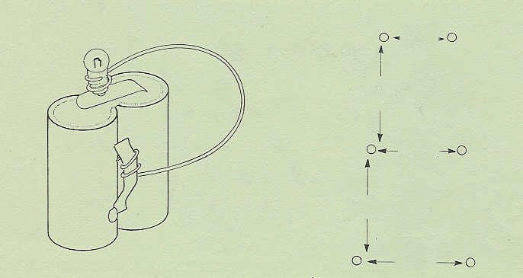

3 mm

5 mm

4 mm

thick copper wire
5 mm

Fig. 1
5 mm
Fig. 2

Experiment 4b. The iris diaphragm (2) (Broca’s pupillometer)

Advance preparation
In the centre of a piece of thin card about 5 cm square make a pattern of fine pin-holes as shown
in Fig. 2 and then trim the corners off the card. Provide each student with one of these
cards, called a Broca's pupillometer, and also a sheet of white paper which can be viewed in
good daylight or well lit by artificial light.

Experiment 4b. Discussion

When the closed eye is suddenly opened, the extra light entering causes the irises of both eyes to
reduce the size of the pupils and as a result, the blurred images of the pin-holes become smaller and sharper (see Fig. 3, p. 4.03).
This shows that the response of one eye is geared to the other. The actual distance apart of the discs which appear to be just touching is also the diameter of the pupil. Some students may notice the 'overshoot' effect by which the pupil closes 'too much' at first and then re-opens slightly

