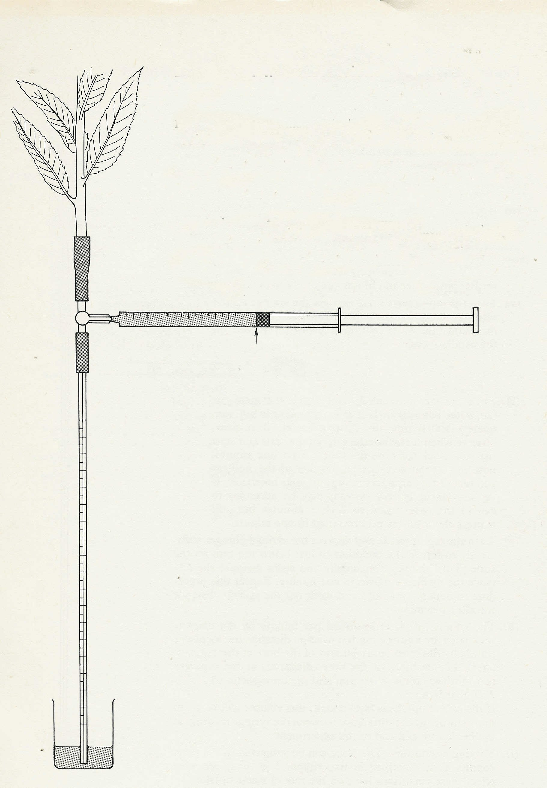
Experiment 4. Discussion

1 It is assumed that most of the loss in mass is due to the water evaporated from the shoot. What other events in the shoot might cause a loss in mass?

2 If these other losses are presumed to be negligible, what was the
rate of transpiration of the shoot?

3 In what terms should the results be expressed in order to make
comparisons with other shoots?

4 Assuming that 1 cm³ water weighs 1 g what was the mass of
water taken up and the mass of water transpired?

5 Offer explanations for any difference between these two masses

1 cm³ syringe

