Experiment 4. Diffusion through a membrane

You are provided with a length of cellophane tubing which has been soaked in water to make it flexible.

(a) If the cellophane tubing is not already knotted at one end, tie a knot close to one end of the tubing, leaving the other end open.

(b) Use a dropping pipette to half fill the cellophane tubing with starch solution.

(c) Place the cellophane tubing, with its starch solution, inside a test-tube, fold the open end of the tubing over the rim of the test-tube and secure it with an elastic band as shown in the Figure below.

(d) Wash the test-tube and cellophane tubing under a running tap to remove all traces of starch solution from the outside of the tubing and then fill the test-tube with dilute iodine solution and leave it in the rack for 10-15 minutes.

(e) After 10-15 minutes, examine the iodine and starch solutions in the test-tube and record any colour changes. .

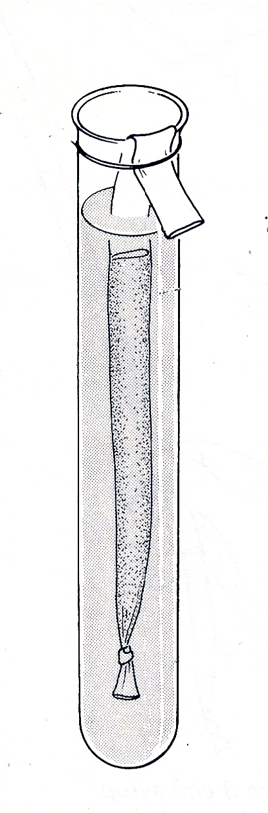
elastic band
dilute iodine
cellophane tube containing starch solution

