Experiment 2. Discussion

I At which pH was the reaction between starch and amylase most rapid ?

2 What was the pH in your mouth?

3 The enzyme amylase is present in human saliva, so is this the pH you would expect to be most effective for digesting the starch in bread? Explain.

4 If the conditions in the stomach are acid, what would happen to the reaction between
salivary amylase and the starch in a piece of bread when the bread was swallowed ?

5 Suggest ways in which the sodium carbonate and ethanoic (acetic) acid could influence the reaction between starch and saliva apart from merely altering the pH.

6 How could you extend the experiment to try and eliminate the possibility that the acid
and alkali were affecting the reaction in some way other than through pH change ?

1 cm³ sodium carbonate solution
0.5 cm³ sodium carbonate solution
2 cm³ ethanoic acid
4 cm³ ethanoic acid
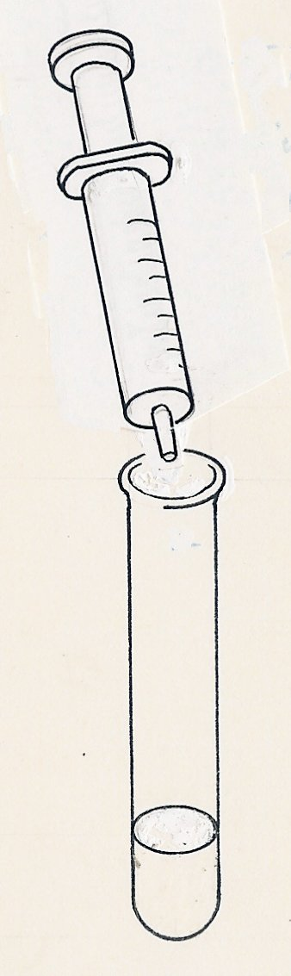
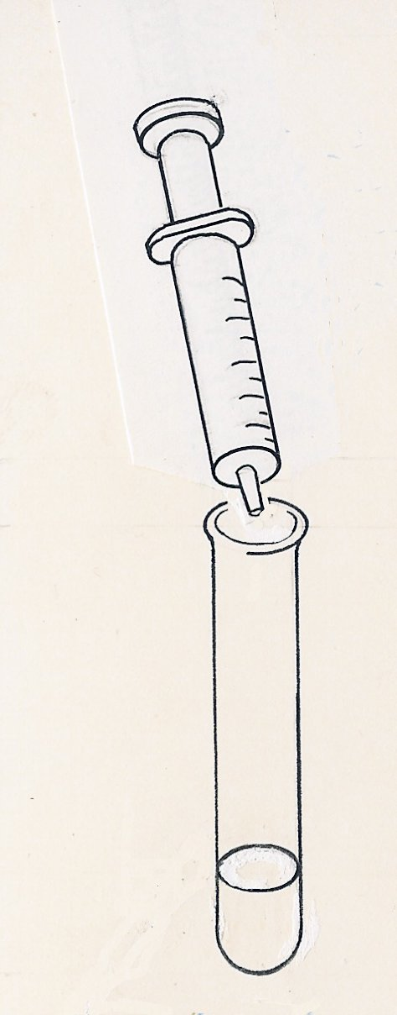
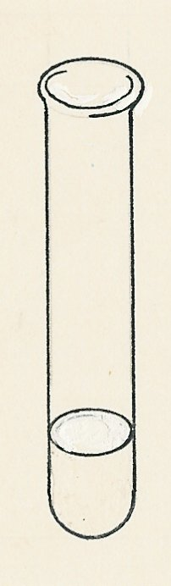
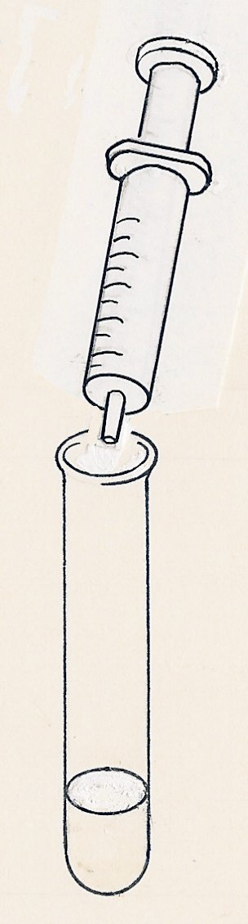
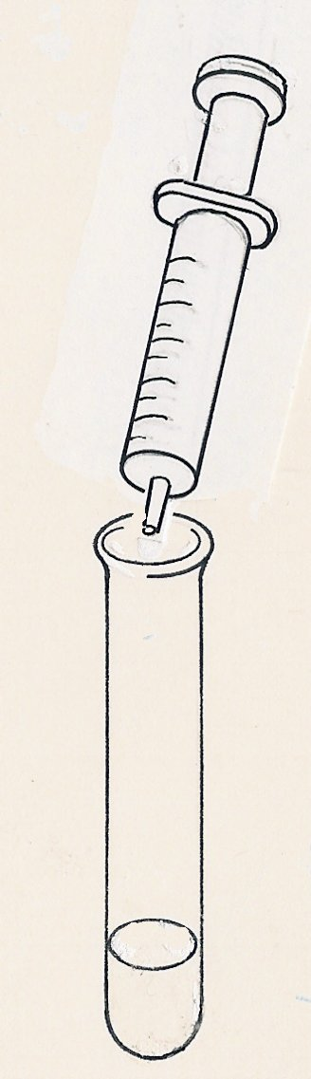
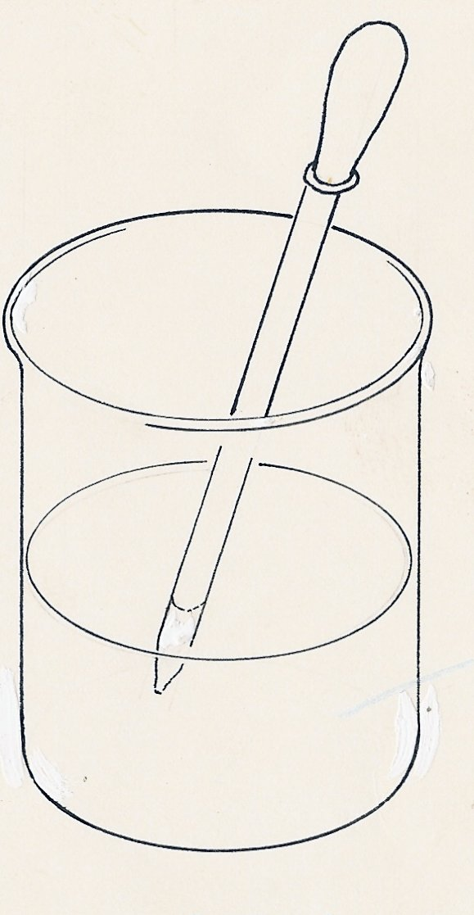
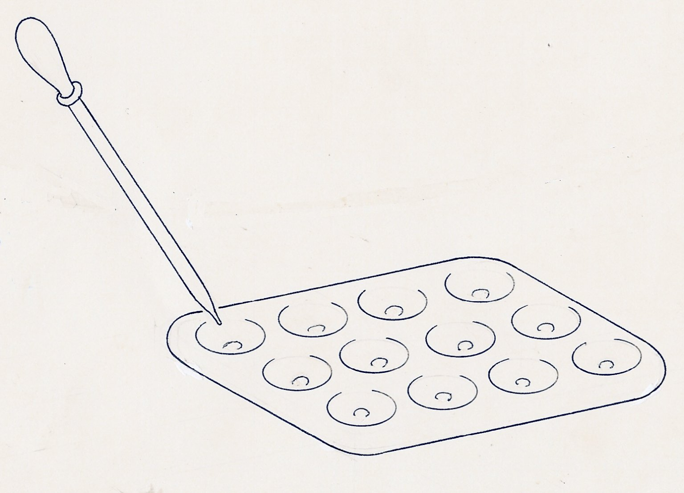
Place 5 cm³ starch solution in each tube. Note the time and add 1 cm³ amylase solution to each
Test samples with iodine
Rinse the pipette between samples
1
2
3
4
5

