Experiment 3 Inversion of the image on the retina

(a) Hold the apparatus close to your eye, with the card touching your face. Point it towards a
brightly lit area or window and look at the pin-head through the pin-hole. Describe what you see.

(b) Again hold the apparatus close to your face but this time with the pin nearer to you than the
card. Hold the wooden base against your cheek-bone and move the apparatus about slightly
while looking through the pin-hole until the pin-head can be seen as a silhouette against the
pin-hole. Describe what you see.
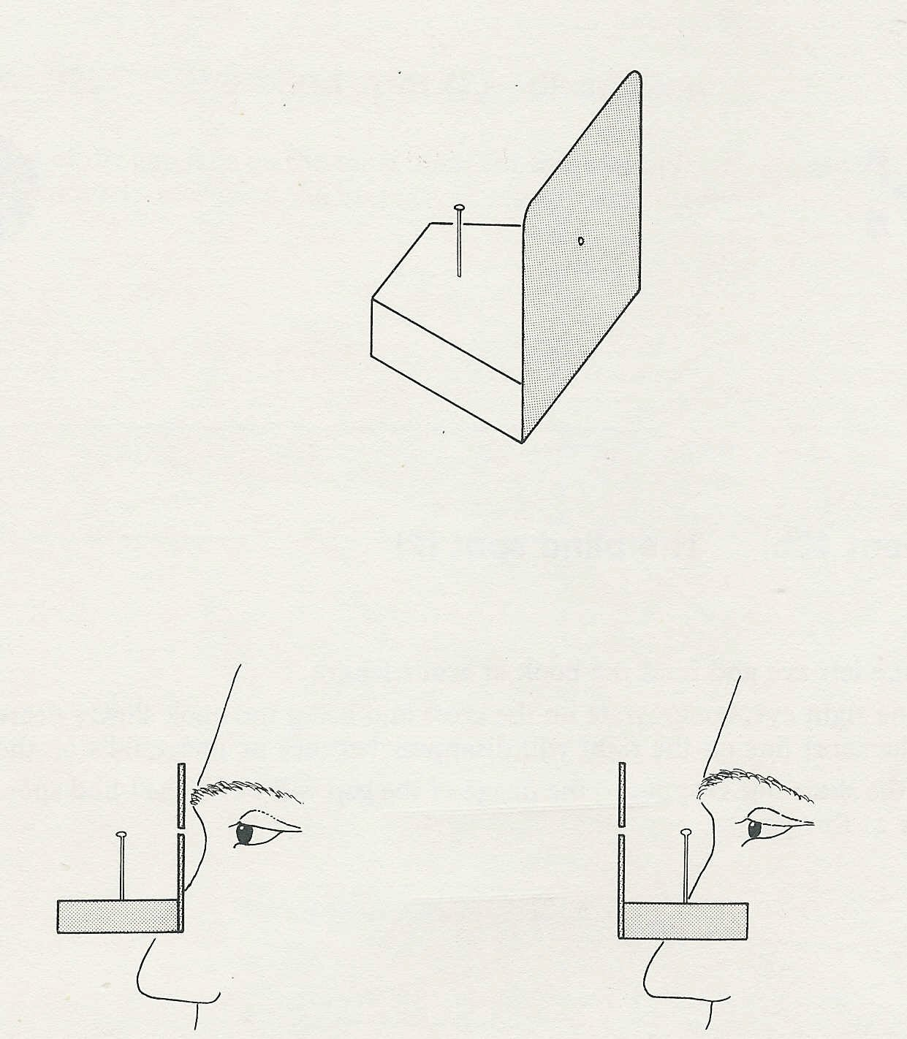
pin-hole
Firstly view the pin
through the pin-hole
Then line up the pin in
front of the pin-hole

