Experiment 3. The need for light in photosynthesis

You are provided with a potted plant which has been kept in darkness for at least 48 hours so that any starch in its leaves has been converted to sugar and removed.

(a) Water the plant if the soil appears to be dry

(b) DO NOT REMOVE ANY LEAVES but select one at the top of the shoot, preferably one held out from the stem nearly horizontally.

(c) Round this leaf wrap a strip of aluminium foil. Press it close to the surface so that this part of the leaf cannot receive any light at all. Put your initials on the foil with a spirit marker.

(d) Place the plant in direct sunlight or under the light source so that the leaf is directly under the fluorescent tube. When the whole class has prepared the plants, the tube can be lowered to within a centimetre or two of the top leaves.

(e) After a period of time (40-50 minutes is the minimum), detach the leaf with the foil and test it for starch as described in Experiment 2.

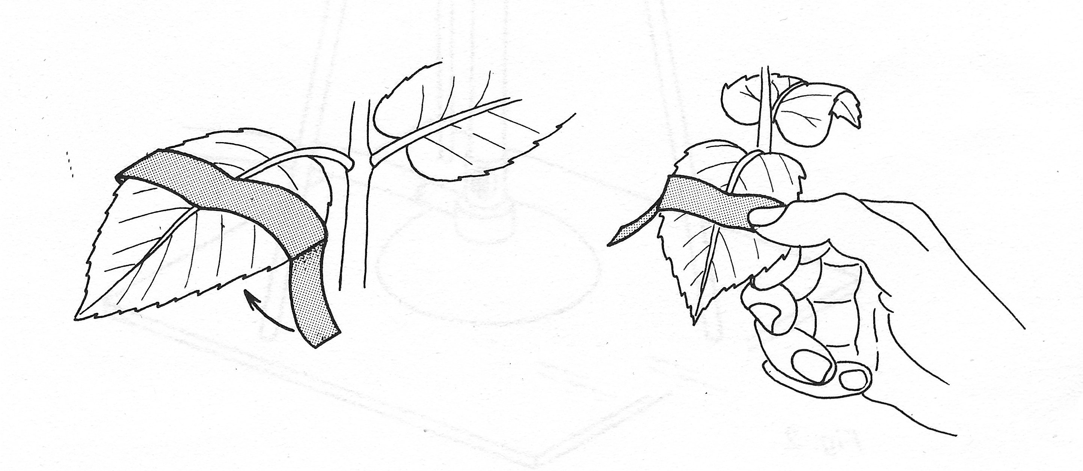
aluminium foil
press foil closely to leaf to exclude light

Experiment 3. Discussion

.I Describe the appearance of the leaf after it had been tested for starch.

2 (a) What is the significance of the colours and their distribution in the leaf ?
(b) How could this be explained in terms of photosynthesis and light ?
(c) Suggest at least one other way in which the results could be explained.

3 (a) Apart from cutting off the light from part of the leaf, what other effect might the
aluminium foil have had on the leaf which could influence the results ?
(b) What control experiments could be conducted which would check whether these
effects had influenced the results ?

4 In this experiment, the plant was not tested at the beginning to ensure that its leaves were free from starch. Why was this precaution omitted?

5 Explain how the method used for destarching (not decolourizing) the plant tends to assume the results of this experiment.?

.

