Experiment 2. Discussion

I What is the reason for extracting the chlorophyll from the leaf?

2 If one is testing a leaf for the products of photosynthesis, why is it necessary to arrest all chemical reactions after detaching it ?

3 For what substance is iodine a test ? What result do you see if this substance is present ?

4 What was the colour of the leaf (a) immediately before adding iodine, (b) after adding iodine?

5 How do you interpret this change ?

6 In subsequent experiments we are going to claim that the presence of starch in a leaf is strong evidence that photosynthesis has taken place. Why is the result in the present experiment not good evidence of this ?

7 What products of photosynthesis might be present which are not revealed by this test?

8 Assuming that the leaf has, in fact, been photosynthesizing and has produced starch, do your results indicate whether starch is the first product of photosynthesis to be formed?

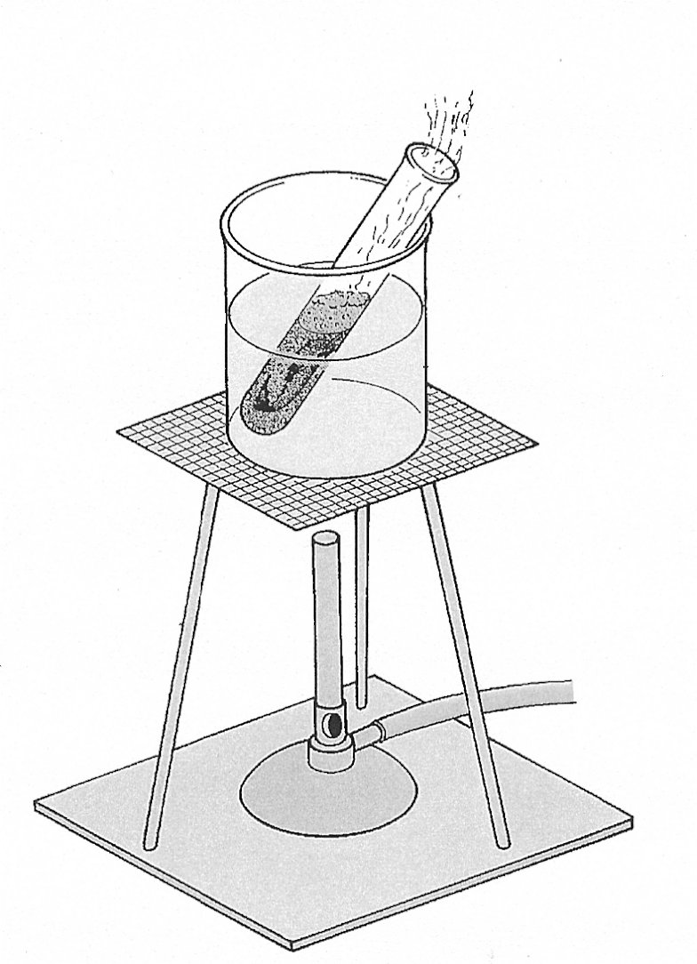
inflammable vapour
BUNSEN OUT
boiling alcohol
leaf
hot water

Extracting chlorophyll from a leaf

