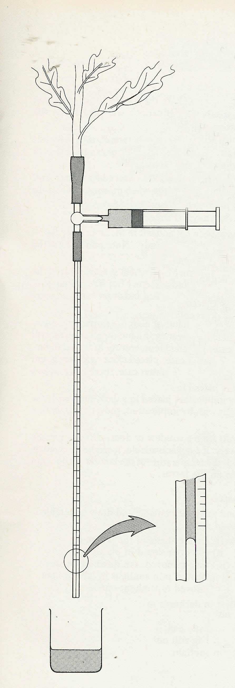
Experiment 2. Discussion
1 The water that disappears from the capillary must be entering the shoot. Suggest processes in the shoot which might make use of this water.

2 Probably most of the water taken in by the shoot is eventually evaporated from the leaves and only a small proportion retained for the processes listed in your answer to Question 1. What effect might an increase in (a) light intensity, (b) temperature, have on the rate of water uptake? Explain your answers.

Fig. 2

3 If you wanted to compare the rates of uptake of water in two different types of-shoot, what steps would you need to take in order to be reasonably sure that any observed differences were valid?

4 The rate of uptake of water in a shoot when cut from a plant may not be the same as its rate of uptake while still attached to the plant. Suggest reasons for this difference (apart from the environmental changes involved).

5 If a shoot with 12 leaves had an uptake of 30 mm³ per minute, what might the rate of uptake be for the entire shrub from which the shoot was taken, if the shrub has1500 leaves? Express your answer in cm³ per hour.

Distance in mm, moved by water in 1 minute
First reading
Second reading
Third reading
Fourth reading
Total
Average

the meniscus is just below the start of the scale

