Experiment 2a. The blind spot (1) - discussion - answers

The act of concentrating attention on the cross throws its image on to the fovea and the image of the dot on to the periphery of the retina to the left of the fovea. As the book approaches the face, the distance between the images of the cross and dot increases until that of the dot falls on the blind spot, whereupon the dot disappears (Figs. 1a and b).
These results can be used to establish the relative positions of the blind spot and fovea since the dot cannot be made to disappear when the experiment is repeated with the dot and cross in other positions.
One is not usually aware of the blind spot because (a) both eyes are used, (b) the eyes make constant scanning movements (c) the gap in the visual field never coincides with the image of the object on which we are concentrating and (d) the brain 'fills in' the gap (see Experiment 2b).

Experiment 2b. The blind spot (2) - discussion - answers

When the image of the gap falls on the blind spot, the line appears to be continuous. It is as if the brain does not normally recognize the absence of sensory information from the blind spot.
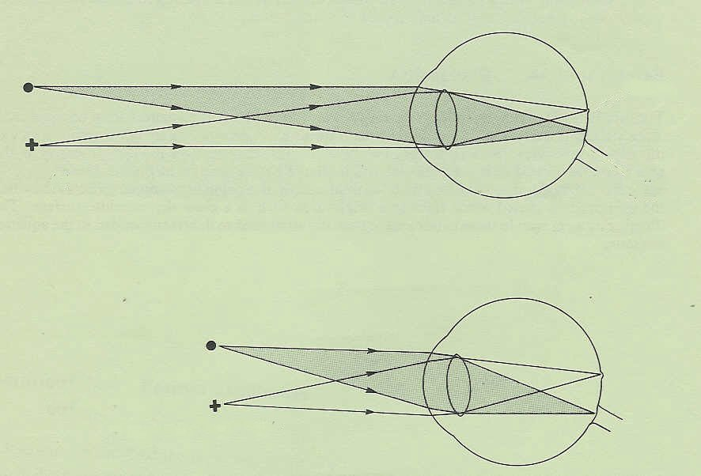
fovea
blind spot
optic nerve
(a)
page moved closer
(b)
Fig. 1 Right eye in horizontal section
image of dot falls on blind spot

