Experiment 2. Discussion

I What difference did you observe between the two tubes containing
lime water at the end of the experiment?
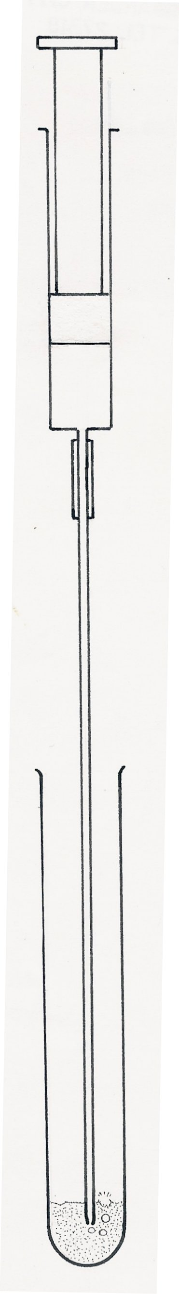

2 What gas affects lime water in this way ?

3 What gas is given out by the living organisms in your experiment ?

4 How do you know that this gas comes from the living organisms and
not from the air already in the tube ?

5 From your results can you say that all living organisms produce this
gas?

6 If you used dead organisms in tube B suggest a reason for having them
rather than an empty tube.
lime water
Figure 2

