Experiment 2. Uptake of water by shoots

(a) Copy the table on p. 1.02 into your notebook.

(b) Half fill a small jar with tap water; fill the syringe from this and expel all air bubbles.

(c) Fit the syringe to the side arm of the 3-way tap. Turn the tap down and press the syringe
plunger gently until water wells out of the rubber tubing.

(d) Select a shoot and push the stem into the rubber tubing as far as possible.

(e) Turn the tap upwards and depress the syringe plunger to expel all air bubbles from the
capillary.

(f) With the tap still upwards, withdraw the syringe plunger slightly to bring the water column to
just below the start of the scale (Fig. 2).
Unless readings are being made in the field, the apparatus can be clamped in a retort stand at
this stage.

(g) Turn the tap horizontally and watch the meniscus (air/water boundary) in the capillary. As the meniscus reaches the beginning of the scale note the time (or start the stop-clock) and after one minute, notice how far the water has travelled up the capillary. Record this figure, in mm, in
your table.
(i) If, on turning the tap horizontally, the water column falls, there is a leak, probably where
the shoot is inserted into the rubber tubing. The best remedy is to select another shoot with a
wider stem and start again from (c).
(ii) If the water column is travelling very rapidly, it may be necessary to record the distance
travelled in 15 or 30 seconds and multiply this value by 4 or 2 to obtain the rate per minute.
(iii) Do not let the water column recede above the scale. If air enters the upper part of the
apparatus, it will impede the water uptake.

(h) To take further readings, turn the tap upwards and depress the syringe plunger to return the meniscus below the scale. Turn the tap horizontally and again measure the distance travelled by the water column in one minute. Take 3 or 4 successive readings in this way and record them
in your table.

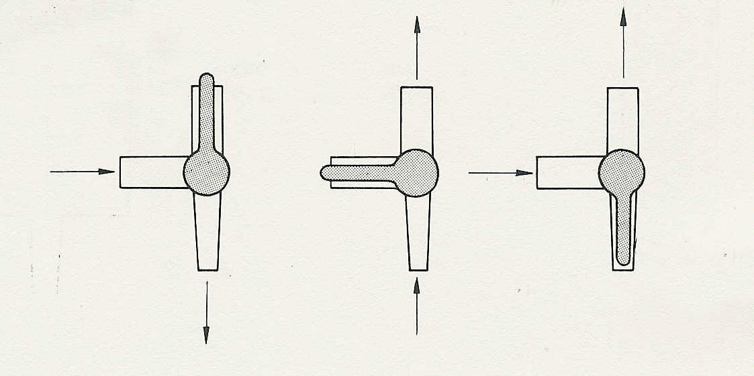
Fig. 1
The 3-way tap
this arm is closed
closed
closed

