Experiment 2a. The blind spot (1)

(a) Close your left eye.

(b) Hold this page about 60 cm away from your face.

(c) Concentrate on the cross with the right eye and slowly bring the page closer to the face, still concentrating on the cross.

(d) Repeat the experiment with the page held sideways so that the dot is above the cross; and also with the page upside down with the dot on the left of the cross.

(e) Describe what you see in each case and explain it as far as possible.

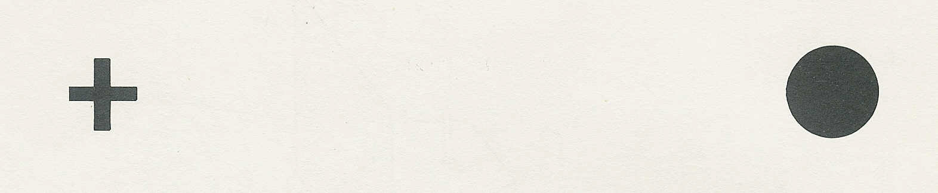

Experiment 2b. The blind spot (2)

(a) Close the left eye and hold the page at arm's length.

(b) With the right eye, concentrate on the cross and bring the page slowly nearer your face. At first, the short line on the right will disappear because its image falls on the blind spot.

(c) When the short line reappears, the image of the gap will be on the blind spot. Describe what
you see at this point.

