Glucose test p.1

Experiment 2. The test for glucose

(a) Half fill a beaker with tap water and place it on a tripod and gauze. Heat the
water with a Bunsen burner. While waiting for the water to boil, carry on with instructions (b) to (d).

(b) Label four test-tubes 1-4.

1% starch solution into tube 1

10% glucose solution into tube 2
(c) Put 20 mm (depth) of
1% albumen solution into tube 3

water into tube 4

(d) To each tube add about 10 mm Benedict's solution.

(e) Place the test-tubes in the beaker of hot water (see Figure on p. 2), and adjust the flame to keep the water just boiling and then copy the table below into your notebook

(f) After about 5 minutes, turn out the flame. Place the four tubes in a test-tube rack and compare the colours. Record the results in the form of a table in your notebook and match the final colours as nearly as possible with crayons.

 | Solution | Colour change on heating with Benedict’s reagent | Final colour (crayon)
1 | 1% starch
2 | 10% glucose
3 | 1% albumen
4 | water

CLEANING THE TUBES. If a coloured deposit sticks to the inside of the tube even after rinsing with water, it can be removed by pouring in a little dilute hydrochloric acid (HCl).
Rinse the tube with water afterwards.

Experiment 2. Discussion
Glucose test p.2
I What colour changes took place when Benedict's solution was added to each liquid ?

2 The solutions selected for testing are examples of three of the principal chemical substances found in cells: glucose, starch, protein (albumen). With which of these food materials did Benedict's solution give a decisive change on heating?

3 Apart from the colour, what change took place in the consistency of the Benedict's
solution ?

4 Do your results indicate that any sugar (e.g. sucrose, fructose and maltose) will give the same colour as glucose did when tested with Benedict's solution?

5 Do your results allow you to say that (a) no protein will give a colour change when
heated with Benedict's solution, (b) albumen never reacts with Benedict's solution to
give a colour change ?

6 Can you predict that glucose will always give the same result with Benedict's solution
as it did in your experiment ?

7 Why was water included in the test ?

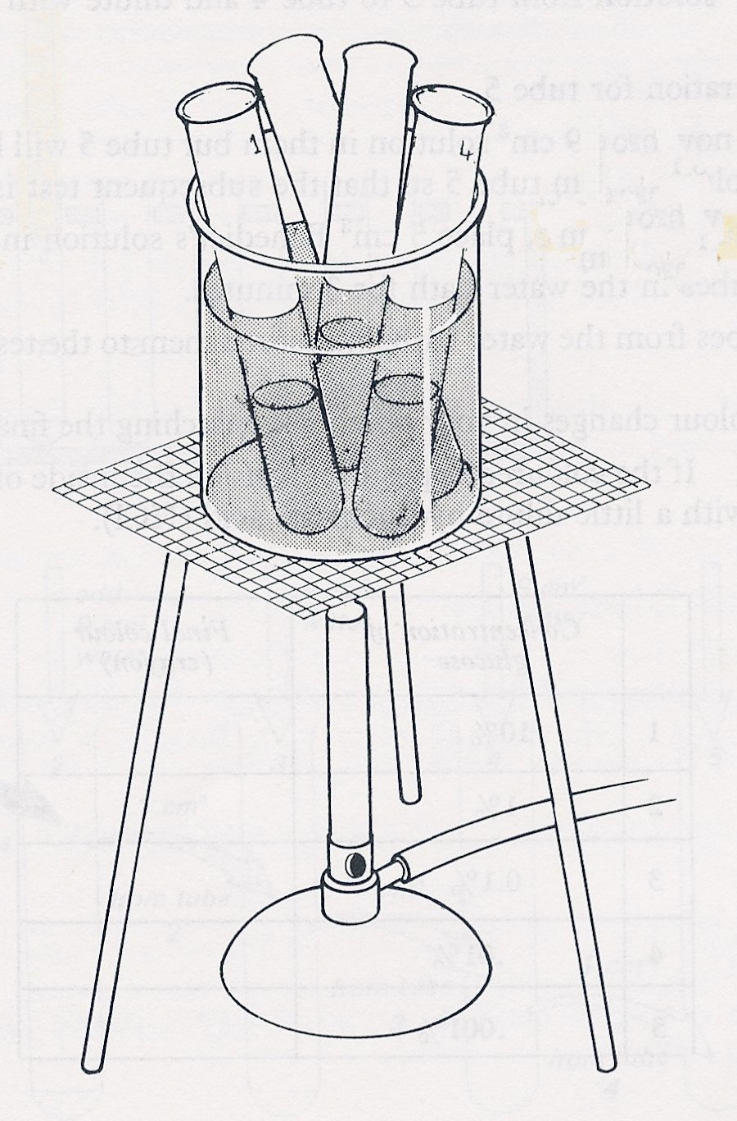
Heat the test-tubes in a water bath

Experiment 2. Discussion - answers
Glucose test p.3
I No colour change should occur in the cold.

2 The only 'decisive' change, i.e. a red/orange colour, is with the glucose solution. The 1% starch may give a cloudy green colour .

3 Students may have observed the change from a clear solution to a suspension or precipitate.

4 Glucose is an example of a sugar and not 'sugars' in general. Fructose and maltose will react with Benedict’s solution but sucrose will not.

5 Neither of the generalizations are admissible from the results of this single experiment.

6 Such a prediction is not justified from the results of a single experiment.

7 Although failure to give a red precipitate with albumen and starch provides a control, it could be argued that Benedict's solution always gives a red precipitate on boiling and that this change is inhibited by albumen and starch but not sugar. Water acts as a control against this hypothesis.

Experiment 2. The test for glucose- preparation
TEACHERS NOTES
Glucose test p.4
Outline The Benedict's test is applied to starch, glucose and a protein to establish that it is a specific test for glucose.

Prior knowledge None

Advance preparation and materials

10% glucose solution
1% starch solution * 5-10 cm³ per group
1% albumen solution

Benedict's solution ⁺ 30 cm³ per group

Apparatus-per group

test-tube racks and 4 test-tubes test-tube brush
Bunsen burner 4 labels or spirit marker
tripod and gauze 250 cm³ beaker
heat mat (to protect bench)

*See p. 01
⁺ Details of preparation given on p.01. Benedict's solution is preferred to Fehling's solution since (a) it can be kept for a long time as a single solution, (b) it is less caustic.

