Experiment 16. Respiratory activity in maize seedlings

Respiration is the process by which energy from food is made available for chemical reactions in the cells of living organisms.
This process involves removing hydrogen atoms (oxidation) from the food and passing them to
other chemicals known as hydrogen acceptors.
Tetrazolium chloride is an 'artificial' hydrogen acceptor which goes pink in solution when it has
taken up hydrogen atoms.
You are provided with two soaked maize fruits one of which has been boiled. You are also provided with a 6-day-old maize seedling.

(a) Prepare a water bath by half filling a beaker or jar with water, adjusting the volumes of hot
and cold water to give a temperature of about 40 °C.

(b) Label three test-tubes A, B and C. Use a graduated pipette or syringe to put 2 cm³ tetrazolium chloride solution into both A and B, and 6 cm³ into C. Place all three tubes in the water bath.

(c) Place the fruits and the seedling on a tile or Petri dish lid. Using a scalpel or razor blade cut the soaked fruits in half longitudinally so that the cut passes through the long axis of the embryo
(Fig. 1). Drop both halves of the boiled grain into tube A and the half grains of the other fruit into tube B. Cut longitudinally through the mid line of the seedling in the same way, starting
by splitting the coleoptile down its length. Continue the cut through the fruit and if possible
down the length of the radicle. If the radicle is too long for this, cut it into 20 cm lengths and split these. Put all the seedling parts into tube C and leave all the tubes for 10 minutes.

(d) During the 10 minutes, copy the outlines of Figs. 2 and 3 into your notebook.

(e) If the cut surfaces of the fruits do not show much pink colour after 10 minutes leave them for
another l0 minutes and check that the water has not cooled below 30 °C.

(f) Pour the solution back into the beaker and shake the fruits out on to the bench. Blot them dry, examine each cut surface with a hand lens and shade your drawings to show both the
distribution and intensity of colour in B and C.
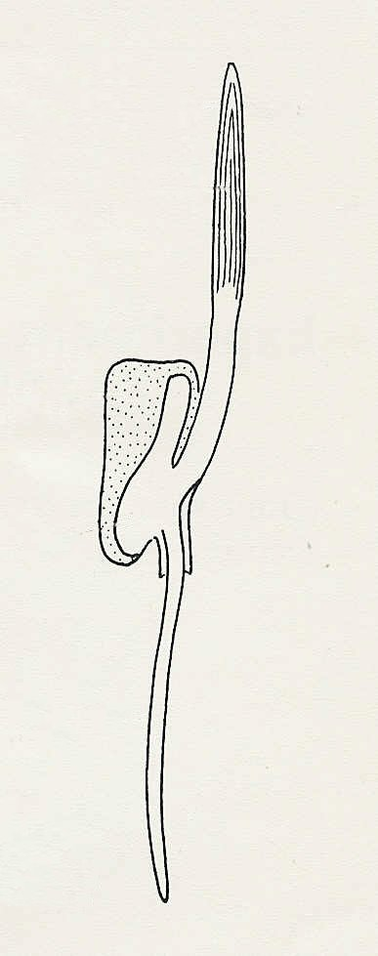
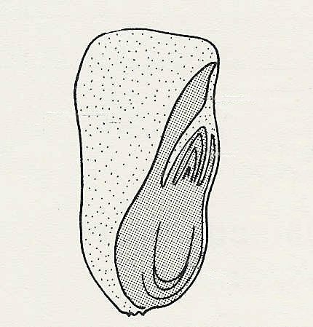
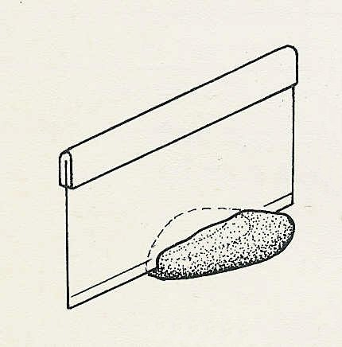
coleoptile

Fig. 1
endosperm
cotyledon
plumule

radicle

Fig. 2 Longitudinal section through maize fruit
Experiment 16 Discussion
endosperm

Assuming that when tetrazolium chloride turns pink, it
cotyledon
indicates that respiration is taking place, give an account
of the regions where respiration appears to be happening
in the fruits and germinating grains. Discuss any changes
in the distribution of these areas during the course of
radicle
germination.
Fig. 3 Vertical section through maize seedling

