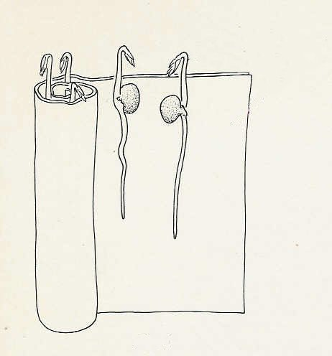
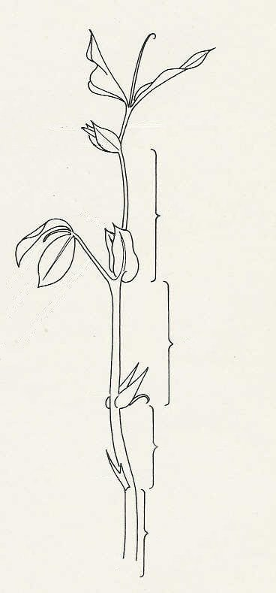
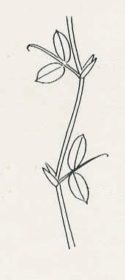
epicotyl clear of blotting paper
growing point
stipule
tendril
leaflet
leaf stalk
leaf
stipule
stipule
leaf
stipule
leaf stalk
internode
internode
internode
internode
stipule
leaf
Fig. 2a Position of leaves and stipules (diagrammatic)
Fig. 2b Pea shoot
Fig. 1

