Experiment 13. Measuring the transpiration rate of a potted plant

(a) Label one pot A, the other B and add your initials to each.

(b) Add sufficient water to each pot to make the soil moist.

(c) Copy the table below into your notebook.

(d) Place each pot in a plastic bag and tie the bag securely round the base of the plant's stem, using string or wire 'ties' (Fig. 1).

(e) Weigh each potted plant on a balance and record their masses in your table.

(f) Leave plant A in a sunny position in the laboratory and place plant B in a shaded position in the same room.

(g) After one day, weigh both potted plants again and record their masses in your table.

(h) If there has not been much change in mass, the experiment can be continued for several more days.

(i) At the end of the experiment, work out the mass lost by each plant and, assuming the loss in
mass is entirely caused by transpiration, calculate the rate of transpiration in grams per day.

Time | Mass of plant  A in sunlight | Mass of plant  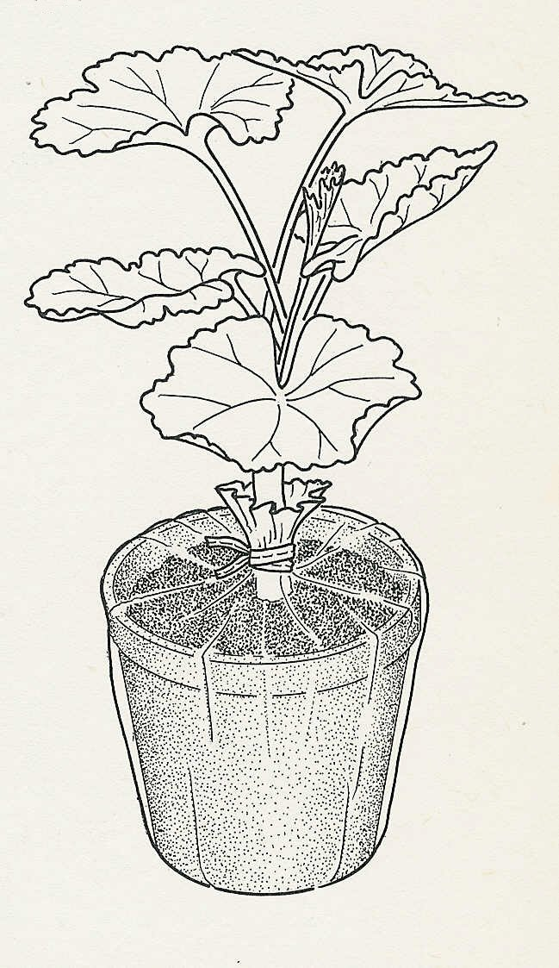  B in shade
Start
After 1 day
After …days
After …days
Loss of mass in …days
Transpiration rate = ……. grams per day

Experiment 13. Discussion

1 We have assumed that the loss in mass is entirely
the result of transpiration of water from the shoot.
What other processes in the plant are likely to cause
(a) a loss in mass, (b) a gain in mass?

2 Are we justified in ignoring the changes of mass
caused by these processes? Explain your answer.

3 Why was it necessary to enclose the pot in the
plastic bag?

4 What difference was there in the transpiration rates
of the plant in sunlight and the plant in the shade?
Fig. 1

5 Apart from light intensity, what other differences in
their positions might have affected the two plants?

