Experiment 13 Location of stimuli

(a) Place a glass marble on a non-slippery surface, e.g. on the page of an open notebook.

(b) Cross the first and second fingers of one hand and press on the marble with the tips of these
fingers (Fig. 1).

(c) Close your eyes and roll the marble firmly, forwards and backwards, side to side and then with a circular motion for about 30 seconds.

(d) Notice any unusual impressions you receive from the fingers.

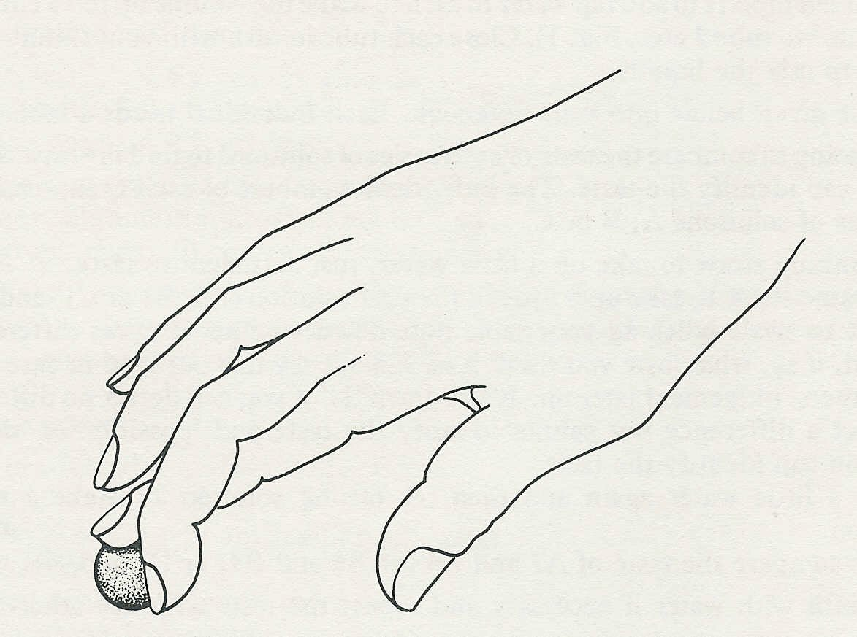

marble
Fig. 1

Experiment 13 Discussion

1 Was there anything unusual in the sensory impressions received from the crossed fingers?

2 Offer a simple explanation of any such impression.

