Experiment 12. Discussion

1 In general terms what was the effect of rising temperature on the rate of carbon dioxide production?

2 Was the change in rate consistent over the whole of the temperature range which you tried? If
not, suggest an explanation for any deviation.

3 As the water bath cooled down during each series of three readings, there would be a contraction in the volume of gas. How could this affect the accuracy of your readings? Suggest a control which could be employed to correct any errors of this kind.

4 The solubility of gases in water decreases with increasing temperature. How might this property affect your results?

5 What factors, apart from temperature, might be limiting the rate of carbon dioxide production
from yeast cells?

Temperature | Mean temperature | Volume | Mean volume  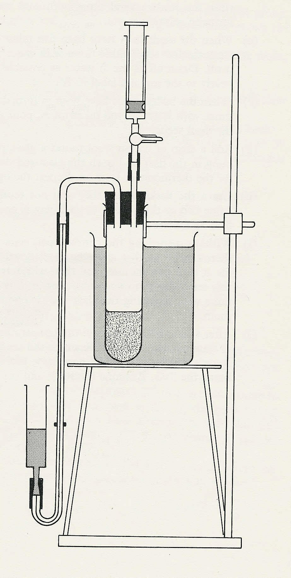
 |  |  | syringe
first |  |  | 3-way tap
final |  |  | 3-way tap
first
final
first
final
first |  |  | yeast and glucose
final |  |  | yeast and glucose

manometer reservoir
level marker
Fig. 1

